PASS AND GO

STUDENT TARGETS
- Skill: I will apply cues for the forearm pass (bump) during this activity.
- Cognitive: I will identify strategies and tactics to attempt to win points for my team.
- Fitness: I will stay actively engaged for the duration of this activity.
- Personal & Social Responsibility: I will provide encouragement and safely cooperate with my peers.
EQUIPMENT & SET-UP | 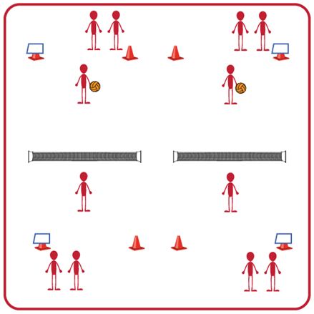
Equipment:
- 1 volleyball, volleyball trainer, or foam ball per group (Teachers: allow student choice of equipment when possible)
- 1 net per group
- 4 boundary cones per group
- Task Tent and Volleyball Cue Charts per group
Set-Up:
- Divide students into groups of 6. Each group splits into even teams (i.e., 3v3) with teams beginning on opposite sides of the net.
- Set up 1 court per group of 6 students. Place cones and task tents with cue charts beside each court.
- Each team begins in a line on their side of the court. The 1st player in line begins on the court, and the others wait to rotate in.
ACTIVITY PROCEDURES
- This activity is called Pass and Go. The object of the game is to continually forearm pass (bump) the volleyball over the net for your team while quickly rotating onto and off of the court.
- The game will begin with 1 player from each team on the court, ready to face off. 1 player will underhand serve the ball over the net to begin play. After the ball is served, the server immediately goes to the end of their line and the next player from their team steps onto the court.
- The player who receives the serve will bump it back over the net, and then immediately move to the end of their line so that the next player can step onto the court and get ready to receive the ball. Each player will be on the court for one attempt, regardless of whether it is successful or not, and then move to the end of their team’s line.
- Teams score a point each time the opposite team doesn’t get the ball over the net, or they hit it out of bounds. But remember, play doesn’t stop while players rotate in/out so you will need to move quickly and be ready to step onto the court if you are the next player in line!
- On the stop signal the team with the most points will stay and their opponents will find a new court to play again.

GRADE LEVEL PROGRESSION
- Grade 6: Play as described above.
- Grade 7: Students can use a bump or a set. They still only get to strike the volleyball one time before it goes over the net but get to choose between a bump or a set.
- Grade 8: Have 2 students from each team on the court at all times. A student will rotate out each time they serve or bump the ball for their team.

PASS AND GO (continued…)

TEACHING CUES
- Cue 1: Make sure you move quickly onto the court when it is your turn and get into ready position.
- Cue 2: Remember the power comes from your legs not your arms.
- Cue 3: Keep your thumbs pointing down and your arms straight.

UNIVERSAL DESIGN ADAPTATIONS
- UDL 1: Increase/decrease the size of the court as needed.
- UDL 2: Use floor lines or jump ropes rather than a net.
- UDL 3: Use modified equipment as needed (e.g., beeper ball, balloon, beach ball).
- UDL 4: Use verbal cues and visual aids along with demonstrations.
- UDL 5: Use peer partners as appropriate.
- UDL 6: Allow a toss to begin the game vs. a serve if needed.

ACADEMIC LANGUAGE
Bump, Control, Cooperation, Accuracy, Pass

PRIORITY OUTCOMES
Locomotor Skills:
- (Grade 6) Safely and purposefully uses mature locomotor skills in rhythms and patterns in dance, fitness, and sport environments.
- (Grade 7) Combines mature locomotor and manipulative skills in dance, fitness, and sport environments.
- (Grade 8) Combines locomotor skills with movement concepts in dance, fitness, and sport environments.

Etiquette:
- (Grade 6) Identifies the rules and etiquette for physical activities/games and dance activities.
- (Grade 7) Demonstrates knowledge of rules and etiquette by self-officiating modified physical activities/games or following parameters to perform, create, or modify a dance.
- (Grade 8) Applies rules and etiquette by acting as an official for modified physical activities/games or creating dance routines within a given set of parameters.

DEBRIEF QUESTIONS
- DOK 1: What is a strategy?
- DOK 2: What is a volleyball strategy or tactic you or your team used today during this activity?
- DOK 3: If your strategy was not successful, what changes did you make the next time it was your turn to bump the ball for your team?

