VOLLEYBALL FOURSQUARE

STUDENT TARGETS
- Skill: I will pass and set to a strategic space.
- Cognitive: I will describe the strategies used to strike with control.
- Fitness: I will actively engage and work to improve my bumping/setting skills.
- Personal & Social Responsibility: I will use positive language and challenge my partner(s) to improve.

EQUIPMENT & SET-UP | 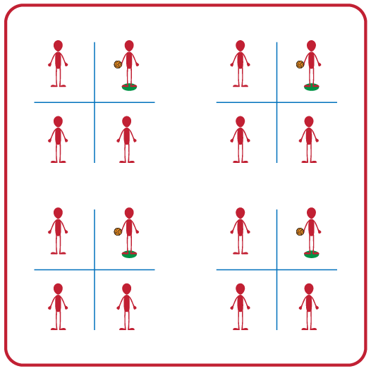
Equipment:
- 1 foam ball or beach ball per group of 4 students
- 2 Jump ropes per group of 4 students
- 1 Spot marker per group of 4 students
- 1 Volleyball Crossnet (optional)

Set-Up:
- Divide students into groups of 4.
- Use 2 Jump Ropes to create a grid of 4 squares (or a Volleyball Crossnet)
- Assign one student to each square.
- Designate one square as the server square and place a spot marker in that square.
- Student in designated server square will begin with the ball.

ACTIVITY PROCEDURES
- This activity is called Volleyball Foursquare. The object of the game is to successfully bump or set the ball into one of your opponent's squares.
- On the start signal, the server will begin the game by underhand tossing the ball to another player who will forearm pass (bump) or overhead pass (set) the ball to another square. Each player gets one attempt to pass the ball to another player without the ball hitting the ground. Play continues as long as the ball is passed in the air from square to square without hitting the ground. If a ball lands on one of the ropes you will replay the point.
- When a score occurs (the ball hits the ground) all players rotate clockwise and the new server begins a new round.
- Teachers: If you have groups with more than 4 students, you can have a student waiting to rotate into the game act as the official until they enter the game.

GRADE LEVEL PROGRESSION
- Grade 6: Play as described above.
- Grade 7: Students must alternate between a bump or a set for each hit.
- Grade 8: Utilize a Crossnet (or modified net that is raised off the ground) vs. the jump ropes on the ground.

TEACHING CUES
- Cue 1: Be in ready position at all times when the ball is in play.
- Cue 2: Remember the power comes from your legs not your arms.
- Cue 3: Get under the ball when it comes into your square.

VOLLEYBALL FOUR SQUARE (continued…)

UNIVERSAL DESIGN ADAPTATIONS
- UDL 1: Increase/decrease the size of the court as needed.
- UDL 2: Allow the game to be played seated vs standing.
- UDL 3: Use modified equipment as needed (e.g., balloon or beach ball with a bell attached).
- UDL 4: Use verbal cues and visual aids along with demonstrations.
- UDL 5: Use peer partners as appropriate.

ACADEMIC LANGUAGE
Bump, Set, Control, Force

PRIORITY OUTCOMES
Etiquette:
- (Grade 6) Identifies the rules and etiquette for physical activities/games and dance activities.
- (Grade 7) Demonstrates knowledge of rules and etiquette by self-officiating modified physical activities/games or following parameters to perform, create, or modify a dance.
- (Grade 8) Applies rules and etiquette by acting as an official for modified physical activities/games or creating dance routines within a given set of parameters.

DEBRIEF QUESTIONS
- DOK 1: Can you remember the cues for forearm (bump) and overhead (set) passing?
- DOK 2: Which of the passing cues affect accuracy the most?
- DOK 3: How is being actively engaged related to accuracy and performance during a 4-Square game?

