PEER COACHING

STUDENT TARGETS
- Skill: I will overhead pass (set) with accuracy.
- Cognitive: I will write and verbally communicate corrective feedback to my partner using positive language.
- Fitness: I will actively engage and work to improve my underhand serving.
- Personal & Social Responsibility: I will use positive language when giving feedback and appropriate responses when receiving feedback.

EQUIPMENT & SET-UP | 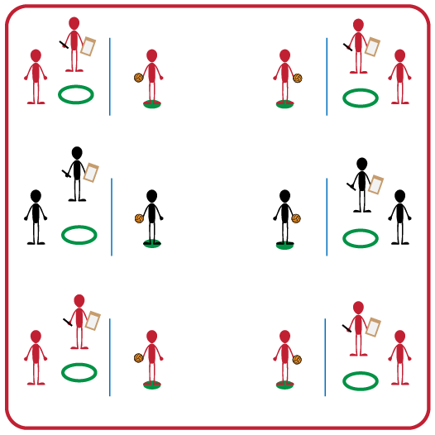
Equipment:
- Volleyball (1 per group)
- Net (1 per group)
- Hula Hoop (1 per group)
- Spot Marker (1 per group)
- Clipboard (1 per group)
- Pencil (1 per group)
- Peer Coaching Feedback Form (1 per group)
Set-Up:
- Divide students into groups of 3.
- Each group will set up their net. There will be a spot maker on one side and a hula hoop on the opposite side.
- Each group will have a clipboard with a Peer Feedback Form and pencil.

ACTIVITY PROCEDURES
- This activity is called Peer Coaching. The object of this activity is to work cooperatively in your group to perform and provide feedback to a peer for the volleyball set. This gives each of you the opportunity to both demonstrate a proper set and apply the cues to provide feedback to classmates.
- Each person in your group will have one of three positions: Tosser, Setter, or Peer Coach.
- On the start signal, the Tosser will underhand toss the ball to the Setter. The Tosser should use a soft toss that finishes above the Setter’s head. The Setter will set the ball back over the net so that it lands in the hula hoop target (repeat this process 5 times). The Peer Coach is observing each of the five set attempts and filling out the feedback form as accurately as possible. Students will rotate until everyone in the group has had a chance to complete all 3 positions.
- On the stop signal you will place the feedback form and ball into the hula hoop so we can discuss our successes and challenges before we play again. During the second round, we will see if your scores can improve by using the feedback you were given.
GRADE LEVEL PROGRESSION
- Grade 6: Play as described above.
- Grade 7: Tosser will toss the ball so that it is a foot or two in front of the setter to force them to move to the ball before setting it over the net.
- Grade 8: Students must analyze results and feedback in order to set a GREAT goal on how they can improve their setting skills.
TEACHING CUES
- Cue 1: Use positive language with your classmates when giving feedback.
- Cue 2: Position yourself under the ball with knees bent.
- Cue 3: Make a triangle with pointer fingers/thumbs near forehead, then extend arms to push ball up.
PEER COACHING (continued…)

UNIVERSAL DESIGN ADAPTATIONS
- UDL 1: Increase/decrease the distance from hoop to spot marker as needed.
- UDL 2: Use modified equipment as needed (e.g., foam ball, balloon or beach ball with bell attached).
- UDL 3: Use verbal cues and visual aids along with demonstrations.
- UDL 4: Use peer partners as appropriate.
- UDL 5: Modify Peer Feedback Form to meet needs of all students, including use of assistive technology or ability to dictate feedback vs. writing it down.

ACADEMIC LANGUAGE
Cues, Feedback, Positive Language, Goal

PRIORITY OUTCOMES
Accepting Feedback:
- (Grade 6) Demonstrates self-responsibility by implementing specific corrective feedback to improve performance.
- (Grade 7) Provides corrective feedback to a peer, using teacher-generated guidelines, and incorporating appropriate tone, and other communication skills.
- (Grade 8) Provides encouragement and feedback to peers without prompting from the teacher.

Social Interaction:
- (Grade 6) Demonstrates respect for self and others in activities and games by following the rules, encouraging others, and playing within the spirit of the game or activity.
- (Grade 7) Demonstrates the importance of social interaction by helping and encouraging others, avoiding trash talk, and providing support to classmates.
- (Grade 8) Demonstrates respect for self by asking for help and helping others in various physical activities.

DEBRIEF QUESTIONS
- DOK 1: How can you recognize corrective feedback?
- DOK 2: How is positive language related to corrective feedback?
- DOK 3: How would you compare and contrast corrective feedback and negative criticism?

