PASS, SET, HIT RALLY

STUDENT TARGETS
- Skill: I will work with my partner to score points for our team during this activity.
- Cognitive: I will discuss strategies that helped my team be successful.
- Fitness: I will stay actively engaged throughout each game in order to increase my heart rate.
- Personal & Social Responsibility: I will show integrity by playing fair and communicating using positive language.

EQUIPMENT & SET-UP | 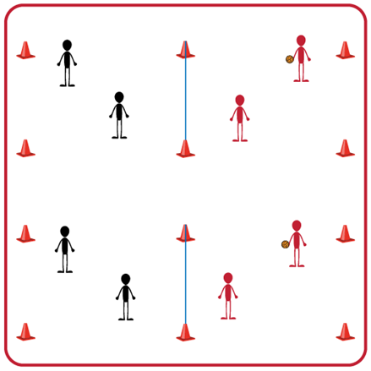
Equipment:
- 1 volleyball, volleyball trainer, or foam ball per group of two teams (Teachers: allow student choice of equipment when possible)
- 1 net per two teams
- 4 boundary cones per two teams

Set-Up:
- Divide students into teams of 2.
- Pair each team of 2 with another team (for a group of 4).
- Divide the space for each group into equal areas using a volleyball net or elevated line. Use 4 boundary cones for each group’s activity area.

ACTIVITY PROCEDURES
- This activity is called Pass, Set, Hit Rally. The object of the game is to work together with your teammate to score points on the opposing team. You do that by keeping the ball from hitting the ground on your side of the net and hitting the ball onto your opponent's side of the net.
- On the start signal the serving team will underhand serve the ball over the net and play begins. Players can use bumps, sets, and overhead hits (spikes) to rally with the other team. Your team will work together to hit the ball over the net to the other team before it hits the ground on your side. You and your teammate can hit the ball a maximum of 3 times on your side before it must go over the net.
- If the ball hits the ground on your opponent's side your team gets a point. If a team hits the ball out of bounds the opponent gets the point.
- On the stop signal, place the ball on the ground. We will rotate the teams every 5 minutes to give everyone a variety of opponents. The team who has the ball when you hear the stop signal will stay, and the other team will rotate to another court.
GRADE LEVEL PROGRESSION
- Grade 6: Play activity as described above. Allow for a throw to begin the game if needed.
- Grade 7: Students must utilize at least 2 different types of passes during each rally.
- Grade 8: Students must use a bump, set, and overhead hit (spike) each series of their rally or point is awarded to opponents.
TEACHING CUES
- Cue 1: Body in Ready Position (knees bent, head up, feet shoulders width apart, hands ready).
- Cue 2: Move feet to get under the ball so you can prevent it from hitting the ground on your side of the net.
- Cue 3: Stay attentive, communicate, and work together with your teammate(s).

PASS, SET, HIT RALLY (continued…)

UNIVERSAL DESIGN ADAPTATIONS
- UDL 1: Increase/decrease the size of activity space/court.
- UDL 2: Use modified equipment as needed (e.g., foam ball, balloon or beach ball with bell attached).
- UDL 3: Use verbal cues and visual aids along with demonstrations.
- UDL 4: Use peer partners as appropriate.

ACADEMIC LANGUAGE
Volley, Rally, Technique, Spike, Spirit of the Game

PRIORITY OUTCOMES
Manipulative Skills:
- (Grade 6-8) Refines manipulative skills to improve performance in dance, fitness, and sport activities.

Working with Others:
- (Grade 6) Accepts differences among classmates in physical development, maturation, and varying skill levels by providing encouragement and positive feedback.
- (Grade 7) Demonstrates cooperation skills by establishing rules and guidelines for resolving conflicts.
- (Grade 8) Responds appropriately to participants’ ethical and unethical behavior during physical activity by using rules and guidelines for resolving conflicts.

DEBRIEF QUESTIONS
- DOK 1: How would you describe the spirit of the game to a new student in our school?
- DOK 2: What do you know about the spirit of the game? (Think beyond the definition.)
- DOK 3: How would you describe a game played with the spirit of the game? How would you describe a game played without it?

- DOK 1: Can you define the word “strategy”?
- DOK 2: What do you know about volleyball offensive strategies? What about defensive strategies?

