ROYAL COURT POINTS ROTATION

STUDENT TARGETS
- Skill: I will demonstrate a variety of volleyball skills during small-sided games.
- Cognitive: I will discuss the importance of integrity with respect to enjoyment of play.
- Fitness: I will demonstrate a variety of skill-related fitness components.
- Personal & Social Responsibility: I will demonstrate respect for myself and my classmates by following the rules of the game and encouraging others.

EQUIPMENT & SET-UP | 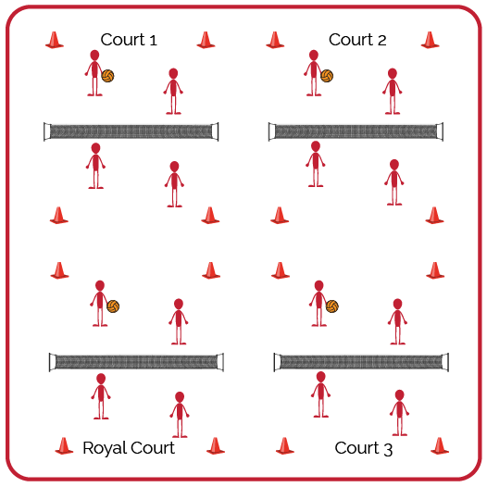
Equipment:
- 1 volleyball per group of 4 students (doubles)
- 1 net per court (or cones/jump ropes if needed)

Set-Up:
- Create enough courts so the entire class can play doubles matches.
- Number each court, with court 1 as the starting court and the highest number court as the “Royal Court.”
- Create teams for doubles and send students to courts. If you have more teams than courts, you can have a team waiting to rotate into a court.

ACTIVITY PROCEDURES
- Today’s activity is called Royal Court Points Rotation. This tournament will be a way to test our skills and have fun with our friends.
- The goal of today’s tournament is to compete with a positive attitude and to work your way to the Royal Court, while your team accumulates as many points as possible. We’ll play 3-minute games. The winner of each game will earn 1 point and move to a higher court. The losing team or player will move down to a lower court and will not earn any points for that round.
- On the start signal, you will play an opposing team for 3 minutes. The winner will move up 1 court toward the Royal Court. The winner on the Royal Court will stay and defend her/his position. The team that loses the match will move 1 court away from the Royal Court. The team that loses on court 1 will stay and try again. If the score is tied on any court when the 3-minute time expires, play Rock, Paper, Scissors to determine the winner.
- We will continue to play until time runs out. The team who earned the most points and ended on the Royal Court will be the winners!

GRADE LEVEL PROGRESSION
- Grade 6: Pair students of similar skill levels and skip the royal court rotation. Instead, rotate students with a focus on setting them up for challenge, success, and fun.
- Grade 7: Play as described above.
- Grade 8: Play as described above.

ROYAL COURT POINTS ROTATION (continued…)

TEACHING CUES
- Cue 1: Apply the volleyball skill cues we have focused on.
- Cue 2: Help and encourage others by demonstrating sportsmanship.
- Cue 3: Play with purpose but have fun!

UNIVERSAL DESIGN ADAPTATIONS
- UDL 1: Increase/decrease the size of activity space/court.
- UDL 2: Use modified equipment as needed (e.g., foam ball, balloon or beach ball with bell attached).
- UDL 3: Use verbal cues and visual aids along with demonstrations.
- UDL 4: Use peer partners as appropriate.

ACADEMIC LANGUAGE
Rotation, Serve, Teamwork, Integrity

PRIORITY OUTCOMES
Manipulative Skills:
- (Grade 6-8) Refines manipulative skills to improve performance in dance, fitness, and sport activities.

Etiquette:
- (Grade 6) Identifies the rules and etiquette for physical activities/games and dance activities.
- (Grade 7) Demonstrates knowledge of rules and etiquette by self-officiating modified physical activities/games or following parameters to perform, create, or modify a dance.
- (Grade 8) Applies rules and etiquette by acting as an official for modified physical activities/games or creating dance routines within a given set of parameters.

DEBRIEF QUESTIONS
- DOK 1: What is integrity?
- DOK 2: Why is integrity important in physical activity or competitive settings?
- DOK 3: How is integrity related to the enjoyment of everyone playing a game of Volleyball?

