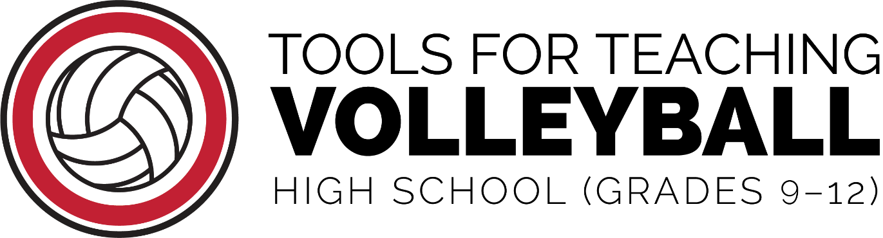

Created by:
Stephanie Dickson, Mary Jo Geddes Brandy Lynch,
Shannon Maly, Deb Van Klei

Special Contribution:
Nichole Wilder, Aaron Hart, Andrea Hart

OPEN is a member of the Varsity Brands family of companies
and is a public service of US GAMES and BSN SPORTS.
In partnership with the SUNY Cortland AMP Lab.

©2023
These documents and all of the content provided
by OPEN are available to all teachers, coaches,
and activity leaders without cost or obligation.

Please print, copy, and share
the content responsibly.
The sale of this work by a third party
is prohibited in any print or electronic format.

