VOLLAPALOOZA

STUDENT TARGETS
- Skill: I will demonstrate a variety of volleyball skills focusing on form and technique.
- Cognitive: I will follow the instructions and apply the strategies/techniques for each station.
- Fitness: I will actively engage and work to improve my volleyball skills.
- Personal & Social Responsibility: I will willingly try new activities and skills.

EQUIPMENT & SET-UP | 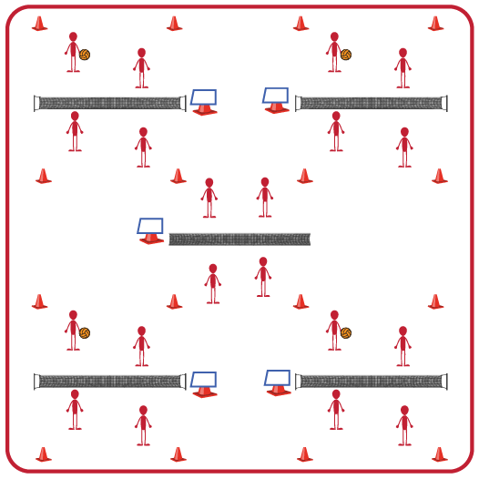
Equipment:
- Variety of volleyball options (e.g., traditional, trainer, foam ball, beach ball)
- Volleyball Station Cards and Task Tents
- Cones to identify boundaries for each station
- See station cards for specific equipment needs at each station
Set-Up:
- Set up a grid for the 5 stations and place equipment needed at each station.
- Place a task tent in each grid with the station card for that station.
- Divide students into 5 equal groups. One group will begin at each station.
ACTIVITY PROCEDURES
- This activity is called Vollapalooza. We will be rotating through stations that allow us to review our volleyball skills before we move into small-sided and traditional games. The object of this activity is for you to rotate through five skill challenges focusing on different volleyball skills we will need to apply during games (forearm pass [bump], overhead pass [set], attack [spike], underhand serve, and overhead serve).
- Each station has a station card that details the skill and activity that is the focus for that station. Teachers: talk through and/or demonstrate each station at the beginning of the lesson.
- On the start signal, you will review the station card at your station and begin the skill challenge. On the stop signal, you will put away any equipment used and rotate to the next station. Wait for the start signal before you begin at the new station.
- Each time you move to a new station, I encourage you to work with new classmates that you haven’t worked with during the previous skill challenges.

GRADE LEVEL PROGRESSION
- Level 1: Complete stations as described above.
- Level 2: Have note cards and pencils at each station where students can add their own student-created challenges for each skill. Then rotate through the stations a second time so students can choose to complete the teacher-created or the student-created challenges for that skill.

TEACHING CUES
- Cue 1: Listen for the stop/start signals to know when to rotate stations.
- Cue 2: Choose the type of ball you feel most comfortable with for each station (e.g., traditional, trainer, foam ball, beach ball).
- Cue 3: Be open to trying new volleyball skills you may have never tried before.
VOLLAPALOOZA (continued…)

UNIVERSAL DESIGN FOR LEARNING
- UDL 1: Use modified equipment as needed (e.g., foam ball, balloon or beach ball with bell attached).
- UDL 2: Use verbal cues and visual aids along with demonstrations.
- UDL 3: Use peer partners as appropriate.
- UDL 4: Identify a group leader for each group that can assist with reading station cards/directions.

ACADEMIC LANGUAGE
Forearm Pass (bump), Overhead Pass (set), Spike, Serve, Spirit of the Game

PRIORITY OUTCOMES
Etiquette:
- (Grades 9-12) Exhibits proper etiquette, respect for others, and teamwork while engaging in physical activity and/or social dance.

Working with Others:
- (Grades 9-12) Uses communication skills and strategies that promote positive team/group dynamics.

DEBRIEF QUESTIONS
- DOK 1: How would you describe the spirit of the game to a new student in our school?
- DOK 2: What do you know about the spirit of the game? (Think beyond the definition.)
- DOK 3: How would you describe a game played with the spirit of the game? How would you describe a game played without it?

