MONEY BALL

STUDENT TARGETS
- Skill: I will perform a volleyball serve with accuracy to score points for our team during this activity.
- Cognitive: I will discuss strategies that helped my team be successful.
- Fitness: I will stay actively engaged throughout in order to increase my heart rate.
- Personal & Social Responsibility: I will communicate using respectful and encouraging language.

EQUIPMENT & SET-UP | 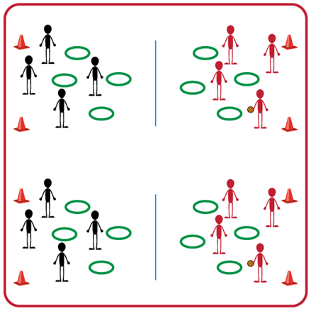
Equipment:
- One court for each group (2 teams per group)
- Net (or modified net) for each court
- Variety of volleyball options (e.g., traditional, trainer, foam ball)
- Hula Hoops and Spot Markers as targets
Set-Up:
- Have one court space for each set of 2 teams.
- Set up nets (or modified nets) for each court and spread out hula hoops and spot markers on the ground on each side of the net.
- Pair students in teams of 4, with one team on each side of the net.
ACTIVITY PROCEDURES
- This activity is called Money Ball. The object of the game is to collect as many hoops or spot markers as you can for your team by hitting the volleyball “on the money” into one of the other team’s targets.
- Each person in your group will have one of two positions: server or rebounder. On the start signal, servers will strike the ball and try to make it land inside a hula hoop or on a spot marker on the other side of the net. Rebounders will collect the ball and return it to the server. Each student will perform 2 serve attempts and then you will rotate positions so all teammates get 2 serve attempts. Teachers: you will need to communicate to students if an overhand or underhand serve will be used (or a combination of both).
- If a serve goes over the net and lands in a hoop or on a spot marker, your team gets to collect that hoop or spot marker for your team. A hoop gives your team one point, and a spot marker will give your team two points.
- We will play until one team has collected all of their hoops and spot markers, or until you hear the stop signal. We will count the points for each team and then discuss our successes and challenges before we play again against a new opponent.

GRADE LEVEL PROGRESSION
- Level 1: Play as described above.
- Level 2: Assign dollar amounts to each color of hula hoop or spot marker (e.g., green = $5, red = $2, etc.) and have students try to collect a specific amount of money instead of points.

TEACHING CUES
- Cue 1: Use skill charts for both the underhand and overhand serve.
- Cue 2: Communicate with respectful and encouraging language.

MONEY BALL (continued…)

UNIVERSAL DESIGN FOR LEARNING
- UDL 1: Increase/decrease the height of the net as needed.
- UDL 2: Use modified equipment as needed (e.g., beeper ball, balloon, beach ball).
- UDL 3: Use verbal cues and visual aids along with demonstrations.
- UDL 4: Use peer partners as appropriate.

ACADEMIC LANGUAGE
Serve, Underhand, Overhand, Target

PRIORITY OUTCOMES
Personal Challenge:
- (Grades 9-12) Chooses an appropriate level of challenge to experience success and a desire to participate in self-selected physical activity while working toward personal fitness goals.

Working with Others:
- (Grades 9-12) Uses communication skills and strategies that promote positive team/group dynamics.

DEBRIEF QUESTIONS
Personal and Social Responsibility Question Set:
- DOK 1: Is there something about volleyball that you have found challenging?
- DOK 2: Did you do something to overcome that challenge? What strategies did you use?
- DOK 3: Would you be willing to continue playing volleyball even if you find it challenging? What could be a benefit of continuing to play during any challenges you were having?

Skill-based Question Set:
- DOK 1: Were you able to consistently serve the ball into your opponents’ hoops?
- DOK 2: What was one thing you did differently if your serve didn’t land in a hoop?
- DOK 3: How did the amount of force you used impact whether your serve landed in the hoop or not? If your serve hit the ground in front of the hoop you were aiming at, what could you do differently on your next attempt?

