VOLLEYBALL TABATA

STUDENT TARGETS
- Skill: I will perform fitness exercises with proper form and a focus on safety.
- Cognitive: I will identify fitness activities that can improve specific volleyball skills.
- Fitness: I will use a heart rate monitor to track and adjust exercise intensity so that I am working in my target zone.
- Personal & Social Responsibility: I will work independently and with consideration for others.
EQUIPMENT & SET-UP |  | 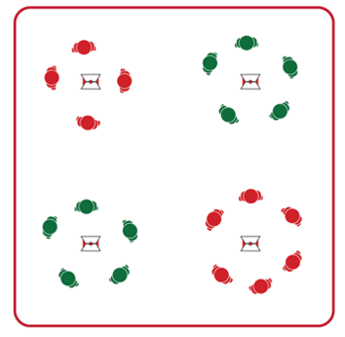
Equipment:
- 4 cones and 4 task tents
- Volleyball Tabata Station Cards
- Station equipment (see station cards for equipment needed at each station)
- Tabata audio cues (Tabata timer app)
- Heart rate monitors (optional)
- YouTube link to Volleyball Skill Tabata Stations: https://www.youtube.com/playlist?list=PLRIuuDO-0RtDOIJ42-YQXlR1aloPrzHmm
Set-Up:
- Create 4 stations using cones, task tents, and Volleyball Tabata Station Cards.
- Place station cards in task tents on cones.
- Distribute station equipment (required at station 1 and station 3) at each area.
- Divide students into 4 even groups, with one group beginning at each station.

ACTIVITY PROCEDURES
- Today’s activity is called Volleyball Tabata. This will be a Tabata-style training with a focus on improving Volleyball skills as well as Muscular Endurance and Aerobic Capacity.
- Tabata training was created by a Japanese scientist named Dr. Izumi Tabata. True Tabata workouts combine 20 seconds of vigorous activity with 10 seconds of rest. Dr. Tabata’s research showed that even 4-minute workouts using his timing formula can have positive results on a person’s overall fitness.
- There are 4 stations, and each one includes Volleyball specific muscular endurance exercises and aerobic capacity exercises. You will rotate through each station to complete the 4-minute Tabata routine. After each Tabata routine is completed, your group will move to the next station. The full workout will be 16 minutes, so you want to pace your activity to stay in your target heart rate zone.
- Teachers: Use YouTube link provided above to demonstrate volleyball specific exercises.
- Listen for the audio cues to start and stop your activity, as well as the rest intervals.
GRADE LEVEL PROGRESSION
- Level 1: Complete activity as described above.
- Level 2: Have note cards and pencils at each station where students can add their own student-created routines at each station. Then rotate through the stations a second time so students can choose to complete the Volleyball Tabata routines, or the student-created routines at that station.
TEACHING CUES
- Cue 1: Focus on proper form and technique at each station.
- Cue 2: Listen for the stop and start signals during each routine, as well as the cues for the rest periods.
VOLLEYBALL TABATA (continued…)

UNIVERSAL DESIGN FOR LEARNING
- UDL 1: Adjust the duration of work and rest intervals to meet the needs of your students.
- UDL 2: Provide modifications at each station and allow students to work at a level of their choice.
- UDL 3: Use verbal cues and visual aids along with demonstrations.
- UDL 4: Use peer partners as appropriate.

ACADEMIC LANGUAGE
Tabata, Strength, Fitness, Body Position

PRIORITY OUTCOMES
Personal Challenge:
- (Grades 9-12) Chooses an appropriate level of challenge to experience success and a desire to participate in self-selected physical activity while working toward personal fitness goals.

DEBRIEF QUESTIONS
- DOK 1: What would you in include on a list about how being physically active leads to a healthy body?
- DOK 2: How can different types of activities have positive impacts on your health?
- DOK 3: Can you formulate a theory for the positive impacts of different activities on overall health? How would you test/prove your theory to be correct?

