BINGO, BANGO, BONGO

STUDENT TARGETS
- Skill: I will demonstrate a variety of volleyball skills during small-sided games.
- Cognitive: I will discuss the importance of communication with respect to enjoyment of play.
- Fitness: I will demonstrate a variety of skill-related fitness components.
- Personal & Social Responsibility: I will demonstrate respect for myself and my classmates by following the rules of the game and encouraging others.

EQUIPMENT & SET-UP | 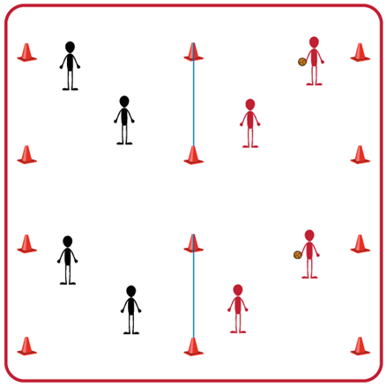
Equipment:
- 1 volleyball, volleyball trainer, or foam ball per group (Teachers: allow student choice of equipment when possible)
- 1 net per group
- 4 boundary cones per group
- Task Tent and Volleyball Cue Charts per group
Set-Up:
- Divide students into groups of 6. Each group splits into even teams (i.e., 3v3) with teams beginning on opposite sides of the net.
- Set up 1 court per group of 6 students. Place cones and task tents with cue charts beside each court. (Teachers: If you do not have enough courts, you can have teams serve as line judges and then rotate into courts)

ACTIVITY PROCEDURES
- This activity is called Bingo, Bango, Bongo. The object of the game is to score a BIG “bongo point” by winning a rally three times during our small-sided volleyball games.
- The first time a team wins a rally they will yell BINGO! When a team wins their second rally they yell BANGO, and on the third win they yell BONGO! Once a team has won three rallies and yells BONGO they score a BIG “bongo point.”
- On the start signal the teacher (or a student) tosses the ball to one of the teams and play begins on that court. All of the teams will be yelling Bingo, Bango, Bongo as they win rallies during the 3-minute games.
- On the stop signal after each 3-minute game, we will determine how many BIG “bongo points” each team has to see which team earned the most.
- Teams will play Rock, Paper, Scissors at the end of each 3-minute game. The winner of Rock, Paper, Scissors will stay on that court, and the other team will rotate to a new court to play again with a new opponent.
GRADE LEVEL PROGRESSION
- Level 1: Play as described above.
- Level 2: Play as described above but use a cross-net set up so that there are 4 teams playing against one another at all times instead of 2.
TEACHING CUES
- Cue 1: Communicate with your team using positive language.
- Cue 2: Follow the skill cues on the charts to assist with success during the games.
- Cue 3: Try to have all of your teammates touch the ball (max of 3 touches) before your team hits it over the net.
BINGO BANGO BONGO (continued…)

UNIVERSAL DESIGN FOR LEARNING
- UDL 1: Increase/decrease the size of the court as needed.
- UDL 2: Use floor lines or jump ropes rather than a net.
- UDL 3: Use modified equipment as needed (e.g., balloon or beach ball with a bell attached).
- UDL 4: Use verbal cues and visual aids along with demonstrations.
- UDL 5: Use peer partners as appropriate.
- UDL 6: Allow a toss to begin the game vs. a serve if needed.

ACADEMIC LANGUAGE
Positive Language, Communication, Teamwork

PRIORITY OUTCOMES
Social Interaction:
- (Grades 9-12) Identifies and evaluates the opportunity for social interaction and social support in self-selected physical activities.

Manipulative Skills:
- (Grades 9-12) Demonstrates competency and/or refines activity-specific movement skills in two or more lifetime activities.

DEBRIEF QUESTIONS
- DOK 1: Was there a communication strategy that your team used during this activity?
- DOK 2: Sometimes we use a strategy during a game or activity, and it doesn’t work well. Was there a communication strategy that you tried during this game that didn’t work very well? What did you do differently if you realized a communication strategy wasn’t working for your team?

