Volley 4-Square

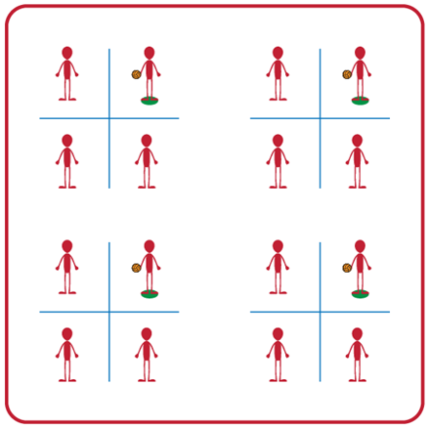
- Make a group of 4 and choose which type of volleyball your group would like to use.
- Use 2 jump ropes to create a grid of 4 squares. Place a spot marker in the square designated as the server square.
- Server will begin the game by tossing the ball to another player who will bump the ball to another square. Play continues as long as the ball is passed in the air from square to square without hitting the ground.
- When a score occurs (the ball hits the ground or goes out of bounds) players rotate clockwise and begin a new round.
Pass & Set Circles

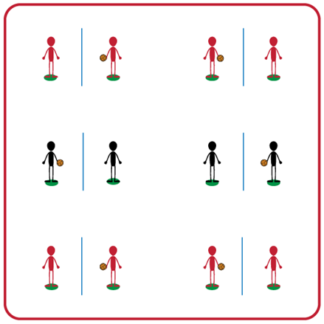
- Place spot markers about 5 feet apart and place a jump rope on the ground between them.
- Find a partner and choose what type of volleyball you would like to use.
- One partner will complete 5 tosses to their partner, who will return each toss back to them using a set (e.g., toss, set, catch). Then the partners will switch roles after each set of 5 attempts.
- You can attempt to set back and forth continuously with your partner as an extra challenge!

Helpful Net

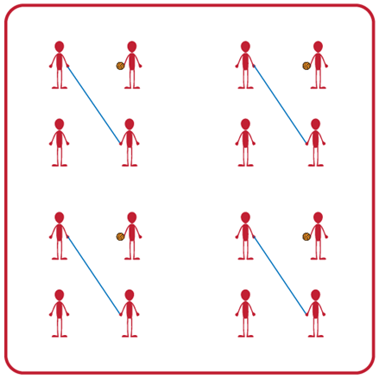
- Make a team of 4, with two players holding a jump rope to make a net for their team.
- The student with the volleyball will underhand serve the ball over the “helpful net” and their partner will catch the ball and then underhand serve the ball back to their partner.
- The two players holding the net can help the servers be successful by moving their feet or altering the height of the net.
- After both teammates have performed an underhand serve, rotate clockwise one spot so everyone gets an opportunity to underhand serve.
I Got It!

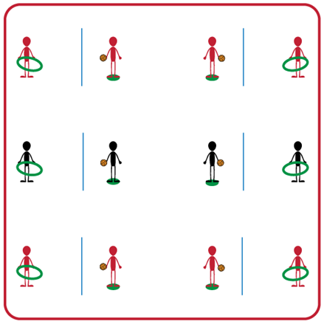
- Find a partner and get a foam ball for your group.
- Place a jump rope on the ground between you and your partner. One person begins with the ball and one with a hula hoop.
- The partner with the ball will spike it, and the partner with the hoop will track the path of the ball to anticipate where it will land. Each time a spike goes through a hoop you get one point!
- Safety Note: make sure to hold the hula hoop away from your body to avoid getting hit with a ball.
- You will trade roles after every 5 spike attempts.
Volley Battleship

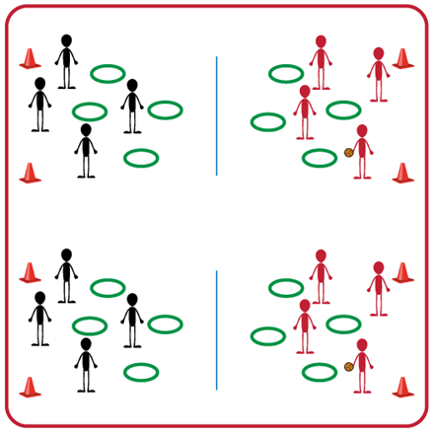
- Make equal teams (e.g., 2v2 or 3v3) and divide the space for your group with a pop-up net or a jump rope between cones.
- Each student begins with a hula hoop and places it on the ground on their side of the net.
- Teams will take turns trying to overhand serve the ball into one of their opponents’ hula hoops. If a serve lands in a hoop you will remove that hoop from your side.
- The game ends when one team loses all of their hoops or if you hear the stop signal. If you are still playing when you hear the stop signal, each team will count any remaining hoops on their side. The team with the most hoops left will be the winner!

