VOLLAPALOOZA

STUDENT TARGETS
- Skill: I will demonstrate a variety of volleyball skills focusing on form and technique.
- Cognitive: I will follow the instructions and apply the strategies/techniques for each station.
- Fitness: I will actively engage and work to improve my volleyball skills.
- Personal & Social Responsibility: I will willingly try new activities and skills.

EQUIPMENT & SET-UP | 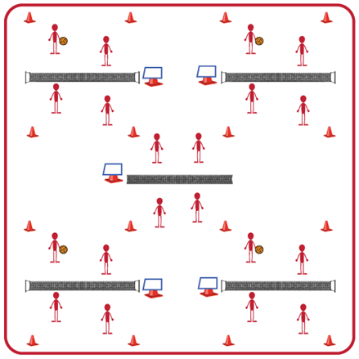
Equipment:
- Variety of volleyball options (e.g., traditional, trainer, foam ball, beach ball)
- Volleyball Station Cards and Task Tents
- Cones to identify boundaries for each station
- See station cards for specific equipment needs at each station
Set-Up:
- Set up a grid for the 5 stations and place equipment needed at each station.
- Place a task tent in each grid with the station card for that station.
- Divide students into 5 equal groups. One group will begin at each station.
ACTIVITY PROCEDURES
- This activity is called Vollapalooza. We will be rotating through stations that allow us to review our volleyball skills before we move into small-sided and traditional games. The object of this activity is for you to rotate through five skill challenges focusing on different volleyball skills we will need to apply during games (forearm pass [bump], overhead pass [set], attack [spike], underhand serve, and overhead serve).
- Each station has a station card that details the skill and activity that is the focus for that station. Teachers: talk through and/or demonstrate each station at the beginning of the lesson.
- On the start signal, you will review the station card at your station and begin the skill challenge. On the stop signal, you will put away any equipment used and rotate to the next station. Wait for the start signal before you begin at the new station.
- Each time you move to a new station, I encourage you to work with new classmates that you haven’t worked with during the previous skill challenges.

GRADE LEVEL PROGRESSION
- Level 1: Complete stations as described above.
- Level 2: Have note cards and pencils at each station where students can add their own student-created challenges for each skill. Then rotate through the stations a second time so students can choose to complete the teacher-created or the student-created challenges for that skill.

TEACHING CUES
- Cue 1: Listen for the stop/start signals to know when to rotate stations.
- Cue 2: Choose the type of ball you feel most comfortable with for each station (e.g., traditional, trainer, foam ball, beach ball).
- Cue 3: Be open to trying new volleyball skills you may have never tried before.
VOLLAPALOOZA (continued…)

UNIVERSAL DESIGN FOR LEARNING
- UDL 1: Use modified equipment as needed (e.g., foam ball, balloon or beach ball with bell attached).
- UDL 2: Use verbal cues and visual aids along with demonstrations.
- UDL 3: Use peer partners as appropriate.
- UDL 4: Identify a group leader for each group that can assist with reading station cards/directions.

ACADEMIC LANGUAGE
Forearm Pass (bump), Overhead Pass (set), Spike, Serve, Spirit of the Game

PRIORITY OUTCOMES
Etiquette:
- (Grades 9-12) Exhibits proper etiquette, respect for others, and teamwork while engaging in physical activity and/or social dance.

Working with Others:
- (Grades 9-12) Uses communication skills and strategies that promote positive team/group dynamics.

DEBRIEF QUESTIONS
- DOK 1: How would you describe the spirit of the game to a new student in our school?
- DOK 2: What do you know about the spirit of the game? (Think beyond the definition.)
- DOK 3: How would you describe a game played with the spirit of the game? How would you describe a game played without it?

MONEY BALL

STUDENT TARGETS
- Skill: I will perform a volleyball serve with accuracy to score points for my team during this activity.
- Cognitive: I will discuss strategies that helped my team be successful.
- Fitness: I will stay actively engaged throughout in order to increase my heart rate.
- Personal & Social Responsibility: I will communicate using respectful and encouraging language.

EQUIPMENT & SET-UP | 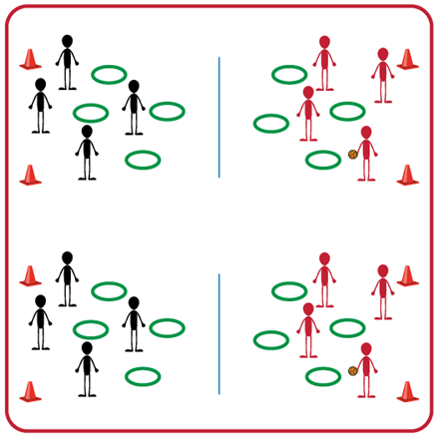
Equipment:
- One court for each group (2 teams per group)
- Net (or modified net) for each court
- Variety of volleyball options (e.g., traditional, trainer, foam ball)
- Hula Hoops and Spot Markers as targets
Set-Up:
- Have one court space for each set of 2 teams.
- Set up nets (or modified nets) for each court and spread out hula hoops and spot markers on the ground on each side of the net.
- Pair students in teams of 2, with one team on each side of the net.
ACTIVITY PROCEDURES
- This activity is called Money Ball. The object of the game is to collect as many hoops or spot markers as you can for your team by hitting the volleyball “on the money” into one of the other team’s targets.
- Each person in your group will have one of two positions: server or rebounder. On the start signal, servers will strike the ball and try to make it land inside a hula hoop or on a spot marker on the other side of the net. Rebounders will collect the ball and return it to the server. Each student will perform 2 serve attempts and then you will rotate positions so both teammates get 2 serve attempts. Teachers: you will need to communicate to students if an overhand or underhand serve will be used (or a combination of both).
- If a serve goes over the net and lands in a hoop or on a spot marker, your team gets to collect that hoop or spot marker for your team. A hoop gives your team one point, and a spot marker will give your team two points.
- We will play until one team has collected all of their hoops and spot markers, or until you hear the stop signal. We will count the points for each team and then discuss our successes and challenges before we play again against a new opponent.

GRADE LEVEL PROGRESSION
- Level 1: Play as described above.
- Level 2: Assign dollar amounts to each color of hula hoop or spot marker (e.g., green = $5, red = $2, etc.) and have students try to collect a specific amount of money.

TEACHING CUES
- Cue 1: Use skill charts for both the underhand and overhand serve.
- Cue 2: Communicate with respectful and encouraging language.

MONEY BALL (continued…)

UNIVERSAL DESIGN FOR LEARNING
- UDL 1: Increase/decrease the height of the net as needed.
- UDL 2: Use modified equipment as needed (e.g., beeper ball, balloon, beach ball).
- UDL 3: Use verbal cues and visual aids along with demonstrations.
- UDL 4: Use peer partners as appropriate.

ACADEMIC LANGUAGE
Serve, Underhand, Overhand, Target

PRIORITY OUTCOMES
Personal Challenge:
- (Grades 9-12) Chooses an appropriate level of challenge to experience success and a desire to participate in self-selected physical activity while working toward personal fitness goals.

Working with Others:
- (Grades 9-12) Uses communication skills and strategies that promote positive team/group dynamics.

DEBRIEF QUESTIONS
Personal and Social Responsibility Question Set:
- DOK 1: Is there something about volleyball that you have found challenging?
- DOK 2: Did you do something to overcome that challenge? What strategies did you use?
- DOK 3: Would you be willing to continue playing volleyball even if you find it challenging? What could be a benefit of continuing to play during any challenges you were having?

Skill-based Question Set:
- DOK 1: Were you able to consistently serve the ball into your opponents’ hoops?
- DOK 2: What was one thing you did differently if your serve didn’t land in a hoop?
- DOK 3: How did the amount of force you used impact whether your serve landed in the hoop or not? If your serve hit the ground in front of the hoop you were aiming at, what could you do differently on your next attempt?

THREE AND RUN!

STUDENT TARGETS
- Skill: I will work with my partners to use a variety of volleyball passes during this activity.
- Cognitive: I will discuss strategies that helped my team be successful.
- Fitness: I will stay actively engaged throughout the game in order to increase my heart rate.
- Personal & Social Responsibility: I will show integrity by playing fair and communicating using positive language.

EQUIPMENT & SET-UP | 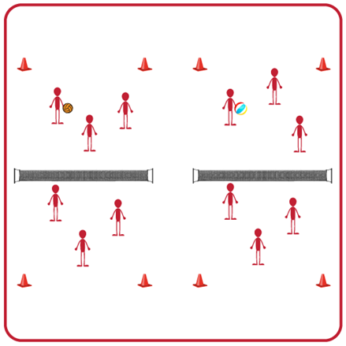
Equipment:
- 1 volleyball per net/activity space
- 1 volleyball net (or modified net) per two groups
- Boundary markers for each net/activity space
Set-Up:
- Pair students in groups of 3 and have each group begin facing another team on one side of a net/activity space.
- Set up one net (or modified net) for each two groups of students. You can also have 4 groups at each net if needed, with two teams in the activity space and one team ready to rotate in on each side.
- Have a variety of equipment available for teams to choose from (e.g., traditional volleyball, volleyball trainer, foam ball).
ACTIVITY PROCEDURES
- This activity is called Three and Run! The object of the game is to practice the different volleyball passes within your team before successfully hitting the ball over the net.
- You do that by using any volleyball pass with your teammate(s) before the ball goes over the net to the other team. You can use a forearm pass (bump) or overhead pass (set) until each person on your team has touched the ball. Remember, all members of your team must touch the ball before it can be hit over the net, but you only get three total touches to make that happen!
- After you pass the ball to one of your teammates, you will run to the court endline (or boundary markers) before re-entering play. Make sure you get back into your athletic stance once you re-enter so you are ready when the ball comes back over the net to your side. Teachers: if you need to have a group waiting to rotate in make sure to describe how and when they rotate in.
- Your team gets one point for each set of 3 passes where the ball successfully goes over the net on the third hit. We will play for 5 minutes, and then the team with the most points will rotate one court to their right before we play again.
GRADE LEVEL PROGRESSION
- Level 1: Have a team of 3 students on each endline. When a player runs to the endline after passing the ball, tag the first person in the line and that person enters into the game in their spot.
- Level 2: Set up your nets so you have 4 courts using a cross net set up. Same procedures as Level 1, but now teams can pass the ball to any of the other three teams after their 3 passes.
TEACHING CUES
- Cue 1: Communicate with your team using positive language.
- Cue 2: Follow the skill cues for the forearm pass (bump) and overhead pass (set).
- Cue 3: Make sure all of your teammates have touched the ball (max of 3 touches) before your team hits it over the net.
THREE AND RUN! (continued…)

UNIVERSAL DESIGN FOR LEARNING
- UDL 1: Use modified equipment as needed (e.g., foam ball, balloon or beach ball with bell attached).
- UDL 2: Use verbal cues and visual aids along with demonstrations.
- UDL 3: Use peer partners as appropriate.
- UDL 4: Use modified nets as needed (e.g., line on floor, jump rope on floor, or jump rope between cones).

ACADEMIC LANGUAGE
Passing, Boundary, Teamwork, Strategy

PRIORITY OUTCOMES
Working with Others:
- (Grades 9-12) Uses communication skills and strategies that promote positive team/group dynamics.

DEBRIEF QUESTIONS
- DOK 1: What is a strategy?
- DOK 2: What is a volleyball strategy or tactic you or your team used today during this activity?
- DOK 3: If your strategy was not successful, what changes did you make for your team? What was the outcome of those changes?

PASS AND GO
STUDENT TARGETS
- Skill: I will demonstrate correct technique for volleyball passes.
- Cognitive: I will discuss the cues for a volleyball bump and set.
- Fitness: I will remain actively engaged throughout the activity.
- Personal & Social Responsibility: I will use encouraging language with my teammates.

EQUIPMENT & SET-UP | 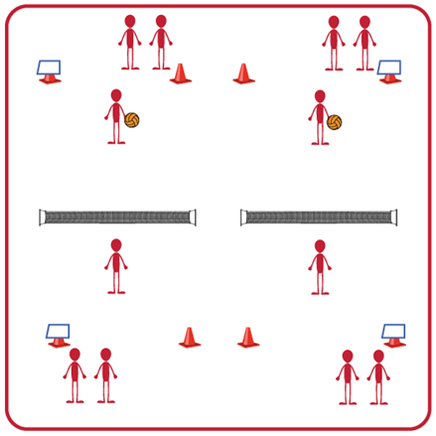
Equipment:
- 1 volleyball, volleyball trainer, or foam ball per group (Teachers: allow student choice of equipment when possible)
- 1 net per group
- 4 boundary cones per group
- Task Tent and Volleyball Cue Charts per group
Set-Up:
- Divide students into groups of 6. Each group splits into even teams (i.e., 3v3) with teams beginning on opposite sides of the net.
- Set up 1 court per group of 6 students. Place cones and task tents with cue charts beside each court.
- Each team begins in a line on their side of the court. The 1st player in line begins on the court, and the others wait to rotate in.
ACTIVITY PROCEDURES
- This activity is called Pass and Go. The object of the game is to continually forearm pass (bump) or overhead pass (set) the volleyball over the net for your team while quickly rotating onto and off of the court.
- The game will begin with 1 player from each team on the court, ready to face off. One player will serve the ball over the net to begin play. After the ball is served, the server immediately goes to the end of their line and the next player from their team steps onto the court.
- The player who receives the serve will bump or set it back over the net, and then immediately move to the end of their line so that the next player can step onto the court and get ready to receive the ball. Each player will be on the court for one attempt, regardless of whether it is successful or not, and then move to the end of their team’s line.
- Teams score a point each time the opposite team doesn’t get the ball over the net, or they hit it out of bounds. But remember, play doesn’t stop while players rotate in/out so you will need to move quickly and be ready to step onto the court if you are the next player in line!
- On the stop signal the team with the most points will stay and their opponents will find a new court to play again.
GRADE LEVEL PROGRESSION
- Level 1: Play as described above.
- Level 2: Have 2 students from each team on the court at all times. A student will rotate out each time they serve or bump the ball for their team.
TEACHING CUES
- Cue 1: Make sure you move quickly onto the court when it is your turn and get into ready position.
- Cue 2: Remember the power for a pass comes from your legs not your arms.
- Cue 3: Use encouraging language with your teammates.

PASS AND GO (continued…)

UNIVERSAL DESIGN FOR LEARNING
- UDL 1: Increase/decrease the size of the court as needed.
- UDL 2: Use floor lines or jump ropes rather than a net.
- UDL 3: Use modified equipment as needed (e.g., balloon or beach ball with a bell attached).
- UDL 4: Use verbal cues and visual aids along with demonstrations.
- UDL 5: Use peer partners as appropriate.
- UDL 6: Allow a toss to begin the game vs. a serve if needed.

ACADEMIC LANGUAGE
Force, Control, Cooperation, Accuracy

PRIORITY OUTCOMES
Manipulative Skills:
- (Grades 9-12) Demonstrates competency and/or refines activity-specific movement skills in two or more lifetime activities.

Working with Others:
- (Grades 9-12) Uses communication skills and strategies that promote positive team/group dynamics.

DEBRIEF QUESTIONS
- DOK 1: Can you remember the cues for forearm (bump) and overhead (set) passing?
- DOK 2: Which of the passing cues affect accuracy the most?
- DOK 3: How is being actively engaged related to accuracy and performance during a volleyball game?

VOLLEYBALL TABATA

STUDENT TARGETS
- Skill: I will perform fitness exercises with proper form and a focus on safety.
- Cognitive: I will identify fitness activities that can improve specific volleyball skills.
- Fitness: I will use a heart rate monitor to track and adjust exercise intensity so that I am working in my target zone.
- Personal & Social Responsibility: I will work independently and with consideration for others.

EQUIPMENT & SET-UP |  | 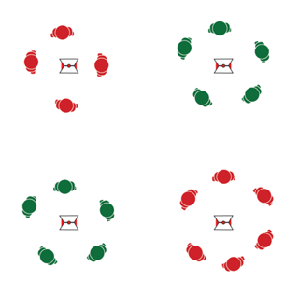  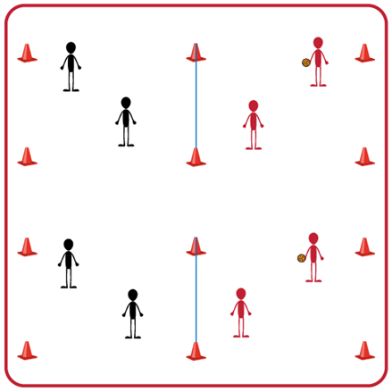
Equipment:
- 4 cones and 4 task tents
- Volleyball Tabata Station Cards
- Station equipment (see station cards for equipment needed at each station)
- Tabata audio cues (Tabata timer app)
- Heart rate monitors (optional)
- YouTube link to Volleyball Skill Tabata Stations: https://www.youtube.com/playlist?list=PLRIuuDO-0RtDOIJ42-YQXlR1aloPrzHmm
Set-Up:
- Create 4 stations using cones, task tents, and Volleyball Tabata Station Cards.
- Place station cards in task tents on cones.
- Distribute station equipment (required at station 1 and station 3) at each area.
- Divide students into 4 even groups, with one group beginning at each station.
ACTIVITY PROCEDURES
- Today’s activity is called Volleyball Tabata. This will be a Tabata-style training with a focus on improving Volleyball skills as well as Muscular Endurance and Aerobic Capacity.
- Tabata training was created by a Japanese scientist named Dr. Izumi Tabata. True Tabata workouts combine 20 seconds of vigorous activity with 10 seconds of rest. Dr. Tabata’s research showed that even 4-minute workouts using his timing formula can have positive results on a person’s overall fitness.
- There are 4 stations, and each one includes Volleyball specific muscular endurance exercises and aerobic capacity exercises. You will rotate through each station to complete the 4-minute Tabata routine. After each Tabata routine is completed, your group will move to the next station. The full workout will be 16 minutes, so you want to pace your activity to stay in your target heart rate zone.
- Teachers: Use YouTube link provided above to demonstrate volleyball specific exercises.
- Listen for the audio cues to start and stop your activity, as well as the rest intervals.
GRADE LEVEL PROGRESSION
- Level 1: Complete activity as described above.
- Level 2: Have note cards and pencils at each station where students can add their own student-created routines at each station. Then rotate through the stations a second time so students can choose to complete the Volleyball Tabata routines, or the student-created routines at that station.
TEACHING CUES
- Cue 1: Focus on proper form and technique at each station.
- Cue 2: Listen for the stop and start signals during each routine, as well as the cues for the rest periods.
VOLLEYBALL TABATA (continued…)

UNIVERSAL DESIGN FOR LEARNING
- UDL 1: Adjust the duration of work and rest intervals to meet the needs of your students.
- UDL 2: Provide modifications at each station and allow students to work at a level of their choice.
- UDL 3: Use verbal cues and visual aids along with demonstrations.
- UDL 4: Use peer partners as appropriate.

ACADEMIC LANGUAGE
Tabata, Strength, Fitness, Body Position

PRIORITY OUTCOMES
Personal Challenge:
- (Grades 9-12) Chooses an appropriate level of challenge to experience success and a desire to participate in self-selected physical activity while working toward personal fitness goals.

DEBRIEF QUESTIONS
- DOK 1: What would you in include on a list about how being physically active leads to a healthy body?
- DOK 2: How can different types of activities have positive impacts on your health?
- DOK 3: Can you formulate a theory for the positive impacts of different activities on overall health? How would you test/prove your theory to be correct?

BINGO, BANGO, BONGO

STUDENT TARGETS
- Skill: I will demonstrate a variety of volleyball skills during small-sided games.
- Cognitive: I will discuss the importance of communication with respect to enjoyment of play.
- Fitness: I will demonstrate a variety of skill-related fitness components.
- Personal & Social Responsibility: I will demonstrate respect for myself and my classmates by following the rules of the game and encouraging others.

EQUIPMENT & SET-UP | 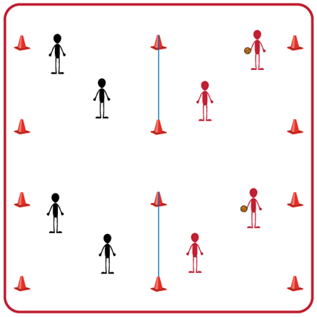
Equipment:
- 1 volleyball, volleyball trainer, or foam ball per group (Teachers: allow student choice of equipment when possible)
- 1 net per group
- 4 boundary cones per group
- Task Tent and Volleyball Cue Charts per group
Set-Up:
- Divide students into groups of 6. Each group splits into even teams (i.e., 3v3) with teams beginning on opposite sides of the net.
- Set up 1 court per group of 6 students. Place cones and task tents with cue charts beside each court. (Teachers: If you do not have enough courts, you can have teams serve as line judges and then rotate into courts)

ACTIVITY PROCEDURES
- This activity is called Bingo, Bango, Bongo. The object of the game is to score a BIG “bongo point” by winning a rally three times during our small-sided volleyball games.
- The first time a team wins a rally they will yell BINGO! When a team wins their second rally they yell BANGO, and on the third win they yell BONGO! Once a team has won three rallies and yells BONGO they score a BIG “bongo point.”
- On the start signal the teacher (or a student) tosses the ball to one of the teams and play begins on that court. All of the teams will be yelling Bingo, Bango, Bongo as they win rallies during the 3-minute games.
- On the stop signal after each 3-minute game, we will determine how many BIG “bongo points” each team has to see which team earned the most.
- Teams will play Rock, Paper, Scissors at the end of each 3-minute game. The winner of Rock, Paper, Scissors will stay on that court, and the other team will rotate to a new court to play again with a new opponent.
GRADE LEVEL PROGRESSION
- Level 1: Play as described above.
- Level 2: Play as described above but use a cross-net set up so that there are 4 teams playing against one another at all times instead of 2.
TEACHING CUES
- Cue 1: Communicate with your team using positive language.
- Cue 2: Follow the skill cues on the charts to assist with success during the games.
- Cue 3: Try to have all of your teammates touch the ball (max of 3 touches) before your team hits it over the net.
BINGO BANGO BONGO (continued…)

UNIVERSAL DESIGN FOR LEARNING
- UDL 1: Increase/decrease the size of the court as needed.
- UDL 2: Use floor lines or jump ropes rather than a net.
- UDL 3: Use modified equipment as needed (e.g., balloon or beach ball with a bell attached).
- UDL 4: Use verbal cues and visual aids along with demonstrations.
- UDL 5: Use peer partners as appropriate.
- UDL 6: Allow a toss to begin the game vs. a serve if needed.

ACADEMIC LANGUAGE
Positive Language, Communication, Teamwork

PRIORITY OUTCOMES
Social Interaction:
- (Grades 9-12) Identifies and evaluates the opportunity for social interaction and social support in self-selected physical activities.

Manipulative Skills:
- (Grades 9-12) Demonstrates competency and/or refines activity-specific movement skills in two or more lifetime activities.

DEBRIEF QUESTIONS
- DOK 1: Was there a communication strategy that your team used during this activity?
- DOK 2: Sometimes we use a strategy during a game or activity, and it doesn’t work well. Was there a communication strategy that you tried during this game that didn’t work very well? What did you do differently if you realized a communication strategy wasn’t working for your team?

VOLLEY TIC TAC TOE

STUDENT TARGETS
- Skill: I will demonstrate a variety of volleyball skills during small-sided games.
- Cognitive: I will discuss the importance of teamwork and cooperation in order to be successful during team sports and activities.
- Fitness: I will demonstrate a variety of skill-related fitness components.
- Personal & Social Responsibility: I will demonstrate respect for myself and my classmates by following the rules of the game and encouraging others.
EQUIPMENT & SET-UP | 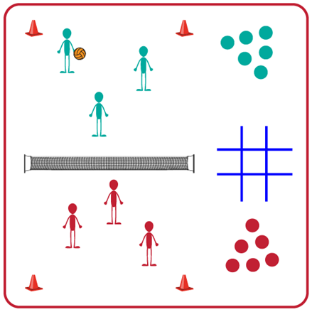
Equipment:
- 1 volleyball, volleyball trainer, or foam ball per group (Teachers: allow student choice of equipment when possible)
- 1 net and 4 boundary cones per group
- 4 jump ropes per court
- 10 Colored spot markers per court (5 of one color and 5 of a different color). Bean Bags could also be used for this.
Set-Up:
- Divide students into groups of 6. Each group splits into even teams (i.e., 3v3) with teams beginning on opposite sides of the net.
- Set up 1 court per group of 6 students. (Teachers: If you do not have enough courts, you can have teams serve as line judges and rotate into courts)
- Use the 4 jump ropes to create a Tic Tac Toe board next to each court.
ACTIVITY PROCEDURES
- This activity is called Volley Tic Tac Toe. The object of this activity is to win a game of Tic Tac Toe. You do that by winning a volley and placing one of your team’s spot markers into an open space on the Tic Tac Toe board next to your activity space. A team wins by creating 3 in a row (up/down, side-to-side, or diagonal) with their colored spot markers on the Tic Tac Toe board.
- On the start signal, play a game of Rock Paper Scissors to determine which team will serve. Once that team serves the ball and play begins, the game will continue until one team wins the volley. The winning team will place one of their colored spot markers into an open space on the Tic Tac Toe board. This continues until one team gets 3 in a row or you hear the stop signal.
- If you hear the stop signal before either team has gotten 3 spot markers in a row, the team with the most filled spaces on the board earns a point.
- The team that scored the most recent point on a court will stay, and the other team will rotate and find a new opponent to play again.
GRADE LEVEL PROGRESSION
- Level 1: Play as described above.
- Level 2: Play as described above but use a cross-net set up so that there are 4 teams playing against one another at all times instead of 2.
TEACHING CUES
- Cue 1: Communicate with your team using positive language.
- Cue 2: Follow the skill cues for volleyball that we have been working on to assist with success during the games.
VOLLEY TIC TAC TOE (continued…)

UNIVERSAL DESIGN FOR LEARNING
- UDL 1: Increase/decrease the size of the court as needed.
- UDL 2: Use floor lines or jump ropes rather than a net.
- UDL 3: Use modified equipment as needed (e.g., balloon or beach ball with a bell attached).
- UDL 4: Use verbal cues and visual aids along with demonstrations.
- UDL 5: Use peer partners as appropriate.
- UDL 6: Allow a toss to begin the game vs. a serve if needed.

ACADEMIC LANGUAGE
Volley, Rally, Technique, Challenge

PRIORITY OUTCOMES
Etiquette:
- (Grades 9-12) Exhibits proper etiquette, respect for others, and teamwork while engaging in physical activity and/or social dance.

Working with Others:
- (Grades 9-12) Uses communication skills and strategies that promote positive team/group dynamics.

DEBRIEF QUESTIONS
- DOK 1: What does it look like when teammates work together?
- DOK 2: How does working with a team compare to working with a partner or by yourself?
- DOK 3: How does it make you feel if you see a teammate not acting responsibly towards you or another classmate? What is something that you could say or do to encourage them to use more responsible behaviors in the future?

VOLLEYBALL ROYAL COURT

STUDENT TARGETS
- Skill: I will demonstrate a variety of volleyball skills during small-sided games.
- Cognitive: I will discuss the importance of integrity with respect to enjoyment of play.
- Fitness: I will demonstrate a variety of skill-related fitness components.
- Personal & Social Responsibility: I will demonstrate respect for myself and my classmates by following the rules of the game and encouraging others.

EQUIPMENT & SET-UP | 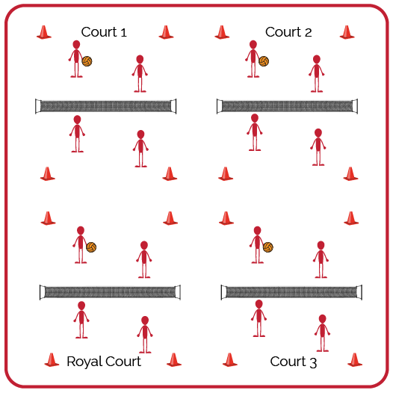
Equipment:
- 1 volleyball per group of 4 students (doubles)
- 1 net per court (or cones/jump ropes if needed)

Set-Up:
- Create enough courts so the entire class can play doubles matches.
- Number each court, with court 1 as the starting court and the highest number court as the “Royal Court.”
- Create teams for doubles and send students to courts. If you have more teams than courts, you can have a team waiting to rotate into a court.

ACTIVITY PROCEDURES
- Today’s activity is called Volleyball Royal Court. This tournament will be a way to test our skills and have fun with our friends.
- The goal of today’s tournament is to compete with a positive attitude and to work your way to the Royal Court, while your team accumulates as many points as possible. We’ll play 3-minute games. The winner of each game will earn 1 point and move to a higher court. The losing team or player will move down to a lower court and will not earn any points for that round.
- On the start signal, you will play an opposing team for 3 minutes. The winner will move up 1 court toward the Royal Court. The winner on the Royal Court will stay and defend her/his position. The team that loses the match will move 1 court away from the Royal Court. The team that loses on court 1 will stay and try again. If the score is tied on any court when the 3-minute time expires, play Rock, Paper, Scissors to determine the winner.
- We will continue to play until time runs out. The team who earned the most points and ended on the Royal Court will be the winners!

GRADE LEVEL PROGRESSION
- Level 1: Pair students of similar skill levels and skip the royal court rotation. Instead, rotate students with a focus on setting them up for challenge, success, and fun.
- Level 2: Play as described above.

TEACHING CUES
- Cue 1: Apply the volleyball skill cues we have focused on.
- Cue 2: Help and encourage others by demonstrating sportsmanship.
- Cue 3: Play with purpose but have fun!
VOLLEYBALL ROYAL COURT (continued…)

UNIVERSAL DESIGN ADAPTATIONS
- UDL 1: Increase/decrease the size of activity space/court.
- UDL 2: Use modified equipment as needed (e.g., foam ball, balloon or beach ball with bell attached).
- UDL 3: Use verbal cues and visual aids along with demonstrations.
- UDL 4: Use peer partners as appropriate.

ACADEMIC LANGUAGE
Rotation, Serve, Teamwork, Integrity

PRIORITY OUTCOMES
Manipulative Skills:
- (Grades 9-12) Demonstrates competency and/or refines activity-specific movement skills in two or more lifetime activities.

Etiquette:
- (Grades 9-12) Exhibits proper etiquette, respect for others, and teamwork while engaging in physical activity and/or social dance.

DEBRIEF QUESTIONS
- DOK 1: What is integrity?
- DOK 2: Why is integrity important in physical activity or competitive settings?
- DOK 3: How is integrity related to the enjoyment of everyone playing a game of Volleyball?

