HELLO RACKET

STUDENT TARGETS
- Skill: I will control the racket and ball using the correct grip.
- Cognitive: I will identify and discuss the skill-related fitness components developed through Street Racket practice.
- Fitness: I will actively participate, with a focus on developing my skill-related fitness.
- Personal & Social Responsibility: I will demonstrate safe behaviors and use equipment responsibly.

EQUIPMENT & SET-UP
Equipment:
- 1 racket and 1 ball per student
- Cones for cue charts and task tents

Set-Up:
- Have rackets and balls spread out in hoops or baskets on perimeter of activity space.
- Each student should get a racket and a ball and spread out in activity space.
- Have cue charts for Paddle Grip, Forehand, and Backhand in task tents in activity space.
ACTIVITY PROCEDURES
- This activity is called Hello Racket! The purpose of this activity is to help you get familiar with the Street Racket paddle and ball. We will try a few different challenges, both on your own and with a partner, to practice gripping the racket as well as experiment with how much force to use when hitting the ball.
- We are going to try three different challenges today. We will begin with Challenge 1 where you will work on your own, then move on to Challenges 2 and 3 where you will work with a partner. Teacher Note: Provide a demonstration of all challenges before students begin.
- Challenge 1: Toss Up/Bounce/Strike/Catch. Begin with a soft underhand toss, then after one bounce hit the ball up about 12 inches above the racket before you catch it with your other hand (hand without the racket). See how many times in a row you can complete this pattern without losing control. Can you call out a letter each time you catch the ball to spell out your first and last name?
- Challenge 2: Toss/Bounce/Catch. Partner 1 underhand tosses the ball to partner 2. Partner 2 will catch the ball after one bounce. Partner 2 will then underhand toss the ball back to partner 1 who will catch it. Continue this pattern until you and your partner have 8 catches in a row.
- Challenge 3: Toss/Hit/Catch. Partner 1 underhand tosses the ball to partner 2. Partner 2 will hit the ball after one bounce back to partner 1 who will catch it. After 5 attempts at Toss/Hit/Catch, trade roles and try again. Remember to try and use both forehand and backhand shots as needed!
GRADE LEVEL PROGRESSION
- Grade 3: Play as described above.
- Grade 4: Allow partners to take one step back after 5 successful tosses/catches during Challenge 2.
- Grade 5: Players can only use backhand strikes during Challenge 3.
TEACHING CUES
- Cue 1: You want to shake hands with the paddle when gripping it.
- Cue 2: Lock your wrist and give the paddle a soft squeeze.
- Cue 3: Use positive and encouraging language with your partner.

HELLO RACKET (continued…)

UNIVERSAL DESIGN FOR LEARNING
- UDL 1: Increase/decrease the activity space.
- UDL 2: Use modified equipment as needed. (e.g., students using their hands to strike the ball instead of a racket, using a balloon instead of a ball).
- UDL 3: Use verbal cues and visual aids along with demonstrations.
- UDL 4: Use peer partners as appropriate.

ACADEMIC LANGUAGE
Racket, Grip, Force, Control

PRIORITY OUTCOMES
Personal Responsibility and Safety:
- (Grade 3) Works independently and safely in physical activity settings.
- (Grade 4) Exhibits responsible behavior in independent group situations.
- (Grade 5) Engages in physical activity with responsible interpersonal behavior (e.g., peer to peer, student to teacher).

DEBRIEF QUESTIONS
- DOK 1: Can you remember the cues for gripping the racket?
- DOK 2: How does the grip affect your ability to hit the ball with control?
- DOK 3: How would you adapt this activity to make it more challenging? Less challenging?

HELPFUL HOOPS

STUDENT TARGETS
- Skill: I will work with my teammates to hit back and forth as long as possible.
- Cognitive: I will identify strategies and tactics needed to hit continuously with my teammates.
- Fitness: I will remain actively engaged throughout the lesson.
- Personal & Social Responsibility: I will work together with my teammates for maximum possible success during this activity.
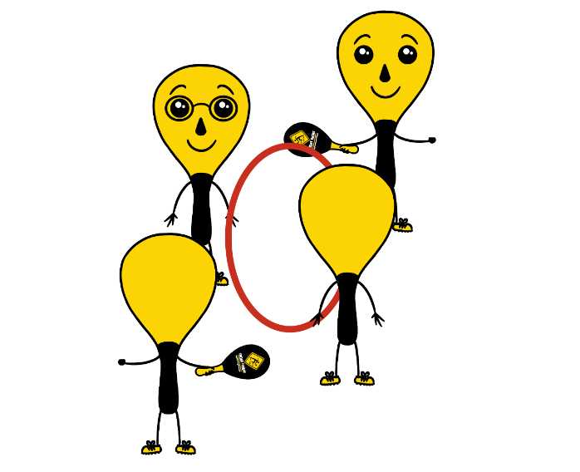
EQUIPMENT & SET-UP
Equipment:
- 2 rackets and 1 ball per group of 4
- 1 hula hoop per group of 4

Set-Up:
- Divide students into teams of 4.
- Two players begin by holding the hula hoop to make a target for the ball to go through.
- Other two players begin on opposite sides of the hoop facing each other, with both students holding a racket and one student holding the ball and ready to serve after hearing the start signal.

ACTIVITY PROCEDURES
- This activity is called Helpful Hoops. The object of the game is to work with your teammates to hit the ball back and forth as long as you can. You do that by working together to hit the ball through the hula hoop (which is a held by two of your teammates).
- On the start signal, the two players with a racket will hit the ball back and forth as many times as they can. The two players holding the hula hoop can help their teammates be successful by moving their feet or altering the height of the hula hoop. The hoop holders and the players hitting back and forth will work together to achieve the highest possible team score! Any time the ball doesn’t go through the hoop, the players will each rotate clockwise one spot. You will use the team score from your longest rally as a new goal each time players rotate positions.
- On the stop signal players will place the hula hoop, the rackets, and the ball down on the ground. The two players who were holding the hoop when you heard the stop signal will move to a new group before we play again.

GRADE LEVEL PROGRESSION
- Grade 3: Play as described above.
- Grade 4: Hoop holders can raise or lower the hoop to help their team but cannot move their feet.
Grade 5: Have two teams of 4 join together to make a group of 8. The 2 hula hoops will be held side by side, with each team hitting the ball through the other team’s hoop (hitting on a diagonal vs. hitting straight ahead).

TEACHING CUES
- Cue 1: Keep your body in ready position so you are ready to receive the ball from your teammate.
- Cue 2: Hoop holders need to stay attentive and work together so they can move where needed during the rally.

HELPFUL HOOPS (continued…)

UNIVERSAL DESIGN FOR LEARNING
- UDL 1: Increase/decrease the activity space.
- UDL 2: Use modified equipment as needed.
- UDL 3: Use verbal cues and visual aids along with demonstrations.
- UDL 4: Use peer partners as appropriate.

ACADEMIC LANGUAGE
Cooperation, Supportive, Encourage, Teamwork

PRIORITY OUTCOMES
Working With Others:
- (Grade 3) Works cooperatively with others.
- (Grade 4) Accepts “players” of all skill levels into the physical activity.
- (Grade 5) Accepts, recognizes, and actively involves others with both higher and lower skill abilities into physical activities and group projects.

DEBRIEF QUESTIONS
- DOK 1: Was there a communication strategy that your team used during this activity?
- DOK 2: Sometimes we use a strategy during a game or activity, and it doesn’t work well. Was there a communication strategy that you tried during this game that didn’t work very well? What did you do differently if you realized a communication strategy wasn’t working for your team?

STREET RACKET BASICS

STUDENT TARGETS
- Skill: I will hit continuously with a partner, demonstrating controlled and balanced weight transfer and striking form.
- Cognitive: I will discuss the concepts of power and accuracy.
- Fitness: I will remain actively engaged in all hitting drills.
- Personal & Social Responsibility: I will provide encouragement and feedback to my partner.

EQUIPMENT & SET-UP | 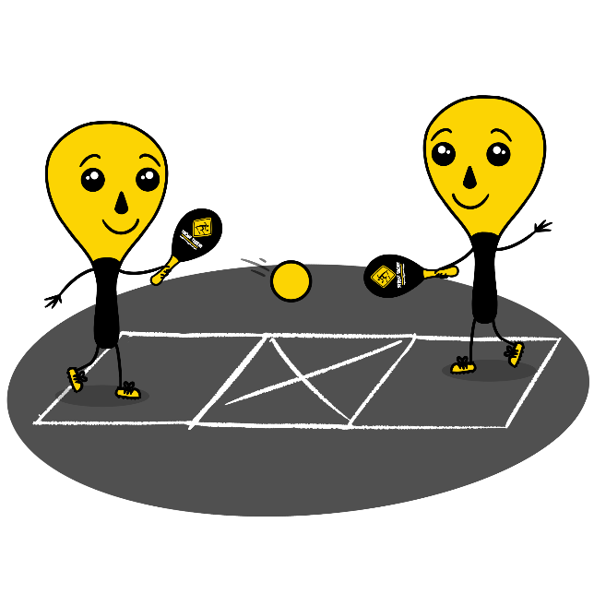
Equipment:
- 1 Street Racket paddle per student
- 1 ball per pair of students
- 1 court per pair of students
- Chalk or tape to create a Street Racket court for each pair of students

Set-Up:
- Set up 1 court per group of students. Teachers: you can have a third student waiting to rotate in if needed with each group.
- Pair students in groups of 2 (or 3 if needed).
- Each group will begin at a court with paddles and a ball.
ACTIVITY PROCEDURES
- It’s time for some partner drills using a Street Racket court. In each drill, you will be working toward 8 consecutive hits. You can increase or decrease the distance between you and your partner as needed.
- We are going to try two different drills to work on being able to continuously hit back and forth with your partner. Each group will begin with Drill 1 in their activity space. Note: Provide a demonstration of both drills before students begin.
- Drill 1: Hit Up and Return. Partner 1 begins with a drop-hit to partner 2. After one bounce, partner 2 will hit the ball up one time, and then after a bounce return it to partner 1. Both partners will continue this pattern to hit the ball up one time before returning it to your partner. After 5 rally attempts with this drill, your group will move on to drill 2.
- Drill 2: 1-Bounce Rally. Partner 1 begins with a drop-hit to partner 2. Partner 2 will hit the ball off of 1 bounce. Partner 2 will return the ball after allowing the ball to bounce. Continue this pattern.
- Remember to try and use both forehand and backhand shots as needed during your rally!
GRADE LEVEL PROGRESSION
- Grade 3: Play as described above.
- Grade 4: Hit the ball up when it is received and then only use a backhand to return the ball to your partner after the bounce.
- Grade 5: Prompt students to provide constructive feedback and encouragement to their peers.
TEACHING CUES
- Cue 1: Make sure to return to the ready position each time you hit the ball to your partner.
- Cue 2: Keep your eyes on the ball.
- Cue 3: Encourage your teammates and have fun!
STREET RACKET BASICS (continued…)

UNIVERSAL DESIGN FOR LEARNING
- UDL 1: Increase/decrease the activity space.
- UDL 2: Use modified equipment and modified game rules based on student needs.
- UDL 3: Use verbal cues and visual aids along with demonstrations.
- UDL 4: Use peer partners as appropriate.

ACADEMIC LANGUAGE
Accuracy, Continuous, Control, Encouragement, Power

PRIORITY OUTCOMES
Manipulative Skills:
- (Grade 3) Demonstrates manipulative skills using mature patterns for accuracy and control.
- (Grade 4) Combines locomotor and manipulative skills using mature patterns for accuracy and control in static and dynamic environments.
- (Grade 5) Executes a variety of manipulative skills with control and accuracy in small-sides games.

DEBRIEF QUESTIONS
- DOK 1: How would you describe “accuracy”?
- DOK 2: How does power affect accuracy?
- DOK 3: How are skill cues related to your power and accuracy?

SWITCH IT UP

STUDENT TARGETS
- Skill: I will perform both forehand and backhand strokes during game play.
- Cognitive: I will identify the skill cues for the forehand and the backhand strokes.
- Fitness: I will stay actively engaged with a focus on developing my fitness.
- Personal & Social Responsibility: I will provide encouragement and safely cooperate with my peers.

EQUIPMENT & SET-UP | 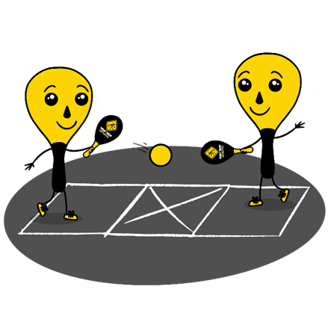
Equipment:
- 1 Street Racket paddle per student
- 1 ball per pair of students
- 1 court per pair of students
- Chalk or tape to create a Street Racket court for each pair of students
Set-Up:
- Set up 1 court per pair of students. Teachers: you can have a third student waiting to rotate in if needed with each group.
- Pair students in groups of 2 (or 3 if needed).
- Each group will begin at a court with paddles and a ball.
ACTIVITY PROCEDURES
- This activity is called Switch it Up. The object of the game is to work on both your forehand and backhand strokes while playing Street Racket. We are going to try three different challenges with your partner today. We will begin with Challenge 1, then move on to Challenges 2 and 3. Teacher Note: Provide a demonstration of all challenges before students begin.
- Challenge 1: Alternating Forehands. This challenge will focus on practicing your forehand stroke, but with the added challenge of switching the racket between your right and left hand for each hit. You and your partner hit back and forth as many times in a row as you can using a forehand stroke, while switching the paddle to a different hand each time.
- Challenge 2: Alternating Backhands. This challenge will focus on practicing your backhand stroke, but with the added challenge of switching the racket between your right and left hand for each hit. You and your partner hit back and forth as many times in a row as you can using a backhand stroke, while switching the paddle to a different hand each time.
- Challenge 3: Forehand/Backhand Switch. This challenge will focus on practicing both your forehand and backhand stroke as you and your partner try to hit the ball continuously back and forth for as long as you can. You will switch between a forehand and backhand each time you hit the ball.
GRADE LEVEL PROGRESSION
- Grade 3: Play as described above.
- Grade 4: Play as described above.
- Grade 5: Have teams of 4, with one person waiting to rotate in on each side of the court. Each time a player returns the ball, they rotate out and the person waiting on their side rotates in.
TEACHING CUES
- Cue 1: Follow the skill cues for the forehand and backhand stroke.
- Cue 2: Maintain your grip like you are shaking hands with the racket each time it changes hands.
- Cue 3: Maintain control and focus on safety throughout the activity.

SWITCH IT UP (continued…)

UNIVERSAL DESIGN FOR LEARNING
- UDL 1: Increase/decrease the activity space.
- UDL 2: Use modified equipment and modified game rules based on student needs.
- UDL 3: Use verbal cues and visual aids along with demonstrations.
- UDL 4: Use peer partners as appropriate.

ACADEMIC LANGUAGE
Forehand, Backhand, Serve, Return, Weight Transfer

PRIORITY OUTCOMES
Manipulative Skills:
- (Grade 3) Demonstrates manipulative skills using mature patterns for accuracy and control.
- (Grade 4) Combines locomotor and manipulative skills using mature patterns for accuracy and control in static and dynamic environments.
- (Grade 5) Executes a variety of manipulative skills with control and accuracy in small-sided games.

DEBRIEF QUESTIONS
- DOK 1: What is “weight transfer”?
- DOK 2: How do you transfer weight when you use a forehand or backhand stroke?
- DOK 3: Why do you think that weight transfer is critical to an accurate hit?

- DOK 1: What does “timing” mean?
- DOK 2: How does timing affect the accuracy of your hits?
- DOK 3: How is timing related to weight transfer?

FITNESS FRENZY

STUDENT TARGETS
- Skill: I will work with my partner to score points for our team during this activity.
- Cognitive: I will categorize fitness activities into the applicable health-related or skill-related fitness component.
- Fitness: I will stay actively engaged for the duration of this activity.
- Personal & Social Responsibility: I will discuss ways integrity can impact physical activities.

EQUIPMENT & SET-UP
Equipment:
- 1 Street Racket paddle per student
- 1 ball per pair of students
- 1 court per pair of students
- Chalk or tape to create a Street Racket court for each pair of students

Set-Up:
- Set up 1 court per group of students. Teachers: you can have a third student waiting to rotate in if needed with each group.
- Pair students in groups of 2 (or 3 if needed).
- Each group will begin at a court with paddles and a ball.
ACTIVITY PROCEDURES
- This activity is called Fitness Frenzy. The object of the game is to play a Street Racket game with your partner while also integrating fitness components into the game.
- We are going to play three rounds of Fitness Frenzy, each time incorporating a different fitness activity into our Street Racket game. Each round will be played for 5 minutes.
- On the start signal we will begin round 1, and you will continue to play until you hear the stop signal. Your group earns one point for each successful rally where both partners complete the fitness activity and are able to return the ball to the correct square.
- Round 1: Run to the middle of the court and touch the “X” with your foot after you hit the ball to your partner. Remember to get back to your square and get in the ready position to receive the ball again.
- Round 2: Touch the floor with both hands after you hit the ball to your partner (perform a squat).
- Round 3: Perform 2 jumping jacks after you hit the ball to your partner.

GRADE LEVEL PROGRESSION
- Grade 3: Play as described above.
- Grade 4: Have students play doubles instead of singles during the Street Racket game. Both partners would complete the fitness exercise each time they return the ball.
- Grade 5: Have students identify the fitness exercises that are integrated into the game instead of using the teacher-created ones.

TEACHING CUES
- Cue 1: Focus on safe form and technique during the fitness exercises.
- Cue 2: Apply the skill cues for the forehand and backhand strokes during the game.
- Cue 3: Use positive and encouraging language with your teammates.

FITNESS FRENZY (continued…)

UNIVERSAL DESIGN FOR LEARNING
- UDL 1: Increase/decrease the activity space.
- UDL 2: Use modified equipment and modified game rules based on student needs.
- UDL 3: Use verbal cues and visual aids along with demonstrations.
- UDL 4: Use peer partners as appropriate.

ACADEMIC LANGUAGE
Fitness, Integrity, Health-related Fitness, Skill-related Fitness

PRIORITY OUTCOMES
Fitness Knowledge:
- (Grade 3) Describes the concept of fitness and provides examples of physical activities to enhance fitness.
- (Grade 4) Identifies the components of health-related and skill-related fitness.
- (Grade 5) Identifies activities that require and/or improve the components of fitness.

DEBRIEF QUESTIONS
- DOK 1: What is integrity?
- DOK 2: Why is integrity important in physical activity or competitive settings?
- DOK 3: How is integrity related to the enjoyment of everyone playing a game of Street Racket?

OFF THE WALLS

STUDENT TARGETS
- Skill: I will perform both forehand and backhand strokes during game play.
- Cognitive: I will use strategy to attempt to rally as long as possible with my partner.
- Fitness: I will stay actively engaged with a focus on developing my fitness.
- Personal & Social Responsibility: I will provide encouragement and will safely cooperate with my teammates.

EQUIPMENT & SET-UP | 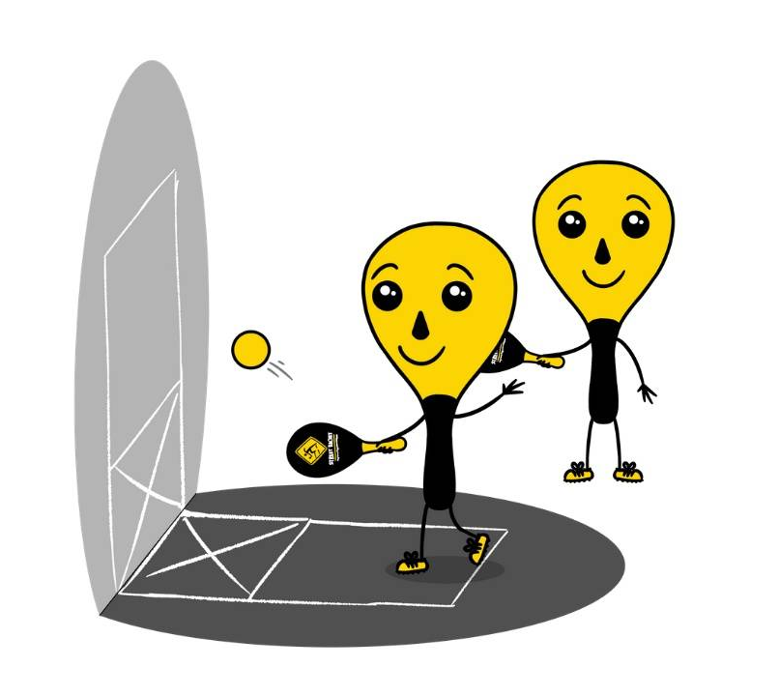
Equipment:
- One racket per student
- One ball per pair of students
- Wall or flat surface to hit against
- Chalk or tape to create a Street Racket wall court
Set-Up:
- Set up 1 wall court per pair of students. Teachers: you can have a third student waiting to rotate in if needed with each group.
- Pair students in groups of 2 (or 3 if needed).
- Each group will begin at a wall court with paddles and a ball.

ACTIVITY PROCEDURES
- This activity is called Off the Walls. The object of the game is to play a Street Racket game using the wall instead of a regular court on the ground. You and your partner will work together to rally as long as possible.
- On the start signal, the person with the ball for your team will drop serve the ball onto the wall. The other teammate will hit the ball after one bounce back towards the wall. This continues as your team tries to get the longest rally possible! Your team earns one point each time you are able to hit continuously for 5 successful shots in a row.
- Each game will last for 5 minutes. Once you hear the stop signal, the person who has the ball will stay at their wall court. The partner who did not have the ball will rotate to a new court to play again with a new partner.
- Remember that you score points by working together to rally as long as possible!

GRADE LEVEL PROGRESSION
- Grade 3: Play as described above.
- Grade 4: Have groups of 4 play on each wall court, as a 2v2 game. Each team must alternate who hits the ball each time.
- Grade 5: Students must alternate using a forehand and a backhand stroke for each hit.

TEACHING CUES
- Cue 1: Be mindful of how much force you use when you hit the ball so it will bounce off the wall and into the square for your partner. This makes it easier to continue the rally.
- Cue 2: Apply the skill cues for the forehand and backhand strokes during the game.
- Cue 3: Use positive and encouraging language with your teammates.

OFF THE WALLS (continued…)

UNIVERSAL DESIGN FOR LEARNING
- UDL 1: Increase/decrease the activity space.
- UDL 2: Use modified equipment and modified game rules based on student needs.
- UDL 3: Use verbal cues and visual aids along with demonstrations.
- UDL 4: Use peer partners as appropriate.

ACADEMIC LANGUAGE
Strategy, Encouragement, Teamwork

PRIORITY OUTCOMES
Personal Responsibility and Safety:
- (Grade 3) Works independently and safely in physical activity settings.
- (Grade 4) Exhibits responsible behavior in independent group situations.
- (Grade 5) Engages in physical activity with responsible interpersonal behavior (e.g., peer to peer, student to teacher).

DEBRIEF QUESTIONS
- DOK 1: What is a strategy?
- DOK 2: Was there a strategy that you and your partner used to keep the rally going?
- DOK 3: How does implementing strategy have an impact on your team’s ability to be successful during a Street Racket game?

ROTATING CORNERS

STUDENT TARGETS
- Skill: I will apply the skill cues for the forehand and backhand shots.
- Cognitive: I will implement specific feedback to improve my performance.
- Fitness: I will take responsibility for developing my skill-related fitness.
- Personal & Social Responsibility: I will engage and respond appropriately using rules, guidelines, and etiquette to resolve conflicts and promote fair play.

EQUIPMENT & SET-UP | 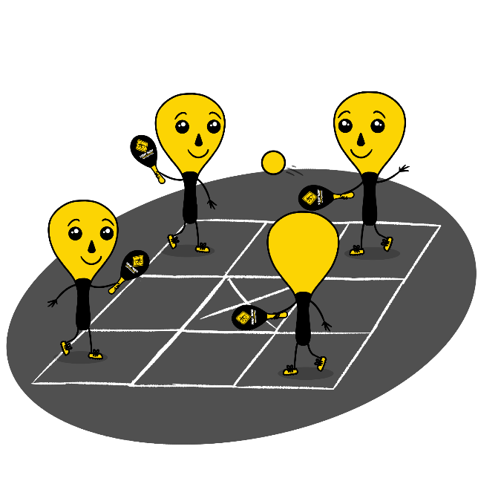
Equipment:
- 1 Street Racket paddle per student
- 2 balls per court
- 1 court per group of students
- Chalk or tape to create a Street Racket Maxi court for each group

Set-Up:
- Set up 1 Maxi Court per group of students.
- Pair students in groups of 8, with 2 students lined up at each of the 4 corners of the court.
- Each group will begin at a court with paddles and 2 balls. Make sure the two students with a ball are not diagonally across from each other.

ACTIVITY PROCEDURES
- This activity is called Rotating Corners. The object of the game is rotate to a new position after each hit during a Street Racket game played on a Maxi Court.
- On the start signal, the two people in your group that have a ball will begin with a serve to start the game. You will always hit the ball to the opposite corner that is diagonally across from you. But remember there will be two balls in play at one time, so make sure you are tracking the ball that is in your diagonal.
- Each time you hit the ball, you will immediately rotate to the next corner counterclockwise. The game will be continuous, so as soon as you get to the new corner make sure you get ready to receive and return the ball!
- Each game will be played for 5 minutes. Once you hear the stop signal, the two players who have a ball will stay on their court, and everyone else will rotate to a different court to play with new teammates.
GRADE LEVEL PROGRESSION
- Grade 3: Have each game begin with a soft underhand toss instead of a serve.
- Grade 4: Play as described above.
- Grade 5: Assign each student a partner, and have students provide specific feedback to their partners based on the skill cues for the forehand and backhand shots after each game.
TEACHING CUES
- Cue 1: Determine whether to use a forehand or a backshot shot based on where the ball lands in your square.
- Cue 2: Apply the skill cues for the forehand and backhand strokes during the game.
- Cue 3: Use positive and encouraging language with your teammates.

ROTATING CORNERS (continued…)

UNIVERSAL DESIGN FOR LEARNING
- UDL 1: Increase/decrease the activity space.
- UDL 2: Use modified equipment and modified game rules based on student needs.
- UDL 3: Use verbal cues and visual aids along with demonstrations.
- UDL 4: Use peer partners as appropriate.

ACADEMIC LANGUAGE
Rotation, Counterclockwise, Encourage, Feedback

PRIORITY OUTCOMES
Accepting Feedback:
- (Grade 3) Accepts and implements specific corrective teacher feedback.
- (Grade 4) Listens respectfully to corrective feedback from others (adults and peers).
- (Grade 5) Gives corrective feedback respectfully to peers.

DEBRIEF QUESTIONS
- DOK 1: How can you recognize corrective feedback?
- DOK 2: How is positive language related to corrective feedback?
- DOK 3: How would you compare and contrast corrective feedback and negative criticism?

FOLLOW YOUR SHOT

STUDENT TARGETS
- Skill: I will move safely within the activity area when moving to a new square during the game.
- Cognitive: I will identify opportunities to be physically active outside of physical education class.
- Fitness: I will remain actively engaged throughout the activity.
- Personal & Social Responsibility: I will work cooperatively with classmates, participating with and accepting all skill levels.

EQUIPMENT & SET-UP | 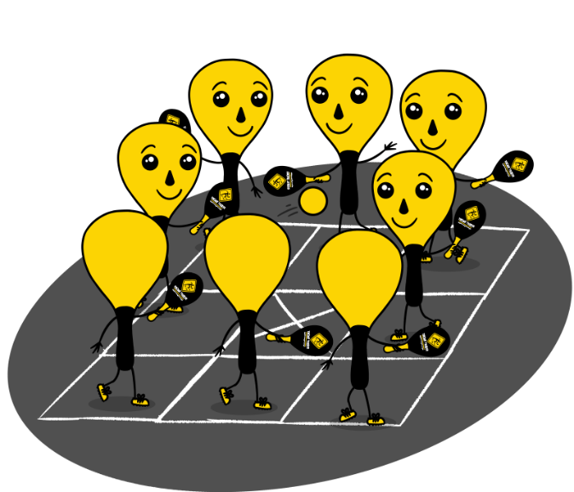
Equipment:
- 1 Street Racket paddle per student
- 1 ball per court
- 1 court per group of students
- Chalk or tape to create a Street Racket Maxi court for each group
Set-Up:
- Set up 1 Maxi Court per group of students.
- Pair students in groups of 8, with 1 student at each of the outside squares of the court. Middle square will have the “X” so no players will be in that square.
- Each group will begin at a court with paddles and a ball.

ACTIVITY PROCEDURES
- This activity is called Follow Your Shot. The object of the game is rotate to the square where you hit the ball after each shot during a Street Racket game played on a Maxi Court.
- On the start signal, the person in your group that has a ball will begin with a serve to start the game. You can hit the ball to any square on the court that you choose, other than the middle square with the “X”.
- After each shot, you will immediately rotate to the square where you hit the ball. There should always be one person in each square. The game will be continuous, so as soon as you get to the new square make sure you get ready to receive and return the ball!
- Each game will be played for 5 minutes. Once you hear the stop signal, the four players who are in the corner squares will stay on their court, and everyone else will rotate to a different court to play with new teammates.

GRADE LEVEL PROGRESSION
- Grade 3: Play as described above.
- Grade 4: Add a second ball into the game.
- Grade 5: Have students play with the racket in their non-dominant hand.

TEACHING CUES
- Cue 1: Determine whether to use a forehand or a backhand shot based on where the ball lands in your square.
- Cue 2: Apply the skill cues for the forehand and backhand strokes during the game.
- Cue 3: Use positive and encouraging language with your teammates.

FOLLOW YOUR SHOT (continued…)

UNIVERSAL DESIGN FOR LEARNING
- UDL 1: Increase/decrease the activity space.
- UDL 2: Use modified equipment and modified game rules based on student needs.
- UDL 3: Use verbal cues and visual aids along with demonstrations.
- UDL 4: Use peer partners as appropriate.

ACADEMIC LANGUAGE
Rally, Aerobic Capacity, Safety, Enjoyment

PRIORITY OUTCOMES
Social Interaction:
- (Grade 3) Describes the positive social interactions that come when engaged with others in physical activity.
- (Grade 4) Describes and compares positive social interactions when engaged in partner, small-group, and large-group physical activities.
- (Grade 5) Describes the social benefits gained from participating in physical activity.

DEBRIEF QUESTIONS
Aerobic Capacity Question Set:
- DOK 1: What is aerobic capacity?
- DOK 2: What do you know about aerobic capacity?
- DOK 3: How is aerobic capacity related to your ability to do the things that you like to do?

Physical Activity Opportunities Question Set:
- DOK 1: What is something you like to do outside of school to be physically active?
- DOK 2: What is something you have learned in physical education class to help you be more physically active?
- DOK 3: How is an active lifestyle related to having fun with your friends and family? Could you play Street Racket during recess or at home?

