HELPFUL HOOPS

STUDENT TARGETS
- Skill: I will work with my teammates to hit back and forth as long as possible.
- Cognitive: I will identify strategies and tactics needed to hit continuously with my teammates.
- Fitness: I will remain actively engaged throughout the lesson.
- Personal & Social Responsibility: I will work together with my teammates for maximum possible success during this activity.

EQUIPMENT & SET-UP | 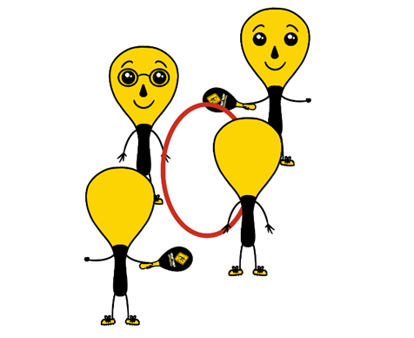
Equipment:
- 2 rackets and 1 ball per group of 4
- 1 hula hoop per group of 4

Set-Up:
- Divide students into teams of 4.
- Two players begin by holding the hula hoop to make a target for the ball to go through.
- Other two players begin on opposite sides of the hoop facing each other, with both students holding a racket and one student holding the ball and ready to serve after hearing the start signal.

ACTIVITY PROCEDURES
- This activity is called Helpful Hoops. The object of the game is to work with your teammates to hit the ball back and forth as long as you can. You do that by working together to hit the ball through the hula hoop (which is a held by two of your teammates).
- On the start signal, the two players with a racket will hit the ball back and forth as many times as they can. The two players holding the hula hoop can help their teammates be successful by moving their feet or altering the height of the hula hoop. The hoop holders and the players hitting back and forth will work together to achieve the highest possible team score! Any time the ball doesn’t go through the hoop, the players will each rotate clockwise one spot. You will use the team score from your longest rally as a new goal each time players rotate positions.
- On the stop signal players will place the hula hoop, the rackets, and the ball down on the ground. The two players who were holding the hoop when you heard the stop signal will move to a new group before we play again.

GRADE LEVEL PROGRESSION
- Grade 3: Play as described above.
- Grade 4: Hoop holders can raise or lower the hoop to help their team but cannot move their feet.
Grade 5: Have two teams of 4 join together to make a group of 8. The 2 hula hoops will be held side by side, with each team hitting the ball through the other team’s hoop (hitting on a diagonal vs. hitting straight ahead).

TEACHING CUES
- Cue 1: Keep your body in ready position so you are ready to receive the ball from your teammate.
- Cue 2: Hoop holders need to stay attentive and work together so they can move where needed during the rally.

HELPFUL HOOPS (continued…)

UNIVERSAL DESIGN FOR LEARNING
- UDL 1: Increase/decrease the activity space.
- UDL 2: Use modified equipment as needed.
- UDL 3: Use verbal cues and visual aids along with demonstrations.
- UDL 4: Use peer partners as appropriate.

ACADEMIC LANGUAGE
Cooperation, Supportive, Encouraging, Teamwork

PRIORITY OUTCOMES
Working With Others:
- (Grade 3) Works cooperatively with others.
- (Grade 4) Accepts “players” of all skill levels into the physical activity.
- (Grade 5) Accepts, recognizes, and actively involves others with both higher and lower skill abilities into physical activities and group projects.

DEBRIEF QUESTIONS
- DOK 1: Was there a communication strategy that your team used during this activity?
- DOK 2: Sometimes we use a strategy during a game or activity, and it doesn’t work well. Was there a communication strategy that you tried during this game that didn’t work very well? What did you do differently if you realized a communication strategy wasn’t working for your team?

