STREET RACKET BASICS

STUDENT TARGETS
- Skill: I will hit continuously with a partner, demonstrating controlled and balanced weight transfer and striking form.
- Cognitive: I will discuss the concepts of power and accuracy.
- Fitness: I will remain actively engaged in all hitting drills.
- Personal & Social Responsibility: I will provide encouragement and feedback to my partner.

EQUIPMENT & SET-UP | 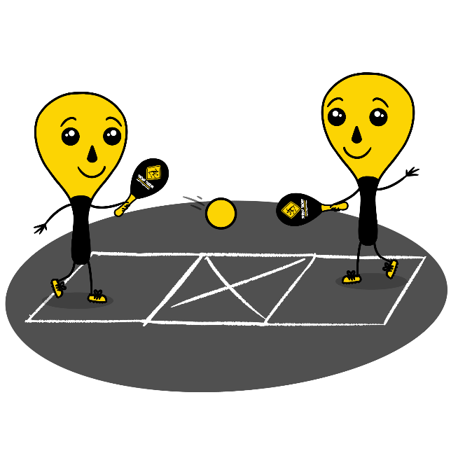
Equipment:
- 1 Street Racket paddle per student
- 1 ball per pair of students
- 1 court per pair of students
- Chalk or tape to create a Street Racket court for each pair of students

Set-Up:
- Set up 1 court per group of students. Teachers: you can have a third student waiting to rotate in if needed with each group.
- Pair students in groups of 2 (or 3 if needed).
- Each group will begin at a court with paddles and a ball.
ACTIVITY PROCEDURES
- It’s time for some partner drills using a Street Racket court. In each drill, you will be working toward 8 consecutive hits. You can increase or decrease the distance between you and your partner as needed.
- We are going to try two different drills to work on being able to continuously hit back and forth with your partner. Each group will begin with Drill 1 in their activity space. Note: Provide a demonstration of both drills before students begin.
- Drill 1: Hit Up and Return. Partner 1 begins with a drop-hit to partner 2. After one bounce, partner 2 will hit the ball up one time, and then after a bounce return it to partner 1. Both partners will continue this pattern to hit the ball up one time before returning it to your partner. After 5 rally attempts with this drill, your group will move on to drill 2.
- Drill 2: 1-Bounce Rally. Partner 1 begins with a drop-hit to partner 2. Partner 2 will hit the ball off of 1 bounce. Partner 2 will return the ball after allowing the ball to bounce. Continue this pattern.
- Remember to try and use both forehand and backhand shots as needed during your rally!
GRADE LEVEL PROGRESSION
- Grade 3: Play as described above.
- Grade 4: Hit the ball up when it is received and then only use a backhand to return the ball to your partner after the bounce.
- Grade 5: Prompt students to provide constructive feedback and encouragement to their peers.
TEACHING CUES
- Make sure to return to the ready position each time you hit the ball to your partner.
- Keep your eyes on the ball.
- Encourage your teammates and have fun!

STREET RACKET BASICS (continued…)

UNIVERSAL DESIGN FOR LEARNING
- UDL 1: Increase/decrease the activity space.
- UDL 2: Use modified equipment and modified game rules based on student needs.
- UDL 3: Use verbal cues and visual aids along with demonstrations.
- UDL 4: Use peer partners as appropriate.

ACADEMIC LANGUAGE
Accuracy, Continuous, Control, Encouragement, Power, Volley

PRIORITY OUTCOMES
Manipulative Skills:
- (Grade 3) Demonstrates manipulative skills using mature patterns for accuracy and control.
- (Grade 4) Combines locomotor and manipulative skills using mature patterns for accuracy and control in static and dynamic environments.
- (Grade 5) Executes a variety of manipulative skills with control and accuracy in small-sides games.

DEBRIEF QUESTIONS
- DOK 1: How would you describe “accuracy”?
- DOK 2: How does power affect accuracy?
- DOK 3: How are skill cues related to your power and accuracy?

