SWITCH IT UP

STUDENT TARGETS
- Skill: I will perform both forehand and backhand strokes during game play.
- Cognitive: I will identify the skill cues for the forehand and the backhand strokes.
- Fitness: I will stay actively engaged with a focus on developing my fitness.
- Personal & Social Responsibility: I will provide encouragement and safely cooperate with my peers.

EQUIPMENT & SET-UP | 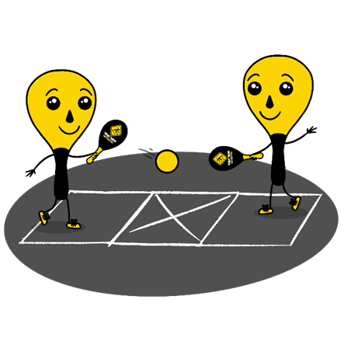
Equipment:
- 1 Street Racket paddle per student
- 1 ball per pair of students
- 1 court per pair of students
- Chalk or tape to create a Street Racket court for each pair of students
Set-Up:
- Set up 1 court per pair of students. Teachers: you can have a third student waiting to rotate in if needed with each group.
- Pair students in groups of 2 (or 3 if needed).
- Each group will begin at a court with paddles and a ball.
ACTIVITY PROCEDURES
- This activity is called Switch it Up. The object of the game is to work on both your forehand and backhand strokes while playing Street Racket. We are going to try three different challenges with your partner today. We will begin with Challenge 1, then move on to Challenges 2 and 3. Teacher Note: Provide a demonstration of all challenges before students begin.
- Challenge 1: Alternating Forehands. This challenge will focus on practicing your forehand stroke, but with the added challenge of switching the racket between your right and left hand for each hit. You and your partner hit back and forth as many times in a row as you can using a forehand stroke, while switching the paddle to a different hand each time.
- Challenge 2: Alternating Backhands. This challenge will focus on practicing your backhand stroke, but with the added challenge of switching the racket between your right and left hand for each hit. You and your partner hit back and forth as many times in a row as you can using a backhand stroke, while switching the paddle to a different hand each time.
- Challenge 3: Forehand/Backhand Switch. This challenge will focus on practicing both your forehand and backhand stroke as you and your partner try to hit the ball continuously back and forth for as long as you can. You will switch between a forehand and backhand each time you hit the ball.
GRADE LEVEL PROGRESSION
- Grade 3: Play as described above.
- Grade 4: Play as described above.
- Grade 5: Have teams of 4, with one person waiting to rotate in on each side of the court. Each time a player returns the ball, they rotate out and the person waiting on their side rotates in.
TEACHING CUES
- Cue 1: Follow the skill cues for the forehand and backhand stroke.
- Cue 2: Maintain your grip like you are shaking hands with the racket each time it changes hands.
- Cue 3: Maintain control and focus on safety throughout the activity.

SWITCH IT UP (continued…)

UNIVERSAL DESIGN FOR LEARNING
- UDL 1: Increase/decrease the activity space.
- UDL 2: Use modified equipment and modified game rules based on student needs.
- UDL 3: Use verbal cues and visual aids along with demonstrations.
- UDL 4: Use peer partners as appropriate.

ACADEMIC LANGUAGE
Forehand, Backhand, Serve, Return

PRIORITY OUTCOMES
Manipulative Skills:
- (Grade 3) Demonstrates manipulative skills using mature patterns for accuracy and control.
- (Grade 4) Combines locomotor and manipulative skills using mature patterns for accuracy and control in static and dynamic environments.
- (Grade 5) Executes a variety of manipulative skills with control and accuracy in small-sided games.

DEBRIEF QUESTIONS
- DOK 1: What is “weight transfer”?
- DOK 2: How do you transfer weight when you use a forehand or backhand stroke?
- DOK 3: Why do you think that weight transfer is critical to an accurate hit?

- DOK 1: What does “timing” mean?
- DOK 2: How does timing affect the accuracy of your hits?
- DOK 3: How is timing related to weight transfer?

