FITNESS FRENZY

STUDENT TARGETS
- Skill: I will work with my partner to score points for our team during this activity.
- Cognitive: I will categorize fitness activities into the applicable health-related or skill-related fitness component.
- Fitness: I will stay actively engaged for the duration of this activity.
- Personal & Social Responsibility: I will discuss ways integrity can impact physical activities.

EQUIPMENT & SET-UP | 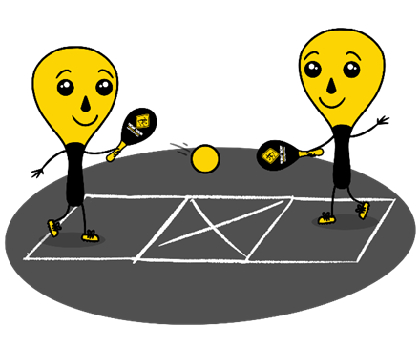
Equipment:
- 1 Street Racket paddle per student
- 1 ball per pair of students
- 1 court per pair of students
- Chalk or tape to create a Street Racket court for each pair of students

Set-Up:
- Set up 1 court per group of students. Teachers: you can have a third student waiting to rotate in if needed with each group.
- Pair students in groups of 2 (or 3 if needed).
- Each group will begin at a court with paddles and a ball.
ACTIVITY PROCEDURES
- This activity is called Fitness Frenzy. The object of the game is to play a Street Racket game with your partner while also integrating fitness components into the game.
- We are going to play three rounds of Fitness Frenzy, each time incorporating a different fitness activity into our Street Racket game. Each round will be played for 5 minutes.
- On the start signal we will begin round 1, and you will continue to play until you hear the stop signal. Your group earns one point for each successful rally where both partners complete the fitness activity and are able to return the ball to the correct square.
- Round 1: Run to the middle of the court and touch the “X” with your foot after you hit the ball to your partner. Remember to get back to your square and get in the ready position to receive the ball again.
- Round 2: Touch the floor with both hands after you hit the ball to your partner (perform a squat).
- Round 3: Perform 2 jumping jacks after you hit the ball to your partner.

GRADE LEVEL PROGRESSION
- Grade 3: Play as described above.
- Grade 4: Have students play doubles instead of singles during the Street Racket game. Both partners would complete the fitness exercise each time they return the ball.
- Grade 5: Have students identify the fitness exercises that are integrated into the game instead of using the teacher-created ones.

TEACHING CUES
- Cue 1: Focus on safe form and technique during the fitness exercises.
- Cue 2: Apply the skill cues for the forehand and backhand strokes during the game.
- Cue 3: Use positive and encouraging language with your teammates.

FITNESS FRENZY (continued…)

UNIVERSAL DESIGN FOR LEARNING
- UDL 1: Increase/decrease the activity space.
- UDL 2: Use modified equipment and modified game rules based on student needs.
- UDL 3: Use verbal cues and visual aids along with demonstrations.
- UDL 4: Use peer partners as appropriate.

ACADEMIC LANGUAGE
Fitness, Integrity, Health-related Fitness, Skill-related Fitness

PRIORITY OUTCOMES
Fitness Knowledge:
- (Grade 3) Describes the concept of fitness and provides examples of physical activities to enhance fitness.
- (Grade 4) Identifies the components of health-related and skill-related fitness.
- (Grade 5) Identifies activities that require and/or improve the components of fitness.

DEBRIEF QUESTIONS
- DOK 1: What is integrity?
- DOK 2: Why is integrity important in physical activity or competitive settings?
- DOK 3: How is integrity related to the enjoyment of everyone playing a game of Street Racket?

