OFF THE WALLS

STUDENT TARGETS
- Skill: I will perform both forehand and backhand strokes during game play.
- Cognitive: I will use strategy to attempt to rally as long as possible with my partner.
- Fitness: I will stay actively engaged with a focus on developing my fitness.
- Personal & Social Responsibility: I will provide encouragement and will safely cooperate with my teammates.

EQUIPMENT & SET-UP | 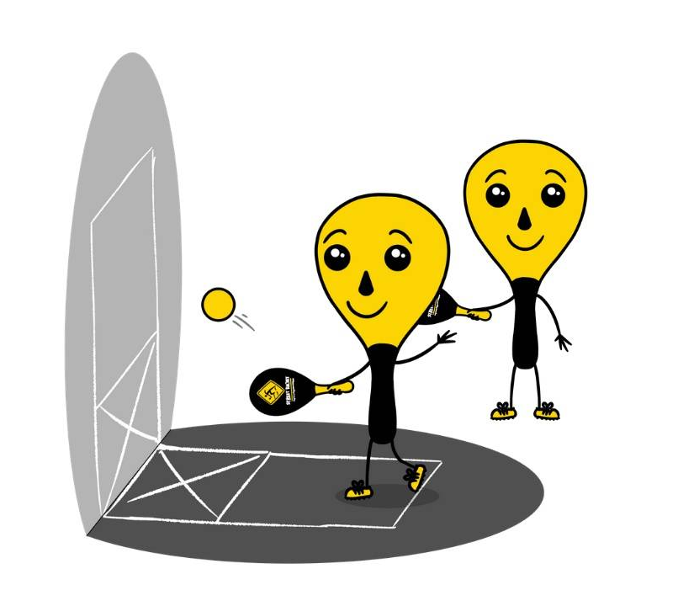
Equipment:
- One racket per student
- One ball per pair of students
- Wall or flat surface to hit against
- Chalk or tape to create a Street Racket wall court
Set-Up:
- Set up 1 wall court per pair of students. Teachers: you can have a third student waiting to rotate in if needed with each group.
- Pair students in groups of 2 (or 3 if needed).
- Each group will begin at a wall court with paddles and a ball.

ACTIVITY PROCEDURES
- This activity is called Off the Walls. The object of the game is to play a Street Racket game using the wall instead of a regular court on the ground. You and your partner will work together to rally as long as possible.
- On the start signal, the person with the ball for your team will drop serve the ball onto the wall. The other teammate will hit the ball after one bounce back towards the wall. This continues as your team tries to get the longest rally possible! Your team earns one point each time you are able to hit continuously for 5 successful shots in a row.
- Each game will last for 5 minutes. Once you hear the stop signal, the person who has the ball will stay at their wall court. The partner who did not have the ball will rotate to a new court to play again with a new partner.
- Remember that you score points by working together to rally as long as possible!

GRADE LEVEL PROGRESSION
- Grade 3: Play as described above.
- Grade 4: Have groups of 4 play on each wall court, as a 2v2 game. Each team must alternate who hits the ball each time.
- Grade 5: Students must alternate using a forehand and a backhand stroke for each hit.

TEACHING CUES
- Cue 1: Be mindful of how much force you use when you hit the ball so it will bounce off the wall and into the square for your partner. This makes it easier to continue the rally.
- Cue 2: Apply the skill cues for the forehand and backhand strokes during the game.
- Cue 3: Use positive and encouraging language with your teammates.

OFF THE WALLS (continued…)

UNIVERSAL DESIGN FOR LEARNING
- UDL 1: Increase/decrease the activity space.
- UDL 2: Use modified equipment and modified game rules based on student needs.
- UDL 3: Use verbal cues and visual aids along with demonstrations.
- UDL 4: Use peer partners as appropriate.

ACADEMIC LANGUAGE
Strategy, Encouragement, Teamwork

PRIORITY OUTCOMES
Personal Responsibility and Safety:
- (Grade 3) Works independently and safely in physical activity settings.
- (Grade 4) Exhibits responsible behavior in independent group situations.
- (Grade 5) Engages in physical activity with responsible interpersonal behavior (e.g., peer to peer, student to teacher).

DEBRIEF QUESTIONS
- DOK 1: What is a strategy?
- DOK 2: Was there a strategy that you and your partner used to keep the rally going?
- DOK 3: How does implementing strategy have an impact on your team’s ability to be successful during a Street Racket game?

