ROTATING CORNERS

STUDENT TARGETS
- Skill: I will apply the skill cues for the forehand and backhand shots.
- Cognitive: I will implement specific feedback to improve my performance.
- Fitness: I will take responsibility for developing my skill-related fitness.
- Personal & Social Responsibility: I will engage and respond appropriately using rules, guidelines, and etiquette to resolve conflicts and promote fair play.

EQUIPMENT & SET-UP | 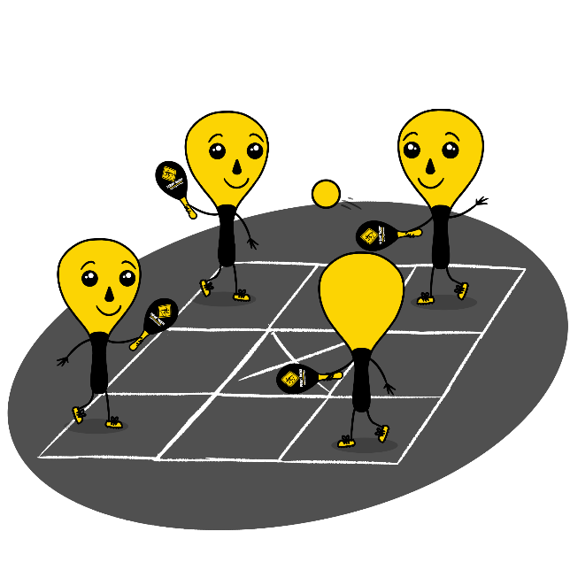
Equipment:
- 1 Street Racket paddle per student
- 2 balls per court
- 1 court per group of students
- Chalk or tape to create a Street Racket Maxi court for each group

Set-Up:
- Set up 1 Maxi Court per group of students.
- Pair students in groups of 8, with 2 students lined up at each of the 4 corners of the court.
- Each group will begin at a court with paddles and 2 balls. Make sure the two students with a ball are not diagonally across from each other.

ACTIVITY PROCEDURES
- This activity is called Rotating Corners. The object of the game is rotate to a new position after each hit during a Street Racket game played on a Maxi Court.
- On the start signal, the two people in your group that have a ball will begin with a serve to start the game. You will always hit the ball to the opposite corner that is diagonally across from you. But remember there will be two balls in play at one time, so make sure you are tracking the ball that is in your diagonal.
- Each time you hit the ball, you will immediately rotate to the next corner counterclockwise. The game will be continuous, so as soon as you get to the new corner make sure you get ready to receive and return the ball!
- Each game will be played for 5 minutes. Once you hear the stop signal, the two players who have a ball will stay on their court, and everyone else will rotate to a different court to play with new teammates.
GRADE LEVEL PROGRESSION
- Grade 3: Have each game begin with a soft underhand toss instead of a serve.
- Grade 4: Play as described above.
- Grade 5: Assign each student a partner, and have students provide specific feedback to their partners based on the skill cues for the forehand and backhand shots after each game.
TEACHING CUES
- Cue 1: Determine whether to use a forehand or a backshot shot based on where the ball lands in your square.
- Cue 2: Apply the skill cues for the forehand and backhand strokes during the game.
- Cue 3: Use positive and encouraging language with your teammates.

ROTATING CORNERS (continued…)

UNIVERSAL DESIGN FOR LEARNING
- UDL 1: Increase/decrease the activity space.
- UDL 2: Use modified equipment and modified game rules based on student needs.
- UDL 3: Use verbal cues and visual aids along with demonstrations.
- UDL 4: Use peer partners as appropriate.

ACADEMIC LANGUAGE
Rotation, Clockwise, Encouragement, Feedback

PRIORITY OUTCOMES
Accepting Feedback:
- (Grade 3) Accepts and implements specific corrective teacher feedback.
- (Grade 4) Listens respectfully to corrective feedback from others (adults and peers).
- (Grade 5) Gives corrective feedback respectfully to peers.

DEBRIEF QUESTIONS
- DOK 1: How can you recognize corrective feedback?
- DOK 2: How is positive language related to corrective feedback?
- DOK 3: How would you compare and contrast corrective feedback and negative criticism?

