FOLLOW YOUR SHOT

STUDENT TARGETS
- Skill: I will move safely within the activity area when moving to a new square during the game.
- Cognitive: I will identify opportunities to be physically active outside of physical education class.
- Fitness: I will remain actively engaged throughout the activity.
- Personal & Social Responsibility: I will work cooperatively with classmates, participating with and accepting all skill levels.

EQUIPMENT & SET-UP | 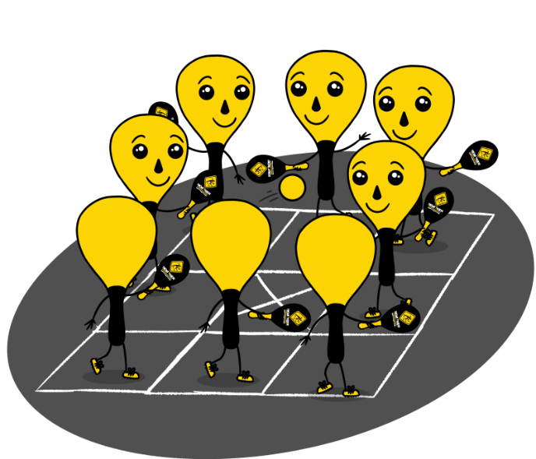
Equipment:
- 1 Street Racket paddle per student
- 1 ball per court
- 1 court per group of students
- Chalk or tape to create a Street Racket Maxi court for each group
Set-Up:
- Set up 1 Maxi Court per group of students.
- Pair students in groups of 8, with 1 student at each of the outside squares of the court. Middle square will have the “X” so no players will be in that square.
- Each group will begin at a court with paddles and a ball.

ACTIVITY PROCEDURES
- This activity is called Follow Your Shot. The object of the game is rotate to the square where you hit the ball after each shot during a Street Racket game played on a Maxi Court.
- On the start signal, the person in your group that has a ball will begin with a serve to start the game. You can hit the ball to any square on the court that you choose, other than the middle square with the “X”.
- After each shot, you will immediately rotate to the square where you hit the ball. There should always be one person in each square. The game will be continuous, so as soon as you get to the new square make sure you get ready to receive and return the ball!
- Each game will be played for 5 minutes. Once you hear the stop signal, the four players who are in the corner squares will stay on their court, and everyone else will rotate to a different court to play with new teammates.

GRADE LEVEL PROGRESSION
- Grade 3: Play as described above.
- Grade 4: Add a second ball into the game.
- Grade 5: Have students play with the racket in their non-dominant hand.

TEACHING CUES
- Cue 1: Determine whether to use a forehand or a backhand shot based on where the ball lands in your square.
- Cue 2: Apply the skill cues for the forehand and backhand strokes during the game.
- Cue 3: Use positive and encouraging language with your teammates.

FOLLOW YOUR SHOT (continued…)

UNIVERSAL DESIGN FOR LEARNING
- UDL 1: Increase/decrease the activity space.
- UDL 2: Use modified equipment and modified game rules based on student needs.
- UDL 3: Use verbal cues and visual aids along with demonstrations.
- UDL 4: Use peer partners as appropriate.

ACADEMIC LANGUAGE
Rally, Aerobic Capacity, Safety, Enjoyment

PRIORITY OUTCOMES
Social Interaction:
- (Grade 3) Describes the positive social interactions that come when engaged with others in physical activity.
- (Grade 4) Describes and compares positive social interactions when engaged in partner, small-group, and large-group physical activities.
- (Grade 5) Describes the social benefits gained from participating in physical activity.

DEBRIEF QUESTIONS
Aerobic Capacity Question Set:
- DOK 1: What is aerobic capacity?
- DOK 2: What do you know about aerobic capacity?
- DOK 3: How is aerobic capacity related to your ability to do the things that you like to do?

Physical Activity Opportunities Question Set:
- DOK 1: What is something you like to do outside of school to be physically active?
- DOK 2: What is something you have learned in physical education class to help you be more physically active?
- DOK 3: How is an active lifestyle related to having fun with your friends and family? Could you play Street Racket during recess or at home?

