Street Racket Court Diagrams
Maxi Court
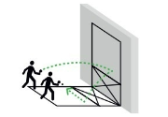
Singles Court
Wall Court
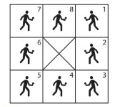

HOW TO DRAW STREET RACKET COURTS
- Use chalk or tape to create courts
- Each square is recommended to be approximately 6 feet
- Courts should be modified as needed based on space available and class size
- The middle square on each court replaces the need for a net, and should be identified with an “X”

