SPIKEBALL KNEE TAG

STUDENT TARGETS
- Purposeful Competition: I will value my opponent as a partner who allows me to work towards excellence.
- Skill: I will work on remaining in an athletic stance during this activity.
- Fitness: I will stay actively engaged throughout the activity.
- Responsible Behaviors: I will demonstrate safe and respectful behaviors.

EQUIPMENT & SET-UP | 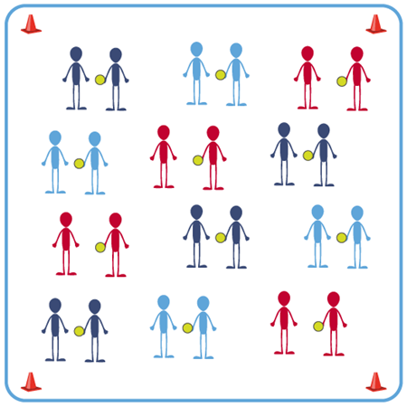
Equipment:
- 1 Spikeball® for each pair of students
- Large cones to delineate boundaries

Set-Up:
- Create an activity space using large cones to mark boundaries.
- Pair students in groups of 2.
- Scatter pairs of students throughout the activity area. Each pair with a ball.

ACTIVITY PROCEDURES
- Today’s instant activity is a game called Spikeball Knee Tag.
- The object of the activity is to tag your partner on the knee with the ball in your hand. We want to focus on remaining in our Athletic Stance used for Roundnet at all times.
- On the start signal, groups will play Rock, Paper, Scissors to determine who will begin with the ball.
- The person with the ball will get 5 attempts to tag their partner on the knee with the ball. Taggers earn one point for themselves for each successful tag on the knee with the ball in their hand.
- After 5 attempts, your group will trade roles so everyone has a chance to the be the tagger and earn points.
- After you and your partner have both had 5 attempts as the knee tagger, you will give each other a high-five and go find a new partner.
- On the stop signal put equipment down and be ready for the next set of instructions.

GRADE LEVEL PROGRESSION
- Level 1: Play as described above.
- Level 2: Combine 2 pairs into a group of 4. Play with two knee taggers instead of one.

TEACHING CUES
- Cue 1: Keep your eyes up and stay alert.
- Cue 2: Tag safely with the Spikeball® (no throwing the ball to tag).
- Cue 3: Maintain your Athletic Stance during activity.

SPIKEBALL KNEE TAG (continued…)

UNIVERSAL DESIGN FOR LEARNING
- UDL 1: Use peer partners as appropriate.
- UDL 2: Use modified equipment as needed and allow students to choose their preference.
- UDL 3: Use verbal cues and visual aids along with demonstrations.
- UDL 4: Decrease the size of the activity area if needed.

ACADEMIC LANGUAGE
Athletic Stance, Excellence, Heart Rate

PRIORITY OUTCOMES
Purposeful Competition – Inclusion of Purpose in All Relevant Activities:
- (HS) Differentiate how higher levels of competition and challenge present greater purpose in the pursuit of excellence.

Movement Concepts:
- (HS) Uses movement concepts and principles to analyze and improve performance of self and others in a selected skill.

DEBRIEF
Debrief Questions:
- DOK 1: How would you describe what your heart rate is?
- DOK 2: How does physical activity affect your heart rate?
- DOK 3: What Roundnet activities have we worked on that increased your heart rate? Why do you feel your heart rate increased during that activity?

