3v3

STUDENT TARGETS
- Purposeful Competition: I will recognize the importance of failed attempts along the path to excellence and learn from them intentionally.
- Skill: I will demonstrate the Roundnet skills and strategies required to play 3v3.
- Fitness: I will remain actively engaged in order to increase my heart rate.
- Responsible Behaviors: I will demonstrate teamwork and cooperative behaviors.

EQUIPMENT & SET-UP | 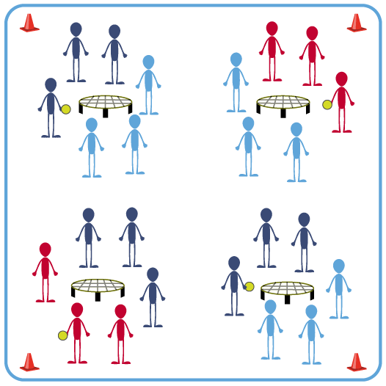
Equipment:
- 1 Spikeball® (or foam ball) per group
- 1 Spikeball® net (or hoop) per group

Set-Up:
- Scatter nets (or hoops) within the activity space allowing enough space for players to move freely.
- Create groups of 3 students, with 2 groups at the net and ready to play.
- Groups will play a 3v3 game of Roundnet, with any additional team members rotating in as substitutions after each 2-minute game.

ACTIVITY PROCEDURES
- We’re going to work on our game play with teams of 3 playing classic Roundnet rules. Adding the 3rd player makes it a little easier for teams to return serves and extend rallies. Each game will be played for 2 minutes (or any teacher chosen time limit), and then we’ll rotate in any waiting players for the next 2-minute game.
- Each team still gets only 3 hits (pass, set, spike) per possession. Any time there is player interference because the playing area is crowded, simply redo the point.
- Each team’s game will begin on the start signal and you will keep your own score.
- After each 2-minute game, each team will rotate in any waiting players to ensure that all players from a Roundnet Season Team have the opportunity to play.
- On the stop signal put equipment down be ready for the next set of instructions.

GRADE LEVEL PROGRESSION
- Level 1: Participate cooperatively and demonstrate skill cues related to passing and spiking.
- Level 2: After the first few games, have students self-identify their preferred challenge level and choose groupings/opponents based on that preference.

TEACHING CUES
- Cue 1: Focus on form and skill cues for passes and spikes.
- Cue 2: Use controlled passes that set towards the net for your teammates.
- Cue 3: Honor the rules of the game and the characteristics of Purposeful Competition during each game.

3v3 (continued…)

UNIVERSAL DESIGN FOR LEARNING
- UDL 1: Provide implements (e.g., paddle) if students have difficulty striking with their hands.
- UDL 2: Use modified equipment as needed (e.g., foam ball) and allow students to choose their challenge preference.
- UDL 3: Use verbal cues and visual aids along with demonstrations.
- UDL 4: Increase the size of the target area or remove the target altogether.
- UDL 5: Allow the ball to bounce in between passes and spikes.

ACADEMIC LANGUAGE
Purposeful Competition, Challenge, Safety, Cooperation, Teamwork

PRIORITY OUTCOMES
Purposeful Competition – Association of Failed Attempts with Future Successes:
- (HS) Identify the importance of fair and consistent officiating/rule following in a competitive environment in order to differentiate errors accurately for future improvement.

Personal Responsibility & Safety:
- (HS) Applies best practices for participating safely in physical activity, exercise, and dance (e.g., injury prevention, proper alignment, hydration, use of equipment, implementation of rules, sun protection).

CLOSURE AND DEBRIEF
Purposeful Competition Closure:
- Let’s hear about how folks got better today. You can either tell the class about something you improved on, something that you’re currently doing well, or something that a classmate seems to be improving on. (Allow time for reflection and feedback) Thanks for sharing the good news!

Debrief:
- DOK 1: What is teamwork?
- DOK 2: How would you compare and/or contrast a team’s Roundnet performance that demonstrates teamwork with a performance that doesn’t?
- DOK 3: What facts would you select to support the importance of teamwork to Roundness success? Can you elaborate on why you chose those facts?

