EXPERIENCE ROUNDNET

STUDENT TARGETS
- Purposeful Competition: I will recognize the importance of failed attempts along the path to excellence and learn from them intentionally.
- Skill: I will demonstrate a variety of Roundnet skills required for maintaining a rally.
- Fitness: I will remain focused and actively engaged in practice tasks.
- Responsible Behaviors: I will work cooperatively to maintain an extended rally.

EQUIPMENT & SET-UP | 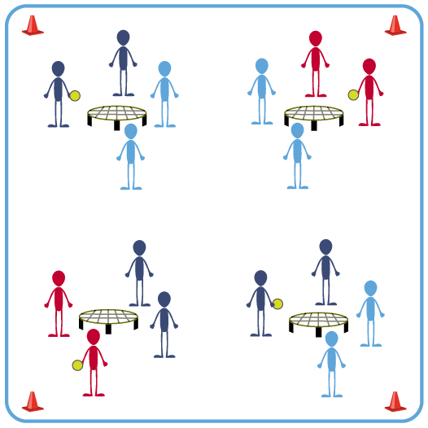
Equipment:
- 1 Spikeball® net (or hoop) and 1 ball per group of 4 students
- Use hoops and foam balls if you do not have enough Spikeball® sets for your entire class

Set-Up:
- Scatter nets (or hoops) in the activity area, allowing space for player movement.
- Place 1 Spikeball® at each net.
- Pair students and send 2 pairs (4 players) to each net.

ACTIVITY PROCEDURES
- This activity is called Experience Roundnet and will give you some practice time to apply the offensive and defensive strategies we have been learning.
- The object of the activity is to build a rally with consecutive Roundnet passes and spikes.
- On the start signal, determine which team will serve first and begin the game. Teams have a maximum of 3 hits (2 passes and 1 spike) to send the ball down to the net for a change of possession.
- We will play 3-minute games. At the end of each game, each of you must play with a different partner. We will play a total of 3 games, so you have an opportunity to partner with everyone at your net for one game. This will also help teams select partners for Roundnet tournaments later on this season.
- On the stop signal put equipment down and be ready for the next set of instructions.

GRADE LEVEL PROGRESSION
- Level 1: Participate cooperatively and demonstrate skill elements related to passing and spiking.
- Level 2: Analyze personal and group performance, discuss opportunities for improvement, and then execute a plan for purposeful skill refinement.

TEACHING CUES
- Cue 1: Apply the Roundnet skill cues and strategies we have practiced.
- Cue 2: Help and encourage others by demonstrating kindness and using supportive language.
Cue 3: Play with purpose but have fun!

EXPERIENCE ROUNDNET (continued…)

UNIVERSAL DESIGN FOR LEARNING
- UDL 1: Provide implements (e.g., paddle) if students have difficulty striking with their hands.
- UDL 2: Use modified equipment as needed (e.g., foam ball) and allow students to choose their challenge preference.
- UDL 3: Use verbal cues and visual aids along with demonstrations.
- UDL 4: Increase the size of the target area or remove the target altogether.
- UDL 5: Allow the ball to bounce in between passes and spikes.
- UDL 6: Use peer partners if applicable.

ACADEMIC LANGUAGE
Cooperation, Respect, Movement Concepts, Control

PRIORITY OUTCOMES
Purposeful Competition – Association of Failed Attempts with Future Successes:
- (HS) Evaluate and target historically less competent or proficient skills for improvement through continued trial and error.

Social Interaction:
- (HS) Identifies and evaluates the opportunity for social interaction and social support in self-selected physical activities.

CLOSURE AND DEBRIEF
Purposeful Competition Closure:
- Let’s hear about how folks got better today.
- You can either tell the class about something you improved on, something that you’re currently doing well, or something that a classmate seems to be improving on. (Allow time for reflection and feedback)
- Thanks for sharing the good news!

Debrief:
- DOK 1: What are the movement concepts related to Roundnet participation?
- DOK 2: How do those concepts affect the performance of specific skills or tactical plays?
- DOK 3: How can you apply what you’ve learned to develop your Roundnet skills? (Teachers: include specific skills when you ask this question. For example, “How can you apply what you’ve learned to develop your spiking skills?”).

