TOSS 3

STUDENT TARGETS
- Skill: I will accurately toss and catch with a partner.
- Fitness: I will stay actively engaged throughout the activity in order to increase my heart rate.
- Responsible Behaviors: I will communicate with my classmates and honor the spirit of the game.
EQUIPMENT & SET-UP | 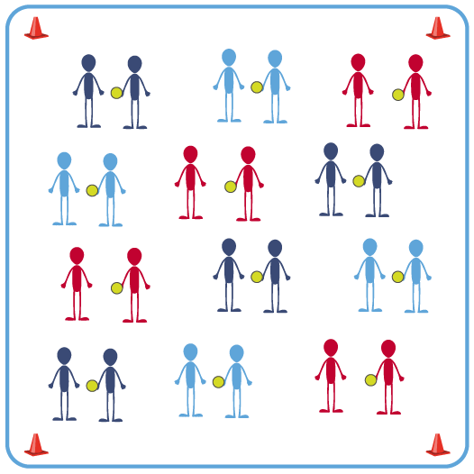
Equipment:
- 1 foam ball per pair of 2 students
- 4 cones for boundaries
- Music and music player

Set-Up:
- Create a large activity space using 4 cones to mark boundaries.
- Scatter pairs of students throughout activity area. Each pair with a ball.

ACTIVITY PROCEDURES
- Today we’re going to focus on using communication skills during the game of Toss 3. Many of our activities during physical education class require us to work with partners or groups. One of the ways we can work successfully with others is by being a good communicator.
- The object of Toss 3 is to work with as many different classmates as you can while the music is playing. When the music starts, the partner with the ball will begin with a toss. Each pair will make 3 tosses. The partner who now has the ball will travel and find a new partner who does not have a ball. Use your communication skills to let your classmates know when you are looking for a new partner.
- For the next round, instead of tossing and catching, we will practice passing with our feet – soccer style! You will pass the ball to your partner with your feet, and they will trap it before passing it back to you. You will continue to communicate with your classmates as you move to find a new partner after 3 passes.
- On the stop signal put equipment down and be ready for the next set of instructions.

GRADE LEVEL PROGRESSION
Level 1: Focus on reciting skill cues and using correct academic language.
Level 2: Increase the number of tosses to any odd number. Odd numbers maintain the change of possession as students change partners.

ACADEMIC LANGUAGE
Communication, Etiquette, Cooperation

PRIORITY OUTCOMES
Working with Others:
Uses communication skills and strategies that promote positive team/group dynamics.

DEBRIEF QUESTIONS
DOK 1: How would you describe good communication during physical education class?
DOK 2: How do communication skills affect the physical activity experience for a set of partners or the members of a group?

