HOOP TOWER RELAY

STUDENT TARGETS
- Skill: I will cooperate with my teammates to complete the relay and build the hoop tower.
- Fitness: I will stay actively engaged throughout the activity in order to increase my heart rate.
- Responsible Behaviors: I will continue to try my best and use encouraging language when challenged.
EQUIPMENT & SET-UP | 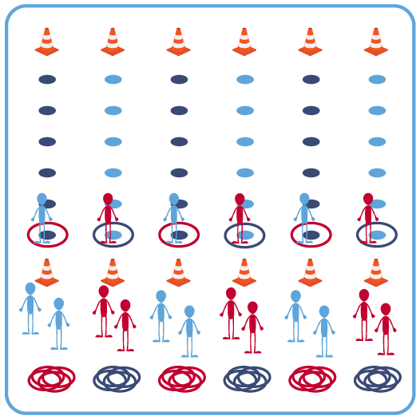
Equipment:
- 12 cones to create start/finish for relay lines
- 36 spot markers (6 for each relay line)
- 36 hula hoops (6 for each relay line)
- Music as a start/stop signal (optional)
Set-Up:
- Space 6 cones in a line on each side of the activity area (across from each other). The cones on one side should also have 6 hoops.
- Evenly space out 6 spot markers between each set of cones.
- Create 6 even groups of students, 1 group begins at each cone with the hula hoops.
ACTIVITY PROCEDURES
- Today we’re going to focus on using positive language when facing a challenge during the game of Hoop Tower Relay. Sometimes we try things during physical education class that we may not be successful at the first few times we try, or that we find challenging. I want you to use positive language with both your teammates and yourself as you face any challenges during this activity.
- The object of the game is for each team to get all 6 hoops across the activity area and then create a Hoop Tower. On the start signal, one teammate moves to the first spot marker inside a hoop. Remaining teammates work together to lift the hoop up and over their teammate’s head without it touching them. All teammates must be touching the hoop at all times (except for the teammate on the spot).
- After the hoop is safely lifted, place it around the next spot marker. The teammate who started on the spot moves to the next spot as soon as the hoop is placed on the ground.
- This pattern continues until the team makes it across all 6 spots and leaves the hoop at the cone.
- Then, the team returns to the start and continues the process with a new teammate on the first spot. Repeat until all 6 hoops have been transported across the activity area.
- Finally, teams work cooperatively to build a hoop tower using all 6 of the hula hoops.
GRADE LEVEL PROGRESSION
Level 1: Play the game without building the hoop tower at the end.
Level 2: Increase the space and number of spots between the start and finish cones.

ACADEMIC LANGUAGE
Communication, Challenge, Cooperation

PRIORITY OUTCOMES
Personal Challenge:
Develops a plan of action and makes appropriate decisions based on that plan when faced with a challenge.

DEBRIEF QUESTIONS
DOK 1: Was there anything your group found challenging during this activity?
DOK 2: How did your group overcome any challenges faced during this activity?

