Spooky Pumpkin Patch Run

STUDENT TARGETS
- Skill: I will apply movement concepts to safely chase or flee from my partner.
- Cognitive: I will identify ways to safely move when chasing or fleeing.
- Fitness: I will stay actively engaged during the activity.
- Personal & Social Responsibility: I will demonstrate ways to support and encourage my teammates.

EQUIPMENT & SET-UP | 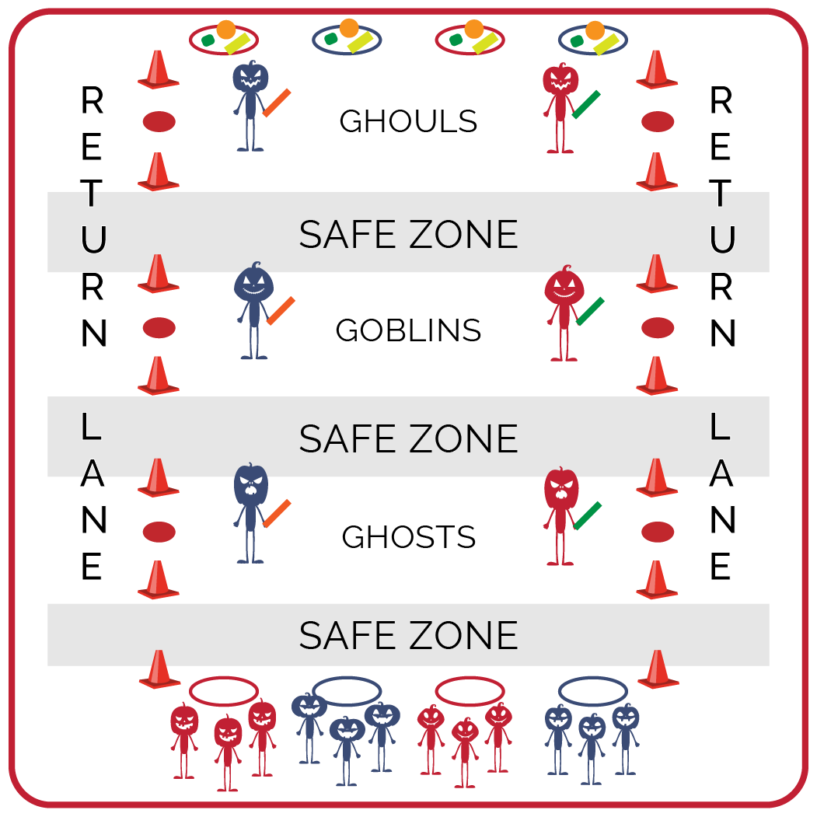
Equipment:
- Variety of objects (e.g., bean bags, foam balls)
- 6 cut foam noodles
- Red spots or dome cones to mark “Tag Zones”
- Medium sized cones for returning lanes
- 2 hoops per team of 3
- Music and music player
Set-Up:
- Create teams of 3 students. 2 teams will begin in middle as defenders (total of 6 students). 2 defenders will be in each tagging zone with foam noodles: 1st zone are Ghosts; 2nd zone are Goblins; 3rd zone are Ghouls.
- Set up a starting line with a hoop for each team.
- On opposite end, place hoops with a variety of objects.
- Use medium sized cones to delineate the return lanes and low-profile cones to delineate the 3 tagging zones on both sides of activity space.

ACTIVITY PROCEDURES
- This activity is called The Spooky Pumpkin Patch Run. The object is to earn points by collecting items for your team by making it through all 3 tag zones without being tagged.
- Each team will line up behind a hoop. On the start signal, one person from each team will attempt to make it across the Spooky Pumpkin Patch (all 3 tag zones) to the other side of the activity area without being tagged. Only one person from each team can attempt to go through at a time.
- Defenders cannot leave their assigned zone. Ghosts must stay in zone 1, Goblins must stay in zone 2, and Ghouls must stay in zone 3.
- If you are tagged in any tag zone, you will move to the outside return lanes to go back to your team’s hoop. There are safe zones between each tag zone as you move through.
- If you make it through without being tagged collect one object from a hoop and use the return lanes to come back. (Teacher Note: assign points for each item collected: orange item = 7 points; green item = 5 points; yellow item = 3 points, etc.)
- You will continue to send one teammate at a time through the tag zones to collect as many objects as you can. The 2 teams with the most points will be our defenders for the next round.

DEBRIEF QUESTIONS
- DOK 1: What does positive and encouraging communication sound like?
- DOK 2: How does positive and encouraging communication impact the way a team interacts and works together?

PRIORITY OUTCOMES
Social Interaction:
- Grades K-2: Discusses ways to encourage others to be physically active with friends.
- Grades 3-5: Describes the positive social interactions that come when engaged with others in physical activity.

