Pumpkin Golf

STUDENT TARGETS
- Skill: I will focus on accuracy and distance when chipping a golf ball.
- Cognitive: I will identify ways to chip for accuracy and distance.
- Fitness: I will stay actively engaged throughout the activity.
- Personal & Social Responsibility: I will use positive self-talk and encouraging language with my partner when facing a challenge.

EQUIPMENT & SET-UP | 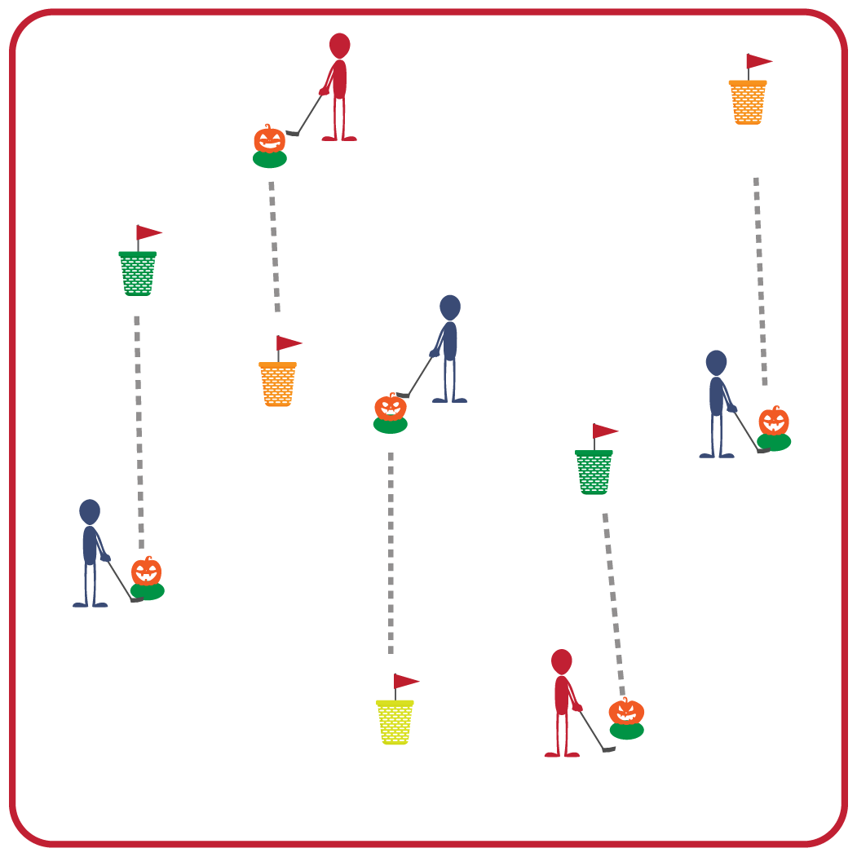
Equipment:
- Bucket Golf 6-Hole or 9-Hole Set
- 1 club and one plastic golf ball per 2 students
- 1 spot marker per 2 students (or hitting mats) if indoors

Set-Up:
- Set up the Pumpkin Golf course so that each hole is 10-20 feet in distance from the tee box to the bucket. Buckets are pinned to the ground using the flag sticks; you can use a gymnastics mat (pin goes in the seam) to pin the buckets indoors.
- Design the course so the end of each hole is where the next hole begins.
- Create groups of 2 students; each pair begins by a tee box with a club and a ball.
ACTIVITY PROCEDURES
- This activity is called Pumpkin Golf. The object of the game is to keep your score as low as possible. This happens by chipping the pumpkin (ball) into the bucket or needing as few hits as possible to get to the bucket.
- Every hole in Pumpkin Golf is a par 3, which means you have 3 shots to get to the bucket to get a par for that hole. Hitting any part of the bucket will end the hole, but chipping into the bucket subtracts one stroke off your score for that hole. For example, if you hit the outside of the bucket on your third shot your score would be a 3 for that hole. If you hit the pumpkin (ball) into the bucket on your third shot, your score would be a 2 for that hole.
- On the start signal, one partner will attempt to chip the pumpkin (ball) into the bucket. Once they have hit the ball into the bucket or hit any part of the bucket, you will determine their score and switch roles. Once both of you have completed that hole, you will move on to the next one. All of the tee boxes have numbers to help guide you from one hole to the next as you complete the course.
- When you hear the stop signal, we will all find a new partner before we play a second round.

DEBRIEF QUESTIONS
- DOK 1: What does it mean to find something challenging?
- DOK 2: Sometimes golf can be a challenging activity. What are some examples of positive self-talk or encouraging language that you experienced or observed during the activity?

PRIORITY OUTCOMES
Personal Challenge:
- Grades K-2: Acknowledges that some physical activities are challenging/difficult.
- Grades 3-5: Discusses the challenge that comes from learning new physical activities.

