Pumpkin Races

STUDENT TARGETS
- Skill: I will safely pace my movements to match my teammates.
- Cognitive: I will find opportunities to praise the performance of my teammates.
- Fitness: I will stay actively engaged throughout the activity.
- Personal & Social Responsibility: I will accept all teammates and recognize their contributions to our team.

EQUIPMENT & SET-UP | 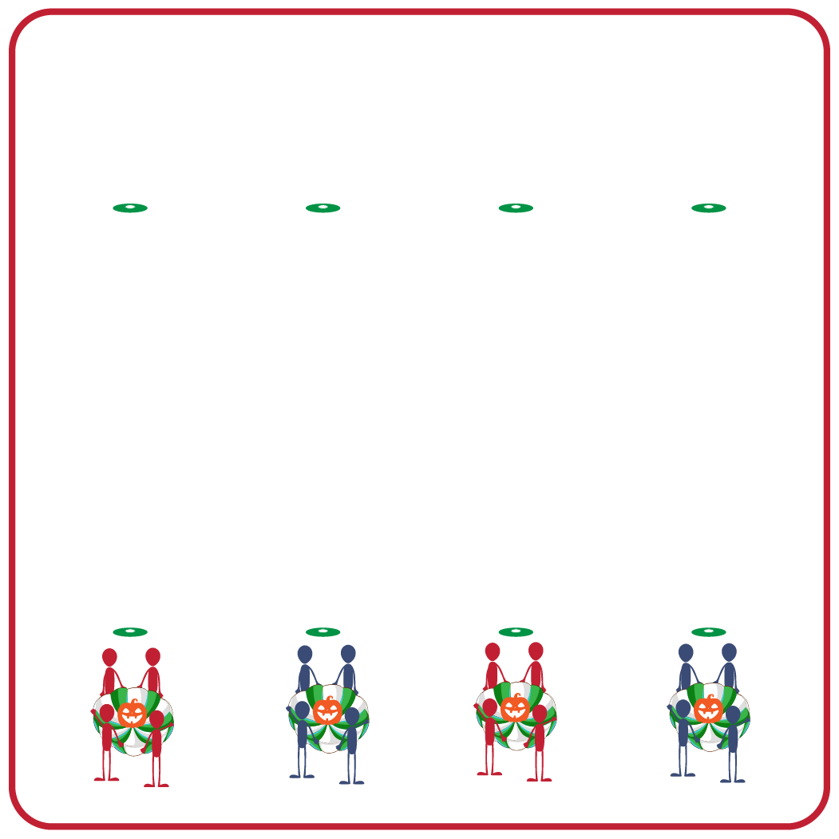
Equipment:
- 2 low-profile cones per group
- 1 partner parachute per group
- 1 foam ball per group

Set-Up:
- Use low-profile cones to create 2 parallel lines on opposite sides of the activity area.
- Create groups of 4 students.
- Each group starts behind their own cone, facing the cone on the other side of the area.
- Each group will have a partner parachute and a foam ball.

ACTIVITY PROCEDURES
- It’s time for our Pumpkin Races! The object of the game is for each team to race their pumpkin around the cone on the opposite side of the activity area.
- On the start signal, each group will hold one corner of the partner parachute, balancing their pumpkin (foam ball) on top of it. Each teammate must be holding onto the parachute at all times.
- Your group will start walking as a group toward the opposite cone, move safely around it, and back to the starting cone. The pumpkin must stay balanced on the partner parachute. If it falls off your team must start that lap over at the starting cone.
- Your team will get one point for each successful pumpkin race that is completed! Teams will see how many successful pumpkin races can be completed in 2 minutes.
- We will now try to race using some different locomotor movements. We will race again while jogging, skipping, and galloping to see how many points your team can earn.
- Each team needs to remember to keep all of their teammates safe by moving together as a group and communicating with their teammates as they move.

DEBRIEF QUESTIONS
- DOK 1: How can you recognize good effort or a good performance?
- DOK 2: How would your praise good effort? How would you praise a good performance?
- DOK 3: How is praise related to feeling accepted by your teammates?

PRIORITY OUTCOMES
Working with Others:
- Grades K-2: Shares equipment and space with others.
- Grades 3-5: Accepts, recognizes, and actively involves others with both higher and lower skill abilities into physical activities and group projects.

