Toss the Pumpkin

STUDENT TARGETS
- Skill: I will use correct form for an underhand toss.
- Cognitive: I will focus my attention on the challenge in an effort to improve my team’s score.
- Fitness: I will be actively engaged in this challenge.
- Personal & Social Responsibility: I will discuss the benefits of social interaction and being physically active with family and friends.

EQUIPMENT & SET-UP | 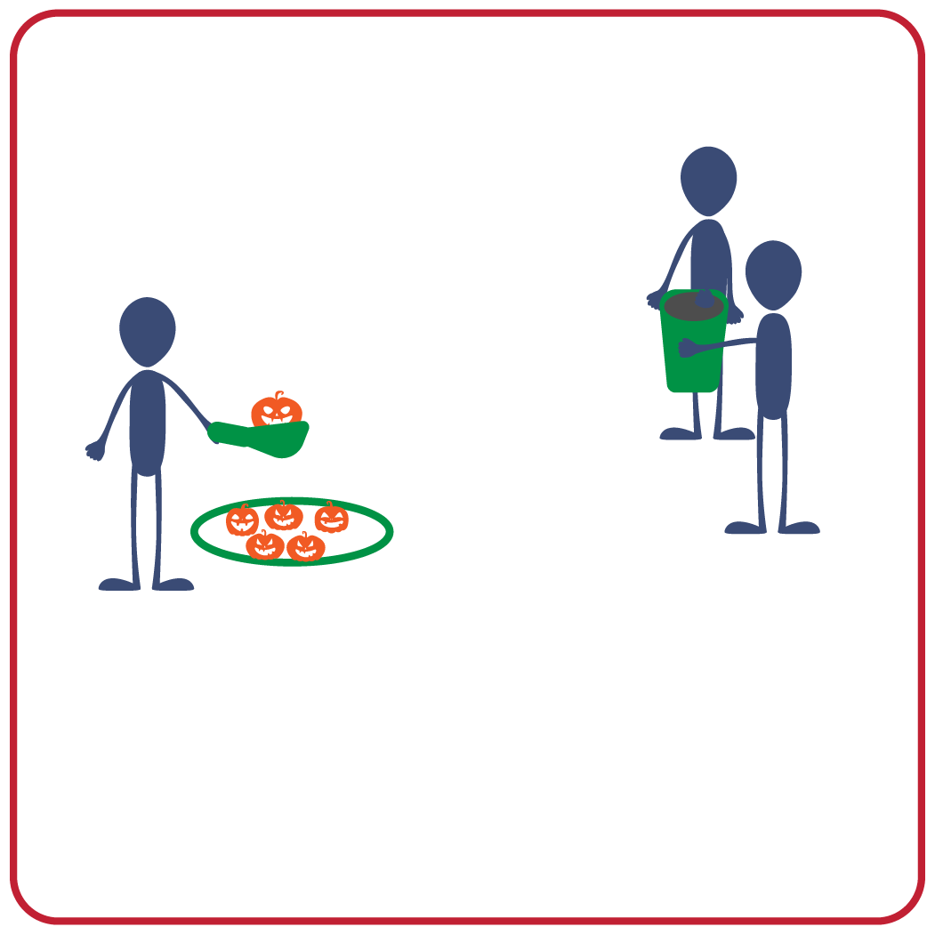
Equipment:
- 1 bucket per team
- 1 scoop per team
- 5 to 10 wiffle balls per team
- 1 hoop per team
- Music and music player
Set-Up:
- Create teams of 3 players.
- Each team has space with wiffle balls placed in a hoop and a bucket 5 paces away from the hoop.
- One teammate is the tosser and stands behind the hoop and wiffle balls with a scoop in their throwing hand.
- The other two teammates are bucket holders and stand 5 paces away with the bucket opening facing the tosser.
ACTIVITY PROCEDURES
- This activity is called Toss the Pumpkin! The object of the game is for your team to use the bucket to catch as many pumpkins (wiffle balls) as you can.
- Get ready with 2 players holding the bucket, and 1 player 5 paces away with a scoop, ready to toss the pumpkin (wiffle ball) into the bucket.
- On the start signal, the tosser makes the first toss from the scoop and quickly picks up another pumpkin for the next toss. The bucket holders count catches aloud to keep track of the score.
- Bucket holders can move the bucket to help the tosser and make the catch. If your team tosses all of your pumpkins successfully in the bucket before time expires, bucket holders quickly dump the pumpkins back into the hoop and play continues. Pumpkins that miss the bucket and fall to the ground can be collected and tossed again.
- We will play for 3 minutes each round. We will play three rounds so teammates can rotate positions until everyone has had the opportunity to be the tosser.
- At the end of the three rounds, teams will count up their total points to see which team caught the most pumpkins!

DEBRIEF QUESTIONS
- DOK 1: What is teamwork? What does it look like? What does it sound like?
- DOK 2: How does teamwork affect how well your team performs in physical activity challenges?
- DOK 3: How does growth mindset affect how well you enjoy physical activity and positively interact with a team?

PRIORITY OUTCOMES
Social Interaction:
- Grades K-2: Discusses the enjoyment of playing with family and friends.
- Grades 3-5: Describes the positive social interactions that come when engaged with other in physical activity.

