SEE IT, DEFEND IT

STUDENT TARGETS
- Skill: I will move to create open space when I do not have an object in my hand.
- Cognitive: I will describe what it means to make a commitment to a team.
- Fitness: I will stay actively engaged throughout in order to increase my heart rate.
- Personal & Social Responsibility: I will discuss actions that show commitment to working toward a team goal.

EQUIPMENT & SET-UP | 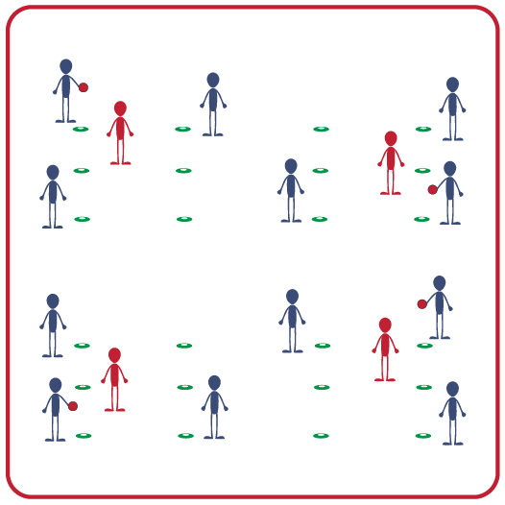
Equipment:
- 6 low profile cones per group
- 1 tossable object per group (offer a variety for students to choose from: foam ball, football, etc.)

Set-Up:
- Create activity areas that are approximately 15-20 feet.
- Place the low-profile cones on the ground so that they look like the number 6 on a die, with three on each side.
- Create groups of 3-4 students, with each group in their own activity area.
- Each group chooses one object to throw from the options provided.
ACTIVITY PROCEDURES
- This activity is called See It, Defend It. The object of the game is to move and create open space so that teammates can throw you a pass.
- Each person in your group will begin standing by one of the 6 cones, which will leave a few cones that are empty. One person will begin holding the object you have chosen to use.
- On the start signal, the person with the object will throw it to someone else in the group. After throwing the object, the thrower will immediately move to another open cone. This will continue as you work to see how many successful throws your team can complete in a row.
- We will now add in a defender who can try and disrupt the passes in a “keep away” style of game. One of your teammates will stay in the middle of the activity area (and not by a cone) until they can intercept or knock the ball away during a pass. But the defender cannot guard the person with the ball. Once they are able to disrupt a pass, they will trade spots with the thrower. Teachers: switch out the defender after about 1 minute if they were not able to successfully disrupt a pass.
- When you hear the stop signal, we will discuss our successes and challenges before we play again.

GRADE LEVEL PROGRESSION
- Level 1: Play as described above, with a focus on committing as a team to achieve the highest number of passes in a row as possible.
- Level 2: Allow defenders to guard the person with the object, with a focus on teammates taking leadership roles that help improve the team.

TEACHING CUES
- Cue 1: Step in opposition when throwing a pass to a teammate.
- Cue 2: Communicate with respectful and encouraging language.
- Cue 3: Move to an open cone as quickly as possible after each throw and get back into an athletic stance that is ready to receive a pass.
SEE IT, DEFEND IT (continued…)

UNIVERSAL DESIGN FOR LEARNING
- UDL 1: Increase/decrease the activity space as needed.
- UDL 2: Use modified equipment as needed (e.g., beeper ball, beach ball).
- UDL 3: Use verbal cues and visual aids along with demonstrations.
- UDL 4: Use peer partners as appropriate.

ACADEMIC LANGUAGE
Open Space, Close Space, Commitment, Communication, Teamwork

PRIORITY OUTCOMES
Working with Others:
- (Grades 9-12) Uses communication skills and strategies that promote positive team/group dynamics.

DEBRIEF QUESTIONS
- DOK 1: Can you describe what it means to make a commitment to a team?
- DOK 2: What does it look like and sound like to commit to creating positive team culture? How many actions can you list that show commitment to working toward a team goal?
- DOK 3: Why are communication and commitment important within a team when working to create space during an invasion game? What strategies did your team use that were successful?

