FLAG 4 TO SCORE

STUDENT TARGETS
- Skill: I will apply offensive and defensive strategies to assist my team to move the ball and score.
- Cognitive: I will describe how to be accountable for my words and actions.
- Fitness: I will stay actively engaged throughout the game in order to increase my heart rate.
- Personal & Social Responsibility: I will demonstrate respect for myself and my classmates by showing accountability for my words and actions during the game.

EQUIPMENT & SET-UP | 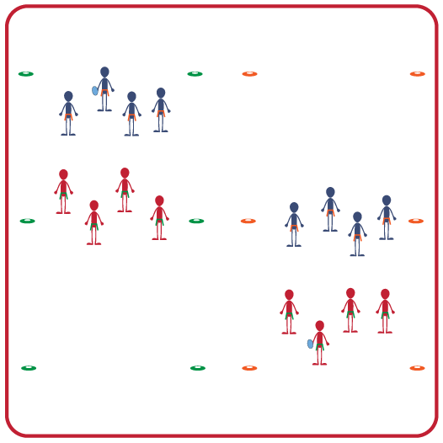
Equipment:
- Cones to create an activity space for each group
- 1 flag belt per student
- 1 ball for each group (offer a variety of sizes and weights for students to choose from: foam ball, football, etc.)
Set-Up:
- Create activity areas that are approximately 20-30 feet using cones.
- Create teams of 4-5 students, with 2 even teams in each activity area.
- All students begin wearing a flag belt, and each group chooses one object to throw from the options provided.
ACTIVITY PROCEDURES
- This activity is called Flag 4 to Score! This is a modified game of flag football, where the object is to score a touchdown with a maximum of only 4 passes. (Teams cannot run the football – only pass.)
- Teams play Rock, Paper, Scissors to determine which team will get the ball first. Play starts on the winning team’s endline. Both teams line up like football teams set for a play. One person on offense is the quarterback, all other teammates are receivers. Change quarterbacks with each possession.
- The quarterback says “Ready, set, hike!” to begin play. Receivers attempt to get open for a pass. Defenders cannot “rush” the quarterback, but can stand and move their arms to try and block/deflect.
- If a pass is completed, the receiver is allowed to take 4 steps maximum with the ball. If their flag is pulled, they stop immediately and teams then line up for another play from that spot. Repeat until the team scores or runs out of downs (more than 4 passes).
- On an interception, the other team takes possession at the spot where it is caught.
- If a team is on 4th down, they have the option of going for the score or “punting.” Punting simply gives the other team the ball at their end to start.
- If a team fails to score on 4th down, play begins at the spot of the last play. So, it may be an advantage to punt if the offensive team has failed to move the ball up field.

GRADE LEVEL PROGRESSION
- Level 1: Focus on teams communicating in a positive way to hold each other accountable for their words and actions.
- Level 2: Defenders can now rush the quarterback after a “7 Mississippi” count. Challenge teams to lead by example and demonstrate respect to not rush the quarterback early.

TEACHING CUES
- Cue 1: Communicate with your team using positive language.
- Cue 2: Evade defenders to create space, and shadow attackers to deny space.
FLAG 4 TO SCORE (continued…)

UNIVERSAL DESIGN FOR LEARNING
- UDL 1: Increase/decrease the activity space as needed.
- UDL 2: Allow student choice of equipment that is a variety of sizes, colors, and weights.
- UDL 3: Use verbal cues and visual aids along with demonstrations.
- UDL 4: Use peer partners as appropriate.

ACADEMIC LANGUAGE
Pass, Incomplete, Boundary, Teamwork, Accountability

PRIORITY OUTCOMES
Working with Others:
- (Grades 9-12) Uses communication skills and strategies that promote positive team/group dynamics.

Social Interaction:
- (Grades 9-12) Identifies and evaluates the opportunity for social interaction and social support in self-selected physical activities.

DEBRIEF QUESTIONS
- DOK 1: How would you describe being accountable for your words and actions?
- DOK 2: Why is it important to be accountable with your teammates?
- DOK 3: Describe how you could communicate in a positive and respectful way with a teammate who you feel isn’t owning their responsibilities.

