SWITCH
STUDENT TARGETS
- Skill: I will demonstrate throwing and catching cues to pass and shoot accurately.
- Cognitive: I will identify how focus is related to team success.
- Fitness: I will remain actively engaged throughout the activity.
- Personal & Social Responsibility: I will demonstrate the concept of Team > (greater than) Self by focusing on team successes instead of individual successes during the activity.

EQUIPMENT & SET-UP | 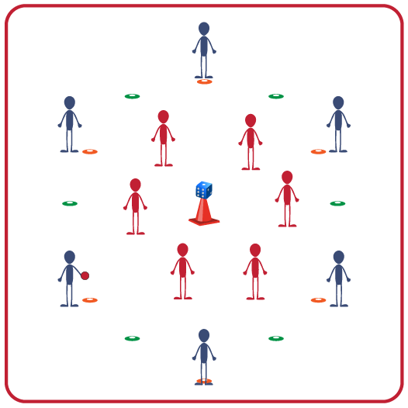
Equipment:
- 1 target per 12 students (cone with a ball or die on top)
- 1 ball per 12 students
- 8-12 spot markers per 12 students
- 6 pinnies or colored wristbands (same color) per 12 students
Set-Up:
- Create 1 activity area per 12 students with a target in the center of each area.
- Use spot markers to create a shooting circle 6-8 feet from target. This delineates the offensive area (outside of the spots) and the defensive area (inside the spots).
- Create teams of 6 students. One team begins inside the spots on offense and one team begins outside the spots on defense.
- One team will begin with pinnies or colored wristbands to identify their team.
ACTIVITY PROCEDURES
- This activity is called Switch. The object of the game is for the offense to score a goal (teacher’s choice: soccer, handball, or basketball style). Three passes must be made before a shot is taken at the target.
- When a goal is scored or an interception is made (defense gains possession), players yell “SWITCH!” On this signal, teams switch positions; offense becomes defense and defense becomes offense. But remember, play doesn’t stop while players rotate in/out so you will need to move quickly and be ready!
- Defensive teams must stay inside the spot markers but may move throughout the defensive area. Offense must stay outside spot markers but may move throughout the offensive area. If a player breaks this rule 3 times, she/he must sit out for 1 minute while the other team has a Power Play.
- Continue play until you hear the stop signal.

GRADE LEVEL PROGRESSION
- Level 1: Play as described above.
- Level 2: Add a second ball to the activity. Teams will need to be extra focused to ensure safety and success with the second ball in play.

TEACHING CUES
- Cue 1: Move quickly when switching between offense and defense to get into position.
- Cue 2: Use communication skills to help your team work together successfully.
- Cue 3: Stay focused in order to anticipate offensive/defensive positioning and scoring opportunities.
SWITCH (continued…)

UNIVERSAL DESIGN FOR LEARNING
- UDL 1: Increase/decrease the size of the activity space as needed.
- UDL 2: Use modified equipment as needed.
- UDL 3: Use verbal cues and visual aids, along with demonstrations.
- UDL 4: Use peer partners as appropriate.
- UDL 5: Allow teammates to hand ball off rather than passing/tossing if needed.

ACADEMIC LANGUAGE
Pass, Shoot, Advantage, Accuracy, Focus

PRIORITY OUTCOMES
Manipulative Skills:
- (Grades 9-12) Demonstrates competency and/or refines activity-specific movement skills in two or more lifetime activities.

Working with Others:
- (Grades 9-12) Uses communication skills and strategies that promote positive team/group dynamics.

DEBRIEF QUESTIONS
- DOK1: What is focus and how is it related to success?
- DOK 2: What does it look like when a person is focused on team results? What team focused strategies could help you gain an offensive advantage?
- DOK 3: What does Team > (greater than) Self mean? How can you demonstrate that concept during the game of Switch?

