ULTIMATE FROLF

STUDENT TARGETS
- Skill: I will use a combination of skills and movement concepts to create open space.
- Cognitive: I will describe how trust between teammates can lead to team success.
- Fitness: I will remain actively engaged in order to enhance my fitness level.
- Personal & Social Responsibility: I will work to earn the trust of my teammates during this activity.

EQUIPMENT & SET-UP |  | 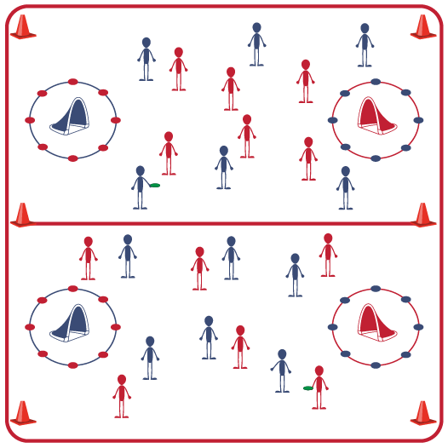
Equipment:
- 2 goals per 12 students
- 1 foam disc per 12 students
- 12 spot markers per goal
- 4 large cones per activity space
- 6 pinnies or colored wrist bands per 12 students
Set-Up:
- Create a large activity area using large cones.
- Set up goals 5-8 feet from each end line.
- Create a shooting circle around each goal using spot markers.
- Create teams of 6 students, with 2 teams beginning in each activity space.
- One team in each activity area will begin wearing pinnies or colored wrist bands.
ACTIVITY PROCEDURES
- This activity is called Ultimate Frolf, which is played similarly to Team Handball but with a foam disc. The object of the game is for your team to score more points than your opponent scores before the stop signal. You’ll use the skills and strategies we’ve learned in previous activities to work as a team on both offense and defense.
- There are a few important rules:
- A point is scored each time the disc goes in the other team’s goal.
- Play begins with a throw from midfield: the starting player stands at midfield and passes to a teammate. This starts the game and is the way players should restart play after each goal.
- If the disc goes out of bounds, restart with a throw-in: a player standing on the sideline or end line throws the foam disc to a teammate who is in bounds.
- Defense must be 5 paces away from the player performing every throw-off and throw-in.
- No contact between players is allowed. Defense must stay an arms-length from the player with the disc.
- Defense cannot touch the disc when an offensive player has control.
- Passes and shots can be intercepted/knocked down with hands and arms.
- Offense can take 3 steps with the disc and/or hold the disc for no more than 3 seconds.
GRADE LEVEL PROGRESSION
- Level 1: Complete activity as described above. Challenge teams to work on building trust by communicating with respect during the game.
- Level 2: Change possession if the ball hits the ground after a pass (a shot at the goal is not considered a pass).
TEACHING CUES
- Cue 1: Move quickly when switching between offense and defense to get into position.
- Cue 2: Use positive communication to encourage teammates and help your team work together.
ULTIMATE FROLF (continued…)

UNIVERSAL DESIGN FOR LEARNING
- UDL 1: Increase/decrease the size of the activity space as needed.
- UDL 2: Use modified equipment as needed.
- UDL 3: Use verbal cues and visual aids, along with demonstrations.
- UDL 4: Use peer partners as appropriate.
- UDL 5: Allow teammates to hand ball off rather than passing/tossing if needed.

ACADEMIC LANGUAGE
Movement Concepts, Trust, Communication, Strategy

PRIORITY OUTCOMES
Movement Concepts:
- (Grades 9-12) Uses movement concepts and principles to analyze and improve performance of self and others in a selected skill.

DEBRIEF QUESTIONS
- DOK1: What is trust and why is trust an important part of being a team?
- DOK 2: What does it look like to be open to trusting others on your team?
- DOK 3: Describe a scenario when you felt like you or a teammate were being trustworthy during the game. How did it impact the overall success of your team?

