SMASH

STUDENT TARGETS
- Skill: I will move into open space to get open for a pass from my teammate.
- Cognitive: I will discuss which offensive strategies and tactics were successful during game play.
- Fitness: I will increase my heart rate by actively engaging in activity.
- Personal & Social Responsibility: I will demonstrate respect for myself and my classmates by following the rules of the game and encouraging others.

EQUIPMENT & SET-UP | 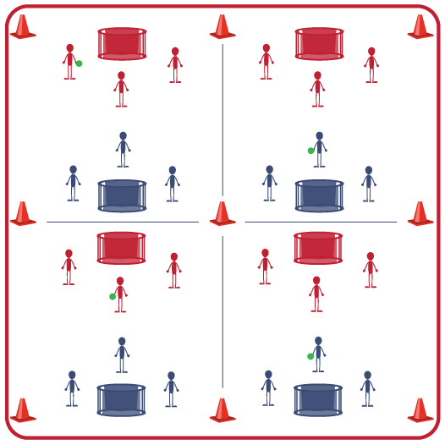
Equipment:
- 1 all-sport ball per 6 students
- Cones to create grids per 6 students
- 3 pinnies or colored wristbands per 6 students
- 2 multi-goals per grid

Set-Up:
- Create 1 large grid per 6 students.
- Position a multi-goal at each end of the grid.
- Create teams of 3 and have 2 teams start at each grid. One team of 3 with pinnies or colored wristbands.
- Teams at each grid will play Rock, Paper, Scissors to see who begins with the ball.

ACTIVITY PROCEDURES
- This activity is called Smash. The goal of this activity is to score more points than your opponent during each 5-minute game.
- On the start signal, each team will begin the game near their goal and one team will start with the ball. The person with the ball will self-toss and strike to a teammate. That teammate will catch it, self-toss, and strike to another teammate as they advance the ball down the activity space. The other team will play defense and attempt to disrupt the attacking team. If the ball hits the ground it is a turnover.
- To score, the ball must be hit into the goal. Throws, kicks, etc., do not count as a score.
- You will play an opposing team for 5 minutes. A team must complete at least 3 passes before attempting to score. Teams must use “soft defense” when guarding the person with the ball and should be an arm’s length away (approximately 3 feet).
- The team with the most points at the end of each game will stay, and the opposing team will move and find a new team to play against. If the score is tied on any court when time expires, play Rock, Paper, Scissors to determine the winner.
- We will continue to play until time runs out. The team who earned the most total points will be the winners!
GRADE LEVEL PROGRESSION
- Level 1: Identify courts/grids that are higher intensity and lower intensity. Allow student choice of intensity level, with a focus on setting them up for challenge, success, and fun.
- Level 2: Play as described above, but without catching. Teams must continuously strike the ball.
TEACHING CUES

- Cue 1: Communicate with teammates to assist with successfully moving the ball on offense.
- Cue 2: Focus on control and accuracy when striking the ball.
SMASH (continued…)

UNIVERSAL DESIGN FOR LEARNING
- UDL 1: Increase/decrease the size of the activity space as needed.
- UDL 2: Use modified equipment as needed (e.g., different weights, colors, and sizes).
- UDL 3: Use verbal cues and visual aids along with demonstrations.
- UDL 4: Use peer partners as appropriate.

ACADEMIC LANGUAGE
Target, Teamwork, Strategy, Communication, Accuracy

PRIORITY OUTCOMES
Movement Concepts:
- Creates open space to create an advantage or with a specific purpose in dance, fitness, and sports activities.
- Analyzes movement and activity situations and makes adjustments with a specific purpose or to create a strategic advantage.

DEBRIEF QUESTIONS

- DOK 1: What is a strategy?
- DOK 2: Share an offensive strategy your team used and if it was successful.
- DOK 3: How is teamwork related to successfully executing a strategy? Give specific examples.

