LEAF LAUNCHERS

STUDENT TARGETS
- Skill: I will demonstrate safe behaviors during the activity.
- Cognitive: I will discuss positive interactions that come through being physically active with others.
- Fitness: I will increase my heart rate during this activity.
- Social/Emotional: I will discuss ways to help and encourage others.

EQUIPMENT & SET-UP | 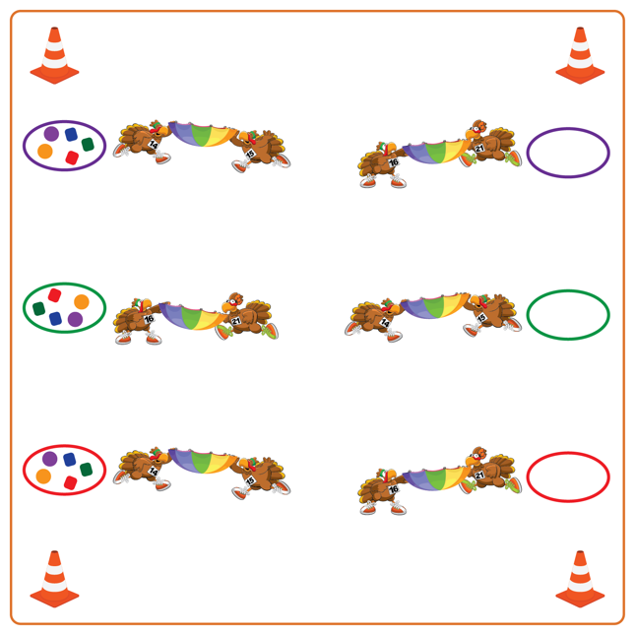
Equipment:
- 2 partner parachutes per team
- 2 hoops per team
- Variety of tossables (foam balls, fluff balls, bean bags, etc.)
- Low profile cones for boundaries
Set-Up:
- Create teams of 4 students.
- Each team’s 2 hoops should be placed about 10-15 feet apart. One hoop should have 5-10 tossables, and the other hoop will be empty.
- Place 1 partner parachute by each hoop.
- 2 students will begin next to each hoop, facing their teammates and holding the partner parachute.

ACTIVITY PROCEDURES
- This activity is called Leaf Launchers! We are going to work on showing gratitude and kindness to our neighbors by helping them pick up the leaves in their yard. The object of the game is for each team to work together to remove as many leaves as possible from their neighbor’s yard.
- When the music starts, the partners that are next to a hoop with leaves (tossable items) will place one leaf on their parachute. They will work together to launch that leaf to their teammates who will try to catch it on the other parachute. If the leaf is caught, it goes inside the hoop by the partners who caught it. If it isn’t caught, it goes back to the original hoop so the team can try again.
- Teams will continue to launch one leaf at a time to their partners until all the leaves have been removed from the neighbor’s yard.
- When the music stops, we will count to see which team removed the most leaves and then trade roles (e.g., tossers become catchers, catchers become tossers) before we try again.

DEBRIEF QUESTIONS
- DOK 1: What are some things you are grateful for?
- DOK 2: What are some ways you can show someone, with your words or actions, that you are grateful for them?
- DOK 3: How does being able to support and help others with your friends impact your willingness to do things like help remove leaves from a neighbor’s yard?

PRIORITY OUTCOMES
Social Interaction:
- Grades K-2: Discusses ways to encourage others to be physically active with friends.
- Grades 3-5: Describes the positive social interactions that come when engaged with others in physical activity.
- Grades 6-8: Demonstrates the importance of social interaction by helping and encouraging others, avoiding trash talk, and providing support to classmates.

