TRAP THE TURKEY

STUDENT TARGETS
- Skill: I will work cooperatively with my team to trap the bean bag under the cone.
- Cognitive: I will discuss why sharing equipment and space safely is important in physical education.
- Fitness: I will describe at least 1 personal benefit to actively participating in physical education.
- Social/Emotional: I will use positive and encouraging words with my teammates.

EQUIPMENT & SET-UP | 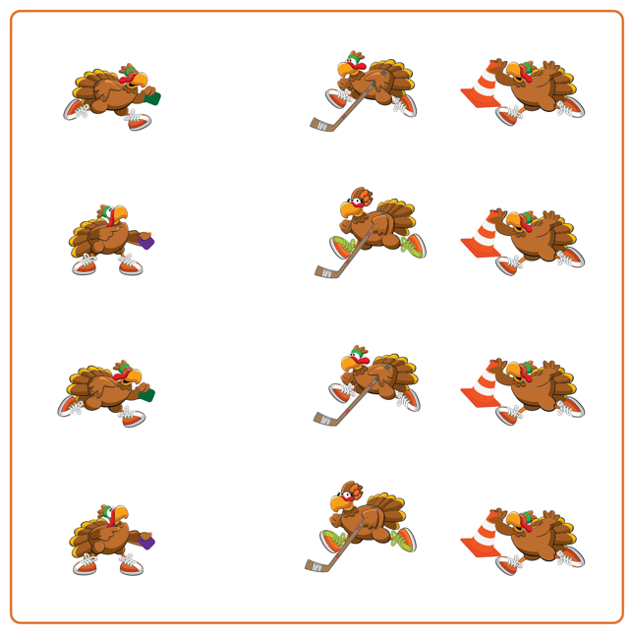
Equipment:
- 1 cone per team
- 1 bean bag (or foam ball) per team
- 2 spot markers per team
- 1 hockey stick per team

Set-Up:
- Create teams of 3 students.
- Each team will place their 2 spot markers about 10 feet apart. The passer will begin on one spot marker with a bean bag, and the trapper will begin on the other spot marker holding the cone.
- The third teammate will be in the middle of the 2 spot markers with a hockey stick and will begin facing the student holding the bean bag (passer).
ACTIVITY PROCEDURES
- This activity is called Trap the Turkey! The object of the game is to pass and trap the turkey (bean bag) under the cone.
- When the music starts, the passer (student with the bean bag) will slide the bean bag on the floor so that the trapper (student with the cone) can trap it under the cone. But watch out, because the defender in the middle will use their hockey stick to try and stop the bean bag from getting past them to the Trapper!
- If the Passer and Trapper are able to trap the turkey (bean bag) under the cone successfully, they each earn 1 point. If the Defender is able to intercept the bean bag with their hockey stick, then they receive 1 point.
- The passer and trapper get 3 attempts to trap the turkey, and then you will switch roles. Passer becomes the Defender, the Defender becomes the Trapper, and the Trapper becomes the Passer.
- When the music stops, we will see who was able to earn the most points.

DEBRIEF QUESTIONS
- DOK 1: What is an example of a responsible behavior?
- DOK 2: Why is it important to use responsible behaviors during physical education class?
- DOK 3: What are some ways that our behaviors can impact safety during our physical activities?

PRIORITY OUTCOMES
Personal Responsibility and Safety:
- Grades K-2: Follows directions for safe participation and proper use of equipment without reminders.
- Grades 3-5: Exhibits responsible behavior in independent group situations.
- Grades 6-8: Engages in physical activity with responsible interpersonal behavior (e.g., peer to peer, student to teacher).

