SLEEPING GIANTS

STUDENT TARGETS
- Skill: I will listen to and follow all teacher instructions.
- Cognitive: I will think about and demonstrate activities that I like to do outside of physical education class.
- Fitness: I will participate in physical education at a level that increases my heart rate and improves my health.
- Personal & Social Responsibility: I will move safely around the activity area, staying in control of my movement and watching out for my classmates.

EQUIPMENT & SET-UP | 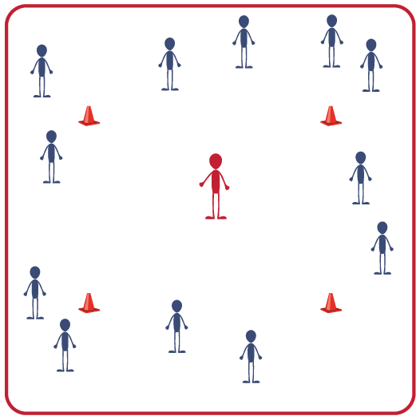
Equipment:
- 4 to 16 cones to create a running loop/track
- Music and music player (with 30 second music intervals)

Set-Up:
- Use cones and task tents to set up a medium-sized running loop in the activity area.
- Scatter students around the running loop.
ACTIVITY PROCEDURES
- It’s time for a Run for Fun game called Sleeping Giants! In this game, think about physically active games that you like to play outside of physical education – like on the playground or at home.
- When the music starts, all giants (all students) will start to jog around the running loop.
- When the music stops, I will call out “SLEEPING GIANTS IT’S TIME TO DREAM!” All giants will lay down on the ground and pretend to sleep. While you’re sleeping you’ll think/dream about a fun physical activity that you like to do outside of physical education.
- When you hear, “WAKE UP! WHAT DID YOU DREAM ABOUT?” You’ll stand up and pretend to play the activity that you were dreaming about. Remember to keep your movements safe and stay balanced on your feet.
- When the music starts again, continue jogging around the running loop. Each time we sleep, dream and play – think of a new activity that you like to do on the playground or at home.

GRADE LEVEL PROGRESSION
- K: Make a list of activities that students can choose from before starting the activity.
- 1 & 2: Play the activity as described above.

TEACHING CUES
- Cue 1: Keep ears and eyes active. Stay aware of classmates as you move around our running loop.
- Cue 2: Control all of your movements in order to keep your classmates safe.

SLEEPING GIANTS (continued…)

UNIVERSAL DESIGN FOR LEARNING
- UDL 1: Create a list of activities that your students enjoy. Choose one that all students will “dream” about.
- UDL 2: Use brightly colored cones and markers to create the running loop.
- UDL 3: Use a visual cue for starts, stops and changes in speed.

ACADEMIC LANGUAGE
Balance, Control, Jog, Physical Activity, Safety

PRIORITY OUTCOMES
Personal Enjoyment:
- (K) Identifies physical activities that are enjoyable.
- (1) Describes positive feelings that result from physical activity participation.
- (2) Discusses personal reasons for enjoying selected physical activities.

Personal Responsibility & Safety
- (K) Follows directions for safe participation and proper use of equipment with minimal reminders.
- (1) Follows directions for safe participation and proper use of equipment without reminders.
- (2) Works independently and safely in physical education.

DEBRIEF QUESTIONS
- DOK 1: Let’s make a list of all of the activities that we dreamt about.
- DOK 2: Why did you choose the game that you dreamt about?
- DOK 3: How do you feel when you play the game that you chose?

