ANIMAL RUN

STUDENT TARGETS
- Skill: I will change the speed of my movement to match the teacher’s instructions.
- Cognitive: I will listen and watch for cues from the Animal Run Cards and change my speed based on those cues.
- Fitness: I will discuss the changes in my heart rate as I move fast and slow around the running loop.
- Personal & Social Responsibility: I will move safely around the running loop, staying in control of my speed and my body’s movement.

EQUIPMENT & SET-UP | 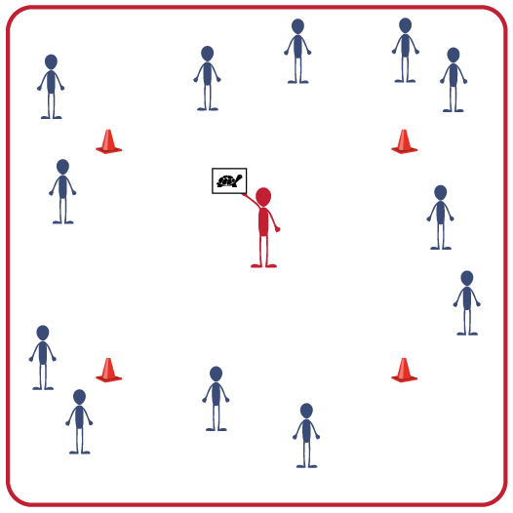
Equipment:
- 4 to 16 cones to create a running loop/track
- Animal Run Cards
- Music and music player

Set-Up:
- Use cones to set up a medium-sized running loop in the activity area.
- Scatter students around the running loop.
ACTIVITY PROCEDURES
- It’s time to have fun with an Animal Run!
- The object is to run around the track while changing speeds to imitate one of 4 animals: Turtle, Pig, Horse, and Cheetah.
- When the music starts, everyone will begin moving around the running loop at a turtle’s pace. Every 30 seconds, I’ll hold up a new Animal Run Card and call out the animal’s name. Change the pace of your movement to match the speed of the animal.
- As you move around the running loop, pay attention to the speed of your heart rate. Does your heart beat faster or slower depending on what animal you’re imitating?

GRADE LEVEL PROGRESSION
- K: Focus on changing speeds from slow to fast. Students can walk to demonstrate slow and run to demonstrate fast.
- 1: Emphasize jogging and a variation of running. Students now walk, jog and run to demonstrate different speeds.
- 2: Increase the size of the running loop. Create longer intervals of jogging and running and shorter intervals of walking.

TEACHING CUES
- Cue 1: Keep your balance. If you feel like you’re losing your balance, slow down.
- Cue 2: Find your heart beat. Feel it on your chest, wrist or neck.

ANIMAL RUN (continued…)

UNIVERSAL DESIGN FOR LEARNING
- UDL 1: Use visual aids with photos of each animal.
- UDL 2: Use verbal cues and demonstrations in addition to the visual aids.
- UDL 3: Use brightly colored cones and markers to create the running loop.

ACADEMIC LANGUAGE
Fast, Heart Rate, Jog, Run, Slow, Walk

PRIORITY OUTCOMES
Fitness Knowledge:
- (K) Recognizes that when you move fast, your heart beats faster and you breathe faster.
- (1) Identifies the heart as a muscle that grows stronger with exercise/play and physical activity.
- (2) Identifies physical activities that contribute to fitness.

Personal Responsibility & Safety
- (K) Follows directions for safe participation and proper use of equipment with minimal reminders.
- (1) Follows directions for safe participation and proper use of equipment without reminders.
- (2) Works independently and safely in physical education.

DEBRIEF QUESTIONS
- DOK 1: How would you describe an animal that is moving fast? One that is moving slow?
- DOK 2: What did you notice about your heart rate when you moved at a fast pace? What about when you moved at a slow pace?
- DOK 3: Your heart is a muscle that gets stronger when you exercise. How is moving fast related to making your heart muscle stronger?
- DOK 4: Let’s make a list of the things that we can do to make our hearts stronger.

