GET ON AN ISLAND

STUDENT TARGETS
- Skill: I will use different locomotor movements to travel around the running loop.
- Cognitive: I will listen to the instructions and move quickly and safely to a hoop on the signal.
- Fitness: I will participate in physical education at a level that increases my heart rate and improves my health.
- Personal & Social Responsibility: I will move safely around the activity area, staying in control of my movement and watching out for my classmates.

EQUIPMENT & SET-UP | 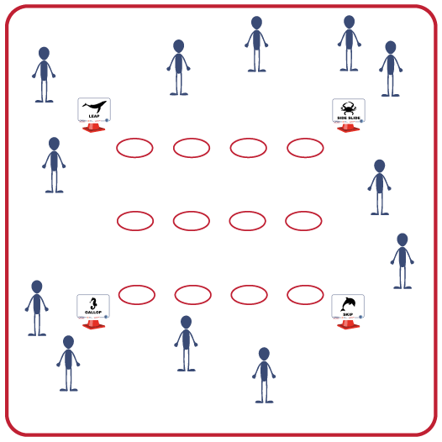
Equipment:
- 4 to 16 cones to create a running loop/track
- 4 Task Tents
- Printable Ocean Creature Cards
- 1 hoop per student
- Music and music player

Set-Up:
- Use cones and task tents to set up a medium-sized running loop in the activity area.
- Place Ocean Creature Cards inside the task tents at each of the 4 corners of the loop.
- Scatter hoops inside the cones creating islands in the large activity area.
- Scatter students around the running loop.
ACTIVITY PROCEDURES
- It’s time for a fun run playing the game Get on an Island! The object is to move with the Ocean Creatures as we travel around the running loop. On the “SHARK!” signal, everyone will safely and quickly move to an island (hoop).
- When the music starts, everyone will begin moving at a jogging pace around the running loop. As you get to the Ocean Creature Cards, look at the creature you’ll be traveling with and match their movement by performing that locomotor movement all the way to the next card. Change your locomotor movement at every corner.
- When the music stops and you hear, “SHARK!” everyone will speed-walk to an island for safety. It’s important to speed-walk. Running will make too many waves and the sharks will find you!
- When the music starts again, begin moving around the loop.

GRADE LEVEL PROGRESSION
- K: Teach, demonstrate, and practice locomotor skills in general space before beginning this activity.
- 1: Participate in the activity as written above.
- 2: Give students an object to dribble as they move around the loop.

TEACHING CUES
- Cue 1: Keep ears and eyes active. Stay aware of classmates as you move through the water.
- Cue 2: Stay calm during shark sightings. Control your speed to control your movement.

GET ON AN ISLAND (continued…)

UNIVERSAL DESIGN FOR LEARNING
- UDL 1: Demonstrate and practice all movements before beginning the game. Give verbal instruction along with visual demonstrations.
- UDL 2: If needed, modify the locomotor movements to match the skills and talents of your students.
- UDL 3: Use brightly colored cones and markers to create the running loop.

ACADEMIC LANGUAGE
Gallop, Heart Rate, Leap, Side Slide, Skip, Speed-Walk

PRIORITY OUTCOMES
Fitness Programming:
- (K) Participates in physical activity in active school programming environments
(PE, Recess, Activity Breaks).
- (1) Participates in physical activity outside of the school environment.
- (2) Participates in physical activities that contribute to fitness.

Personal Responsibility & Safety
- (K) Follows directions for safe participation and proper use of equipment with minimal reminders.
- (1) Follows directions for safe participation and proper use of equipment without reminders.
- (2) Works independently and safely in physical education.

DEBRIEF QUESTIONS
- DOK 1: Let’s make a list of all of the physical activities we do throughout the school day. What about after school and on the weekends?
- DOK 2: Let’s circle all of the activities that increase our heart rates and help us stay healthy and fit.
- DOK 3: How is regular physical activity related to personal health and fitness?
- DOK 4: On our white board, let’s make a weekly schedule of physical activity that a student could follow that includes activity in school and out of school.

