FOOTWORK WARM-UP

STUDENT TARGETS
- Purposeful Competition: I will recognize the role motivation plays in providing me with energy to work towards excellence.
- Skill: I will move with control and at a safe pace to prepare for basketball skills and game play.
- Fitness: I will stay actively engaged throughout the activity in order to increase my heart rate.
- Responsible Behaviors: I will demonstrate etiquette and respect during all practice tasks.

EQUIPMENT & SET-UP | 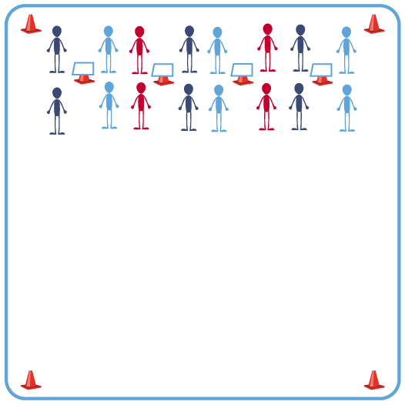
Equipment:
- 1 Task Tent and 1 cone per 4 students
- 1 Footwork Warm-up Challenge Card per 4 students
- Please see USA Basketball videos for demonstrations of footwork challenges listed on Challenge Card.

Set-Up:
- Place cones, Task Tents, and Challenge cards along one side of the activity area. Space out cones with Task Tents so that 2 groups can safely utilize each Challenge Card displayed.
- Create groups of 2-4 students. Send groups of students to one side of the activity space.

ACTIVITY PROCEDURES
- This activity is called the Footwork Warm-up. The object is to allow you to prepare to move safely during our basketball skills and game play.
- On the start signal, work to complete the footwork and stretching challenges found on the challenge card. One student will complete the footwork challenge while their partner performs the designated stretch. Once the partner completes one round of down and back of the footwork challenge, the partners will trade roles.
- Continue to alternate completing the footwork and stretching challenges until all six rounds have been completed.
- Teacher Note: both partners should complete the footwork challenge and the stretching challenge before moving to the next round.
- On the stop signal be ready for the next set of instructions.

GRADE LEVEL PROGRESSION
- Level 1: Complete each challenge with a focus on safely preparing the body to move.
- Level 2: Partners collaborate to create one new footwork or stretching challenge to add to the challenge card.

TEACHING CUES
- Cue 1: Move with control and at a safe pace to avoid injury.
- Cue 2: Continuously move during dynamic stretching without a break.
- Cue 3: Use motivating language with your partner(s).

FOOTWORK WARM-UP (continued…)

UNIVERSAL DESIGN FOR LEARNING
- UDL 1: Increase or decrease the size of activity area as needed.
- UDL 2: Use brightly colored cones/equipment to distinguish boundaries.
- UDL 3: Use verbal cues and visual aids along with demonstrations.
- UDL 4: Use peer partners as appropriate.

ACADEMIC LANGUAGE
Etiquette, Teamwork, Purposeful Competition, Footwork, Dynamic Stretching

PRIORITY OUTCOMES
Purposeful Competition – Inclusion of Purpose in All Relevant Activities:
- (HS) Design pathways to intentionally pursue the purpose of improving less secure social, affective, cognitive, and psychomotor skills.

Etiquette:
• (HS) Exhibits proper etiquette, respect for others, and teamwork while engaging in physical activity and/or social dance.

CLOSURE AND DEBRIEF
Debrief Questions:
- DOK 1: How can you recognize proper etiquette in physical education class?
- DOK 2: How does etiquette affect a physical activity experience for participants?
- DOK 3: How does etiquette change in other settings? How and why does it change? Provide support for your answer.
- DOK 4: Using information provided in this discussion on etiquette, analyze both the positive and negative consequences of past behaviors in physical activity settings.

