DRIBBLE KNOCKOUT

STUDENT TARGETS
- Purposeful Competition: I will recognize the role motivation plays in providing me with energy to work towards excellence.
- Skill: I will move with control demonstrating skill cues for dribbling.
- Fitness: I will stay actively engaged throughout the activity in order to increase my heart rate.
- Responsible Behaviors: I will communicate effectively to promote positive class dynamics during all practice tasks.

EQUIPMENT & SET-UP | 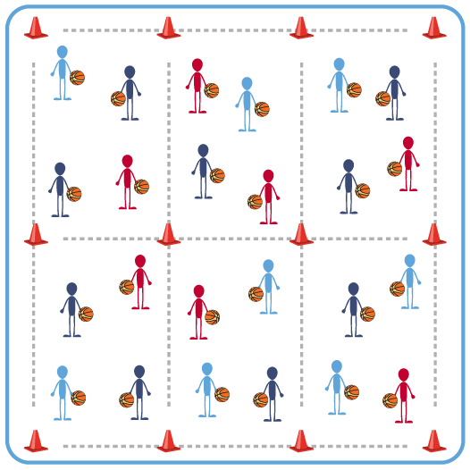
Equipment:
- 1 ball per student
- 24 tall cones to create 6 “courts” (4 cones per court)
Set-Up:
- Create 6 “courts” by using 4 tall cones to create a rectangle. The size of the 6 “courts” will depend on the number of students that will begin in each one.
- Each seasonal team will be divided evenly between all 6 “courts” to begin activity (e.g., a team of 6 would send 1 student to each court).
- Each student will begin with a ball at their designated court. Each team should be identified by their team color (e.g., red team with a red ball, red pinnie, or red wristband).

ACTIVITY PROCEDURES
- This activity is called the Dribble Knockout. The object is to work on the offensive skill of dribbling and the defensive skill of stealing.
- On the start signal, everyone will begin dribbling in their “court” working to maintain control of the ball. Just like in a basketball game, you need to simultaneously try to prevent any other players from causing you to lose control of the ball. Losing control of the ball includes mishandling a dribble, a double dribble, dribbling outside of the boundary, or having another student tap your ball that leads to not maintaining a continuous dribble.
- Anytime you lose control of your ball, you will rotate one court clockwise and begin again.
- Teacher Note: clearly identify and demonstrate the court rotation to avoid any confusion once the game begins.
- We will play for approximately 10 minutes. Continue to rotate one court clockwise any time you lose control of your ball until you hear the stop signal.
- On the stop signal, we will determine which team (e.g., red, purple, etc.) “wins” each of the 6 courts by having the most players from their team in that court.

GRADE LEVEL PROGRESSION
- Level 1: Focus on the skill cues and dribbling with control during this activity.
- Level 2: Students dribble with the non-dominant hand.

TEACHING CUES
- Cue 1: Dribble with control focusing on the skill cues.
- Cue 2: Use your non-dribbling hand to protect the ball.
- Cue 3: Keep your eyes up.

DRIBBLE KNOCKOUT (continued…)

UNIVERSAL DESIGN FOR LEARNING
- UDL 1: Increase or decrease the size of activity area as needed.
- UDL 2: Use brightly colored cones/equipment to distinguish boundaries.
- UDL 3: Use verbal cues and visual aids along with demonstrations.
- UDL 4: Use peer partners as appropriate.
- UDL 5: Provide equipment of different sizes, textures, and weights (e.g., playground balls, foam balls, auditory balls).

ACADEMIC LANGUAGE
Communication, Motivation, Practice Plan

PRIORITY OUTCOMES
Purposeful Competition – Inclusion of Purpose in All Relevant Activities:
- (HS) Design pathways to intentionally pursue the purpose of improving less secure social, affective, cognitive, and psychomotor skills.

Working with Others:
- (HS) Uses communication skills and strategies that promote positive team/group dynamics.

CLOSURE AND DEBRIEF
Purposeful Competition Closure:
- Please try to recollect an instance when you gained one, or multiple fair play points for your team today. How did this make you feel?
- What actions led up to you gaining points for your team? Did they make you better?
- Now try to recollect an instance of when you, or someone on your team lost points today. How did this make you feel?
- Do you see how this deduction of points can help you recognize behaviors that won’t drive you towards excellence, but rather hold you back? Let’s work together to end the season with as many points as possible!

Debrief Questions:
- DOK 1: What is a practice plan?
- DOK 2: How can you apply the skills you’ve learned so far and today’s activities in the development of a practice plan?
- DOK 3: How is practice related to skill development?

