DRIBBLE WARM-UP

STUDENT TARGETS
- Purposeful Competition: I will recognize the importance of failed attempts along the path to excellence and learn from them intentionally.
- Skill: I will move with control and at a safe pace to prepare for basketball skills and game play.
- Fitness: I will identify the skill-related fitness components utilized during the Dribble Warm-up activity.
- Responsible Behaviors: I will demonstrate safe and cooperative behaviors during all practice tasks.

EQUIPMENT & SET-UP | 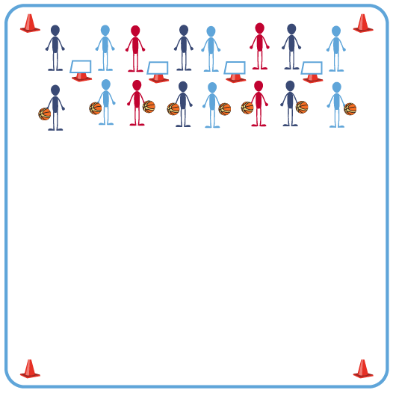
Equipment:
- 1 Task Tent and 1 cone per 4 students
- 1 Dribble Warm-up Challenge Card per 4 students
- Please see USA Basketball videos for demonstrations of dribbling challenges listed on Challenge Card.

Set-Up:
- Place cones, Task Tents, and Challenge cards along one side of the activity area. Space out cones with Task Tents so that 2 groups can safely utilize each Challenge Card displayed.
- Create groups of 2-4 students. Send groups of students to one side of the activity space.

ACTIVITY PROCEDURES
- This activity is called the Dribble Warm-up. The object is to allow you to prepare to dribble with confidence and move safely during our basketball skills and game play.
- On the start signal, work to complete the dribble and stretching challenges found on the challenge card. One student will complete the dribble challenge while their partner performs the designated stretch. Once the partner completes one round of down and back of the dribble challenge, the partners will trade roles.
- Continue to alternate completing the dribble and stretching challenges until all six rounds have been completed.
- Teacher Note: both partners should complete the dribble challenge and the stretching challenge before moving to the next round.
- On the stop signal be ready for the next set of instructions.

GRADE LEVEL PROGRESSION
- Level 1: Complete each challenge with a focus on safely preparing the body to move.
- Level 2: Partners collaborate to create one new dribbling or stretching challenge to add to the challenge card.

TEACHING CUES
- Cue 1: Move with control and at a safe pace to avoid injury.
- Cue 2: Continuously move during dynamic stretching without a break.
- Cue 3: Use motivating language with your partner(s).

DRIBBLE WARM-UP (continued…)

UNIVERSAL DESIGN FOR LEARNING
- UDL 1: Increase or decrease the size of activity area as needed.
- UDL 2: Use brightly colored cones/equipment to distinguish boundaries.
- UDL 3: Use verbal cues and visual aids along with demonstrations.
- UDL 4: Use peer partners as appropriate.
- UDL 5: Provide equipment of different sizes, textures, and weights (e.g., playground balls, foam balls, auditory balls).

ACADEMIC LANGUAGE
Challenge, Teamwork, Skill-related Fitness

PRIORITY OUTCOMES
Purposeful Competition - Association of Failed Attempts with Future Successes:
- (HS) Create higher level tasks to overcome challenge, rather than easily attained victories, in recognition that losses will provide many opportunities to see greater development and lead to growth.

Etiquette:
- (HS) Exhibits proper etiquette, respect for others, and teamwork while engaging in physical activity and/or social dance.

CLOSURE AND DEBRIEF
Debrief Questions:
- DOK 1: What are the components of skill-related fitness?
- DOK 2: How does skill-related fitness affect a person’s ability to reach goals?
- DOK 3: How are the components of skill-related fitness related to the Dribble Warm-up we did today?

