2v1 CATCH AND SHOOT

STUDENT TARGETS
- Purposeful Competition: I will recognize the importance of failed attempts along the path to excellence and learn from them intentionally.
- Skill: I will demonstrate skill cues for passing, receiving, and shooting.
- Fitness: I will remain actively engaged in all challenges.
- Responsible Behaviors: I will demonstrate teamwork and cooperative behaviors.

EQUIPMENT & SET-UP | 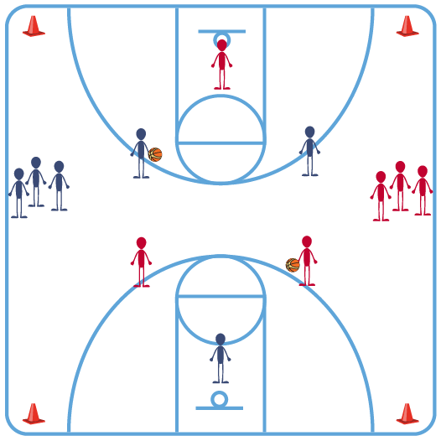
Equipment:
- 1 basketball per 3 to 9 students
- 1 basketball goal per 3 to 9 students

Set-Up:
- Create groups of 3 to 9 students. Each group goes to a basketball goal with a ball.
- 1 student begins as the defender and 2 students begin on offense (with the ball) about 25 feet from the basket.
- Additional students line up 10 feet behind the offensive players.
ACTIVITY PROCEDURES
- This activity is called the 2v1 Catch and Shoot. The object is for the two offensive players to score on the 1 defender. Player with the ball attacks the basket, moves the defender and makes a pass for a quick catch and shoot. This simulates a game setting to help build control and confidence.
- On the start signal, the partner with the ball dribbles toward the basket. The other offensive player starts a cut to the basket. The defender must move to close out and stop the ball. The player with the ball will make a pass to their partner when the defender fully commits. The cutting player will catch and shoot (or finish the layup). Try to catch and shoot without taking a dribble.
- The defender will rebound the ball and pass it out to the next two players at the top of the key, and the student who began with the ball will rotate to become the new defender. The other students go back to get in line for another turn.
- The activity continues until 20 shots have been made or time elapses.

GRADE LEVEL PROGRESSION
- Level 1: Play as described above.
- Level 2: Add a second defender so it becomes 2v2.

TEACHING CUES
- Cue 1: Two hands on the ball (east and west) before the pass.
- Cue 2: Communicate with your partners (verbal and non-verbal) to complete successful passes.
- Cue 3: Use teamwork and cooperative behaviors with your classmates.

2v1 CATCH AND SHOOT (continued…)

UNIVERSAL DESIGN FOR LEARNING
- UDL 1: Increase or decrease the size of activity area as needed.
- UDL 2: Use brightly colored cones/equipment to distinguish boundaries.
- UDL 3: Use verbal cues and visual aids along with demonstrations.
- UDL 4: Use peer partners as appropriate.
- UDL 5: Provide equipment of different sizes, textures, and weights (e.g., playground balls, foam balls, auditory balls).

ACADEMIC LANGUAGE
Pass, Cooperation, Teamwork

PRIORITY OUTCOMES
Purposeful Competition – Association of Failed Attempts with Future Successes:
- (HS) Identify the importance of fair and consistent officiating/rule following in a competitive environment in order to differentiate errors accurately for future improvement.

Personal Responsibility & Safety:
- (HS) Applies best practices for participating safely in physical activity, exercise, and dance (e.g., injury prevention, proper alignment, hydration, use of equipment, implementation of rules, sun protection).

CLOSURE AND DEBRIEF
Debrief Questions:
- DOK 1: What is teamwork?
- DOK 2: How would you compare and/or contrast a team’s Basketball performance that demonstrates teamwork with a performance that doesn’t?
- DOK 3: What facts would you select to support the importance of teamwork to Basketball success? Can you elaborate on why you chose those facts?

