ULTIMATE BASKETBALL

STUDENT TARGETS
- Purposeful Competition: I will recognize the importance of failed attempts along the path to excellence and learn from them intentionally.
- Skill: I will demonstrate a variety of Basketball skills required for participating in a modified game.
- Fitness: I will remain focused and actively engaged in practice tasks.
- Responsible Behaviors: I will work cooperatively to demonstrate the spirit of the game.

EQUIPMENT & SET-UP | 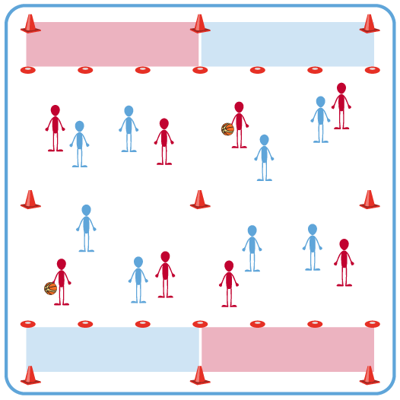
Equipment:
- 1 basketball per court
- 12 low profile cones per court
- 1 pinnie or colored wristband per 2 students

Set-Up:
- Create 1 court for each team using low profile cones, including a scoring zone on the end for each team.
- Create even teams (e.g., 3v3 or 4v4) within each court.
- One of the two teams should be identified with pinnies or colored wristbands.

ACTIVITY PROCEDURES
- This activity is called Ultimate Basketball. The object of the activity is to try to score more points than the other team.
- You have 3 minutes to discuss strategies for scoring points quickly and efficiently with your group. Each team should have one substitute player who will act as the referees providing the final word on any disputed calls. If referees cannot agree, they play rock, paper, scissors to determine the call and keep the game moving.
- On the start signal, each team will begin the game near their scoring zone and one team will start with the ball. The person with the ball will begin by passing to a teammate. That teammate will catch it and pass to another teammate as they advance the ball down the court. If the pass isn’t completed successfully, it is a turnover.
- A team must complete at least 3 passes before attempting to score. A team scores a point by catching a pass in their scoring zone.
- The game will be approximately 10 minutes, and we will rotate the substitute players into the game every 2-3 minutes. Teams are allowed 1 timeout.
- Above all, let’s be respectful and demonstrate the spirit of the game. Your coaches and captains will be able to observe different combinations of players to help inform the development of tournament teams at the end of this season.

GRADE LEVEL PROGRESSION
- Level 1: Play the activity as described above.
- Level 2: Teams are challenged to develop and execute 2-3 new plays for scoring during the game.

TEACHING CUES
- Cue 1: Demonstrate the spirit of the game for the entirety of the activity.
- Cue 2: Communicate effectively with your teammates.
- Cue 3: Use motivating and encouraging language with teammates.

ULTIMATE BASKETBALL (continued…)

UNIVERSAL DESIGN FOR LEARNING
- UDL 1: Increase or decrease the size of activity area as needed.
- UDL 2: Use brightly colored cones/equipment to distinguish boundaries.
- UDL 3: Use verbal cues and visual aids along with demonstrations.
- UDL 4: Use peer partners as appropriate.
- UDL 5: Provide equipment of different sizes, textures, and weights (e.g., playground balls, foam balls, auditory balls).

ACADEMIC LANGUAGE
Movement Concepts, Tactics, Spirit of the Game, Offense, Defense

PRIORITY OUTCOMES
Purposeful Competition – Association of Competition with Partnership:
- (HS) Distinguish the self-selection of tasks with greater levels of difficulty, or more highly skilled opponents/partners, as purposeful movement towards excellence.

Social Interaction:
- (HS) Identifies and evaluates the opportunity for social interaction and social support in self-selected physical activities.

CLOSURE AND DEBRIEF
Purposeful Competition Closure:
- How did you navigate the progression from something easy to something harder today? Were you impatient waiting to get to something harder? Try enjoying the moment and helping others around you.
- Were you overwhelmed by the parts that were more challenging? Try going back to what you felt comfortable with and building a little more slowly and patiently, learning intentionally from your mistakes along the way.
- Share something new you learned with someone near you and explain how that information will help you in the future. (Teacher: allow time to move and talk) Thank you for your effort!

Debrief:
- DOK 1: What are the movement concepts related to Basketball participation?
- DOK 2: How do those concepts affect the performance of specific skills or tactical plays?
- DOK 3: How can you apply what you’ve learned to develop your Basketball skills? (Teachers: include specific skills when you ask this question. For example, “How can you apply what you’ve learned to develop your passing skills?”).

