3v3

STUDENT TARGETS
- Purposeful Competition: I will value my opponent as a partner who allows me to work towards excellence.
- Skill: I will apply offensive and defensive strategies to assist my team in scoring points.
- Fitness: I will remain actively engaged in all challenges.
- Responsible Behaviors: I will engage and respond appropriately using rules, guidelines, and etiquette to resolve conflicts and promote fair play.

EQUIPMENT & SET-UP | 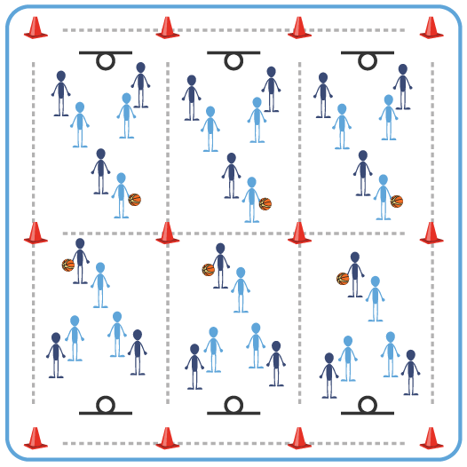
Equipment:
- 1 basketball per 6 students
- 1 basket per 6 students
- 1 colored wristband per student, enough colors for several teams of 3
- Cones to create grids with large activity areas

Set-Up:
- Create 1 large grid per 6 students with 1 basket (or modified basket) for a half-court game.
- Group students into teams of 3, each team with its own color and each student with a wristband.
- Teams play Rock, Paper, Scissors to see who starts with the ball.
ACTIVITY PROCEDURES
- This activity is called 3v3. This game will give us the opportunity to have some fun and apply many of the different basketball skills we have practiced in a half-court format.
- Each team will try to score a point by successfully shooting in the basket. Additional points can be scored by making complete passes to each member of your team in a single possession (e.g., before scoring or before turning the ball over to the other team).
- Each basket equals 1 point for your team if the shot was made off a dribble, and each shot made directly after catching a pass will equal 2 points. In addition, each set of 3 completed passes without a turnover equals 1 point for your team.
- Defense must play 3 full arm-lengths away from offensive players and can only intercept passes. They cannot touch offensive players. If a foul is made, then the offense scores a point.
- When a team successfully scores a basket, change possession. If the defense gets a rebound, they must pass it back to the top of the activity area before attacking the basket.
- Activity will continue until 20 shots have been made or time elapses.
GRADE LEVEL PROGRESSION
- Level 1: Play as described above.
- Level 2: Change scoring to focus on rebounding. Each basket equals 1 point for a team, but every rebound by either team will also count as 1 point.

TEACHING CUES
- Cue 1: When on offense, try and use ball fakes to freeze the defense.
- Cue 2: Use verbal and non-verbal communication to help your team successfully move the ball.
- Cue 3: Keep your eyes on opponent’s waist (not the ball) to anticipate the direction they will move.

3v3 (continued…)

UNIVERSAL DESIGN FOR LEARNING
- UDL 1: Increase or decrease the size of activity area as needed.
- UDL 2: Use brightly colored cones/equipment to distinguish boundaries.
- UDL 3: Use verbal cues and visual aids along with demonstrations.
- UDL 4: Use peer partners as appropriate.
- UDL 5: Provide equipment of different sizes, textures, and weights (e.g., playground balls, foam balls, auditory balls).

ACADEMIC LANGUAGE
Strategy, Accuracy, Target, Teamwork

PRIORITY OUTCOMES
Purposeful Competition – Association of Competition with Partnership:
- (HS) Distinguish the self-selection of tasks with greater levels of difficulty, or more highly skilled opponents/partners, as purposeful movement towards excellence.

Working with Others:
- (HS) Uses communication skills and strategies that promote positive team/group dynamics.

CLOSURE AND DEBRIEF
Purposeful Competition Closure:
- I want you to tell a partner something you KNOW you are going to need to work on if you can hope to improve in Basketball in the coming weeks. (Allow talk time)
- Partner, I want you to thank your friend for sharing, and I would like you to now share something that you will be looking to improve. (Allow talk time)
- And now, I would like you to share HOW you plan on improving that skill that needs assistance. However, if you don’t know a good way to work towards improvement, please ask your partner for ideas. And if neither of you can come up with a way to improve, I will be happy to assist you. Of course, if I don’t know, then I will be happy to research an answer that I can provide for you next class. Because getting answers is important, but the modesty, comradery, and community that comes from seeking that answer are a greater benefit to us all.

Debrief:
- DOK 1: Can you define the word “strategy”?
- DOK 2: What do you know about Basketball offensive strategies? What about defensive strategies?
- DOK 3: How is open space related to Basketball strategies (offensive and/or defensive)?

