CREATE A DRILL

STUDENT TARGETS
- Purposeful Competition: I will recognize the importance of failed attempts along the path to excellence and learn from them intentionally.
- Skill: I will apply Basketball skill cues and strategies to the development of a new activity.
- Fitness: I will remain focused and actively engaged during development and while learning games from other teams.
- Responsible Behaviors: I will demonstrate safe and cooperative behaviors during the entire class.

EQUIPMENT & SET-UP | 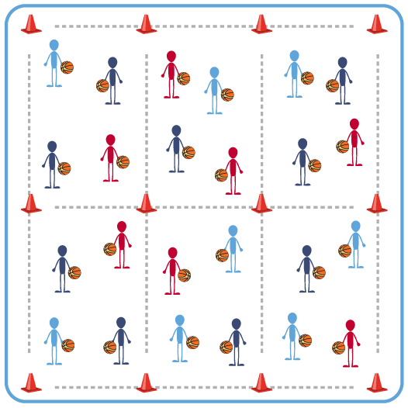
Equipment:
- Variety of Basketball and other equipment requested by each team (e.g., nets, hoops, balls, cones)
- Create A Drill Worksheet for each team

Set-Up:
- Each team should have a designated activity area for development of a drill/game and to play the activity created.
- Each team will complete the Create a Drill Worksheet at beginning of class.
- Each team will identify and set up equipment needed for the drill/game they create.

ACTIVITY PROCEDURES
- It’s time for the students to become the teacher! This activity is called Create a Drill, since each team will develop a drill or game to improve their Basketball skills. Each team will also teach their activity to the rest of the class!
- Each team will use the Create a Drill Worksheet as a guide to develop your drill or game. Once you have the chart filled in, your captain will lead your team through participating in the activity.
- After you have experienced the activity as a team, discuss if you want to make any changes to the rules, equipment, etc. before you demonstrate and teach your activity to the other teams.
- On the stop signal put equipment down and be ready for the next set of instructions.

GRADE LEVEL PROGRESSION
- Level 1: Complete the Create a Drill Worksheet as a team.
- Level 2: Demonstrate and teach your new drill/game to the other teams.

TEACHING CUES
- Cue 1: Be an active listener during group discussions.
- Cue 2: Be open to ideas from your teammates.
- Cue 3: Be creative and have FUN!
- Cue 4: Use the Create a Drill Worksheet to ensure you are addressing all development considerations and requirements.

CREATE A DRILL (continued…)

UNIVERSAL DESIGN FOR LEARNING
- UDL 1: Ensure any assistive technology that is needed is available on the day of this activity.
- UDL 2: Provide equipment of different sizes, textures, and weights (e.g., playground balls, foam balls, auditory balls).
- UDL 3: Use verbal cues and visual aids along with demonstrations.
- UDL 4: Use peer partners as appropriate.

ACADEMIC LANGUAGE
Rules, Equipment, Creativity, Kindness

PRIORITY OUTCOMES
Purposeful Competition – Application of Purpose Including the Community:
- (HS) Evaluate the benefit of engaging/challenging new members of the community in pursuit of purpose.

Working with Others:
- (HS) Uses communication skills and strategies that promote positive team/group dynamics.

CLOSURE AND DEBRIEF
Purposeful Competition Closure:
- Let’s take this opportunity to connect with a partner right now and work on Exit Cards. I want you to tell this partner something you KNOW you are going to need to work on if you can hope to improve in Basketball in the coming weeks. (Allow talk time)
- Partner, I want you to thank your friend for sharing, and I would like you to now share something that you will be looking to improve. (Allow talk time)
- And now, first partner, I would like you to thank your partner for sharing and let them know HOW you plan on improving that skill that needs assistance. However, if you don’t know a good way to work towards improvement, please ask your partner for ideas. And if neither of you can come up with a way to improve please seek out a Coach or Captain that you believe might be able to assist you.
- But if you STILL can’t come up with something I will be happy to assist you. Of course, if I don’t know, then I will be happy to research an answer that I can provide for you next time we get together, because getting answers is important, but the modesty, comradery, and community that comes from seeking that answer are a greater benefit to us all. I invite you to carry on this conversation walking to your next class.

Debrief Questions:
- DOK 1: What is something you found challenging about creating your own drill or activity?
- DOK 2: How did your team work through making a final decision if there were multiple ideas being shared in the beginning of the conversation?

