GOLF BOWLING

STUDENT TARGETS
- Skill: I will use proper grip and stance when putting.
- Cognitive: I will identify the basic rules and etiquette of golf.
- Fitness: I will stay actively engaged throughout the activity.
- Personal & Social Responsibility: I will support teammates by communicating with respectful and encouraging language.

EQUIPMENT & SET-UP | 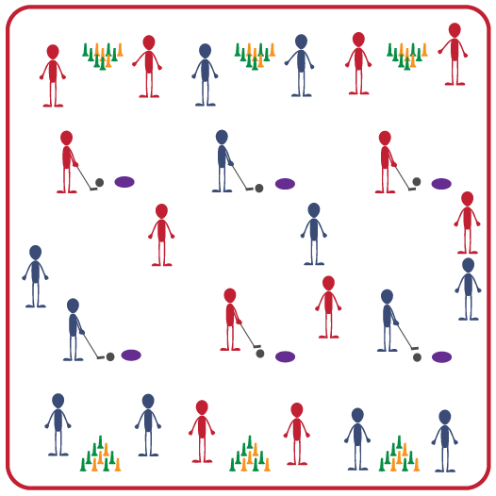
Equipment:
- 1 club per 4-5 students
- 1 plastic golf ball per 4-5 students
- 1 spot marker per 4-5 students
- 10 Mini Markerz cones per 4-5 students
Set-Up:
- Create activity areas that are approximately 8-10 feet long.
- Set up the Mini Markerz cones like bowling pins (in a triangle) and place the spot marker about 8-10 feet away from the cones.
- Create groups of 4-5 students; each group begins by a spot marker with one club and one ball. Students will rotate through 4 roles: putter, pin setter, ball returner, and putter on deck.
ACTIVITY PROCEDURES
- This activity is called Golf Bowling. The object of the game is to knock down as many of the cones as possible in two tries, just like traditional bowling.
- Today we are going to work on putting. You will work with your team and rotate through 4 different team roles: putter, pin setter, ball returner, and putter on deck.
- On the start signal, the putter will begin by the spot marker and putt the ball to try and knock down all of the pins (cones). If you knock them all down on the first try you get a score of 10. Just like in bowling, if you don’t knock them all down on the first try you get a second attempt.
- After the putter has completed their attempts, everyone will rotate to the next spot and the putter on deck now becomes the putter. You will continue to rotate through the 4 roles until everyone has had 10 attempts or time expires.
- When you hear the stop signal, we will discuss our successes and challenges before we play again.

GRADE LEVEL PROGRESSION
- Grade 6: Play as described above.
- Grades 7-8: Increase the distance between the spot marker and the cones.

TEACHING CUES
- Cue 1: Stand with feet shoulder width apart.
- Cue 2: Align the face of the putter square to your target.
- Cue 3: Use a smooth and controlled “tick tock” motion when swinging.

GOLF BOWLING (continued…)

UNIVERSAL DESIGN FOR LEARNING
- UDL 1: Increase/decrease the activity space as needed.
- UDL 2: Use modified equipment as needed.
- UDL 3: Use verbal cues and visual aids along with demonstrations.
- UDL 4: Use peer partners as appropriate.

ACADEMIC LANGUAGE
Alignment, Etiquette, Grip, Stance, Putt

PRIORITY OUTCOMES
Etiquette:
- Identifies the rules and etiquette for physical activities/games and dance activities.

Social Interaction:
- Demonstrates the importance of social interaction by helping and encouraging others, avoiding trash talk, and providing support to classmates.

DEBRIEF QUESTIONS
- DOK 1: What does it mean to show etiquette during the game of golf?
- DOK 2: What are some golf rules that are related to golf etiquette?
- DOK 3: How can etiquette impact a person’s success during golf?

