BACKYARD BOCCE

STUDENT TARGETS
- Skill: I will work to roll the ball close to the pallino.
- Cognitive: I will focus my attention on the challenge in an effort to improve my team’s score.
- Fitness: I will stay actively engaged during this activity.
- Personal & Social Responsibility: I will use positive and encouraging communication with my teammates.

EQUIPMENT & SET-UP | 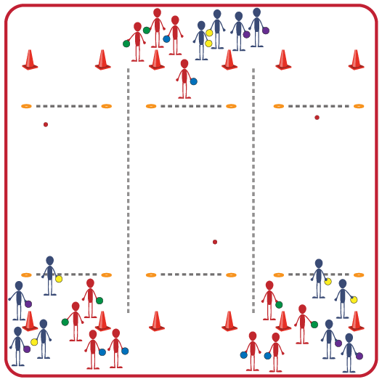
Equipment:
- Bocce Set per 8 students
- 4 Medium cones per 8 students
- 2 Low profile cones per 8 students
Set-Up:
- Create groups of 8 students, with 2 teams of 4 in each group.
- Set up 4 medium cones to mark the boundary of the Bocce court. Set up a foot fault line to roll from with 2 low profile cones.
- Each group will begin at a court with 8 bocce balls and 1 pallino. Identify the colors of the bocce balls for each team: one team is yellow and purple; other team is green and blue.
ACTIVITY PROCEDURES
- This activity is called Backyard Bocce! The object of the game is to get your team’s bocce balls closer to the pallino than the other team.
- Teams will play Rock, Paper, Scissors to determine who will roll the pallino at the beginning of the game and roll their bocce ball first. The pallino and the bocce balls must all be thrown/rolled underhand during the game.
- Each team has 4 bocce balls to roll during each frame and will alternate rolls with the other team. The team that gets their ball closest to the pallino gets one point for that frame. If a bocce ball is touching the pallino at the end of the frame then the winning team would get 2 points.
- The winning team gets to throw the pallino and roll their bocce ball first to begin the next frame.
- The game will continue until one team gets to 11 points or you hear the stop signal.

DEBRIEF QUESTIONS
- DOK 1: What does positive and encouraging communication sound like?
- DOK 2: What is an example of positive or encouraging communication you heard during the game?
- DOK 3: How does positive and encouraging communication impact the way a team works together?

PRIORITY OUTCOMES
Social Interaction:
- Grades 3-5: Describes the positive social interactions that come when engaged with others in physical activity.
- Grades 6-8: Demonstrates respect for self and others in activities and games by following the rules, encouraging others, and playing within the spirit of the game or activity.
- Grades 9-12: Demonstrates the importance of social interaction by helping and encouraging others, avoiding trash talk, and providing support to classmates.

