SPIKE IT UP

STUDENT TARGETS
- Skill: I will demonstrate a variety of Roundnet skills required to score points for my team.
- Cognitive: I will identify ways my team can work together cooperatively during the game.
- Fitness: I will stay actively engaged during this activity.
- Personal & Social Responsibility: I will demonstrate integrity and proper etiquette by respecting others and following the rules of the game.

EQUIPMENT & SET-UP | 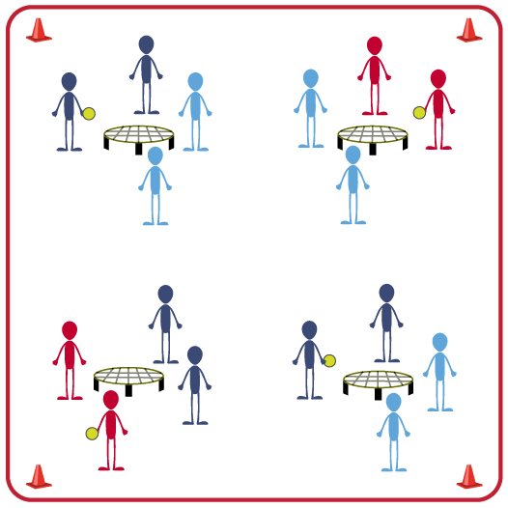
Equipment:
- 1 Spikeball® net (or hoop) and 1 ball per group of 4 students
- Use hoops and foam balls if you do not have enough Spikeball® sets for entire class

Set-Up:
- Scatter nets (or hoops) in the activity area, allowing space for player movement.
- Place 1 Spikeball® at each net.
- Pair students and send 2 pairs (4 players) to each net.
ACTIVITY PROCEDURES
- This activity is called Spike it Up. The object of the activity is to score more points than the other team. That is done by building a rally with consecutive Roundnet passes and spikes with your partner.
- On the start signal, play Rock, Paper, Scissors to determine which team will serve first to begin the game. Teams have a maximum of 3 hits (2 passes and 1 spike) to send the ball down to the net for a change of possession.
- We will play 5-minute games. At the end of each game, each of you must play with a different partner within your group. We will play a total of 3 games, so you have an opportunity to partner with everyone at your net for one game.
- The game will continue until one team gets to 21 points or you hear the stop signal.

DEBRIEF QUESTIONS
- DOK 1: What is integrity?
- DOK 2: Why is integrity important in physical activity or competitive settings?
- DOK 3: How is integrity related to the enjoyment of everyone playing a game of Roundnet?

PRIORITY OUTCOMES
Etiquette:
- Grades 3-5: Recognizes the role of rules and etiquette in physical activity with peers.
- Grades 6-8: Exhibits etiquette and adherence to rules in a variety of physical activities.
- Grades 9-12: Exhibits proper etiquette, respect for others, and teamwork while engaging in physical activity and/or social dance.

